CSE 581:

INTRODUCTION TO DATABASE MANAGEMENT SYSTEMS

PROJECT: 1

*Submitted by*

PAVAN JIGNESH PANDYA

SUID: 340197894

*Table Of Contents*

*Abstract……………..…………………………………………………………………………………. 03*

*Section: A - Database Setup……………………………………………………………………….. 04*

*Section: B – Essential SQL Skills……………………………………………………………………15*

*Section C – Advanced SQL Skills……………………………………………………………………56*

*Section D – Database Design……………………………………………………………………….76*

Remarks……………………………………………………………………………………………….80

***Abstract***

*This project focuses on utilizing SQL Server Management Studio to load and manipulate databases. The following topics are covered: fundamental queries, keywords, statements, operators, joins, subqueries, summary queries, aggregate functions, datatypes, and tables. Insertion, deletion, and updating are all types of data change. The subjects addressed include views, scripts, scalar and table valued functions, database implementation, and others. Moreover, creating a database using an E-R diagram is a crucial step. The majority of the important SQL and database principles are the subject of this project.*

SECTION A:

DATABASE SETUP

1. Download sql files from this project tab and open CreatMyCollege.sql in SQL server management studio. Execute the entire script and show the message in the Message tab, indicating the script is executed successfully.

**Answer 1: -** As I didn’t have a windows, I had a Mac Instead of setting up SQL Management Studio I set up Azure Data studio.

Step 1: I Installed Docker

Step 2: I Installed Azure Data Studio and configured it with my docker.

Step 3: After the Configuration I just imported the scripts given in the lab question and then I created a server called localhost to run them all.

Step 4: all the scripts imported are now up and running.

The Screenshots for the steps are given below.

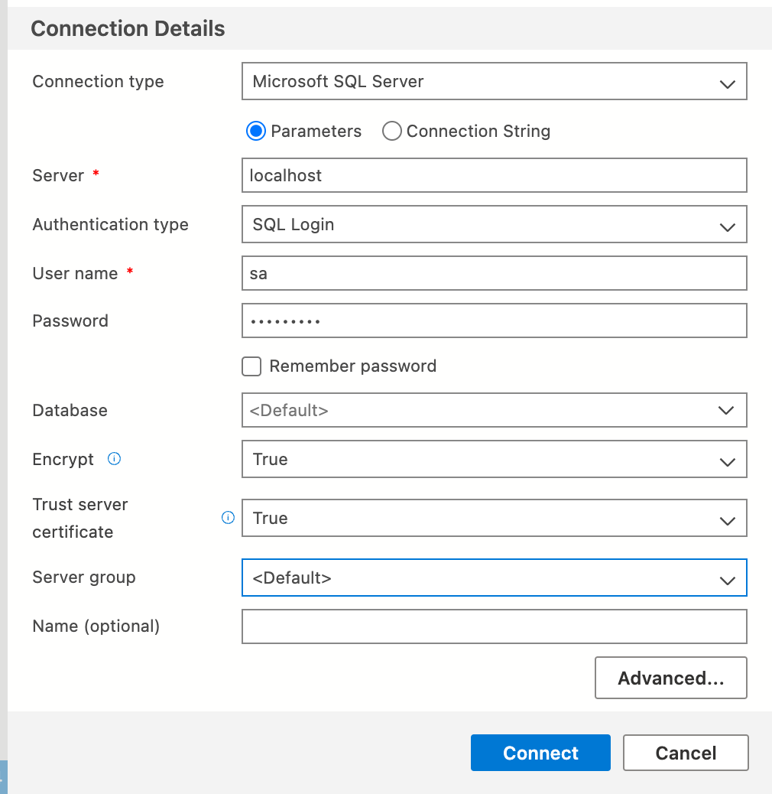

Azure Data studio connection details

Server: - localhost

Username: - sa

Password: - Pawan@123

**Remarks: -** I Downloaded all the SQL files as given in the problem and ran all the scripts in Azure Data Studio, After I ran the script all the files were compiled successfully, and the result is displayed in the given screenshot.

**Output: -**

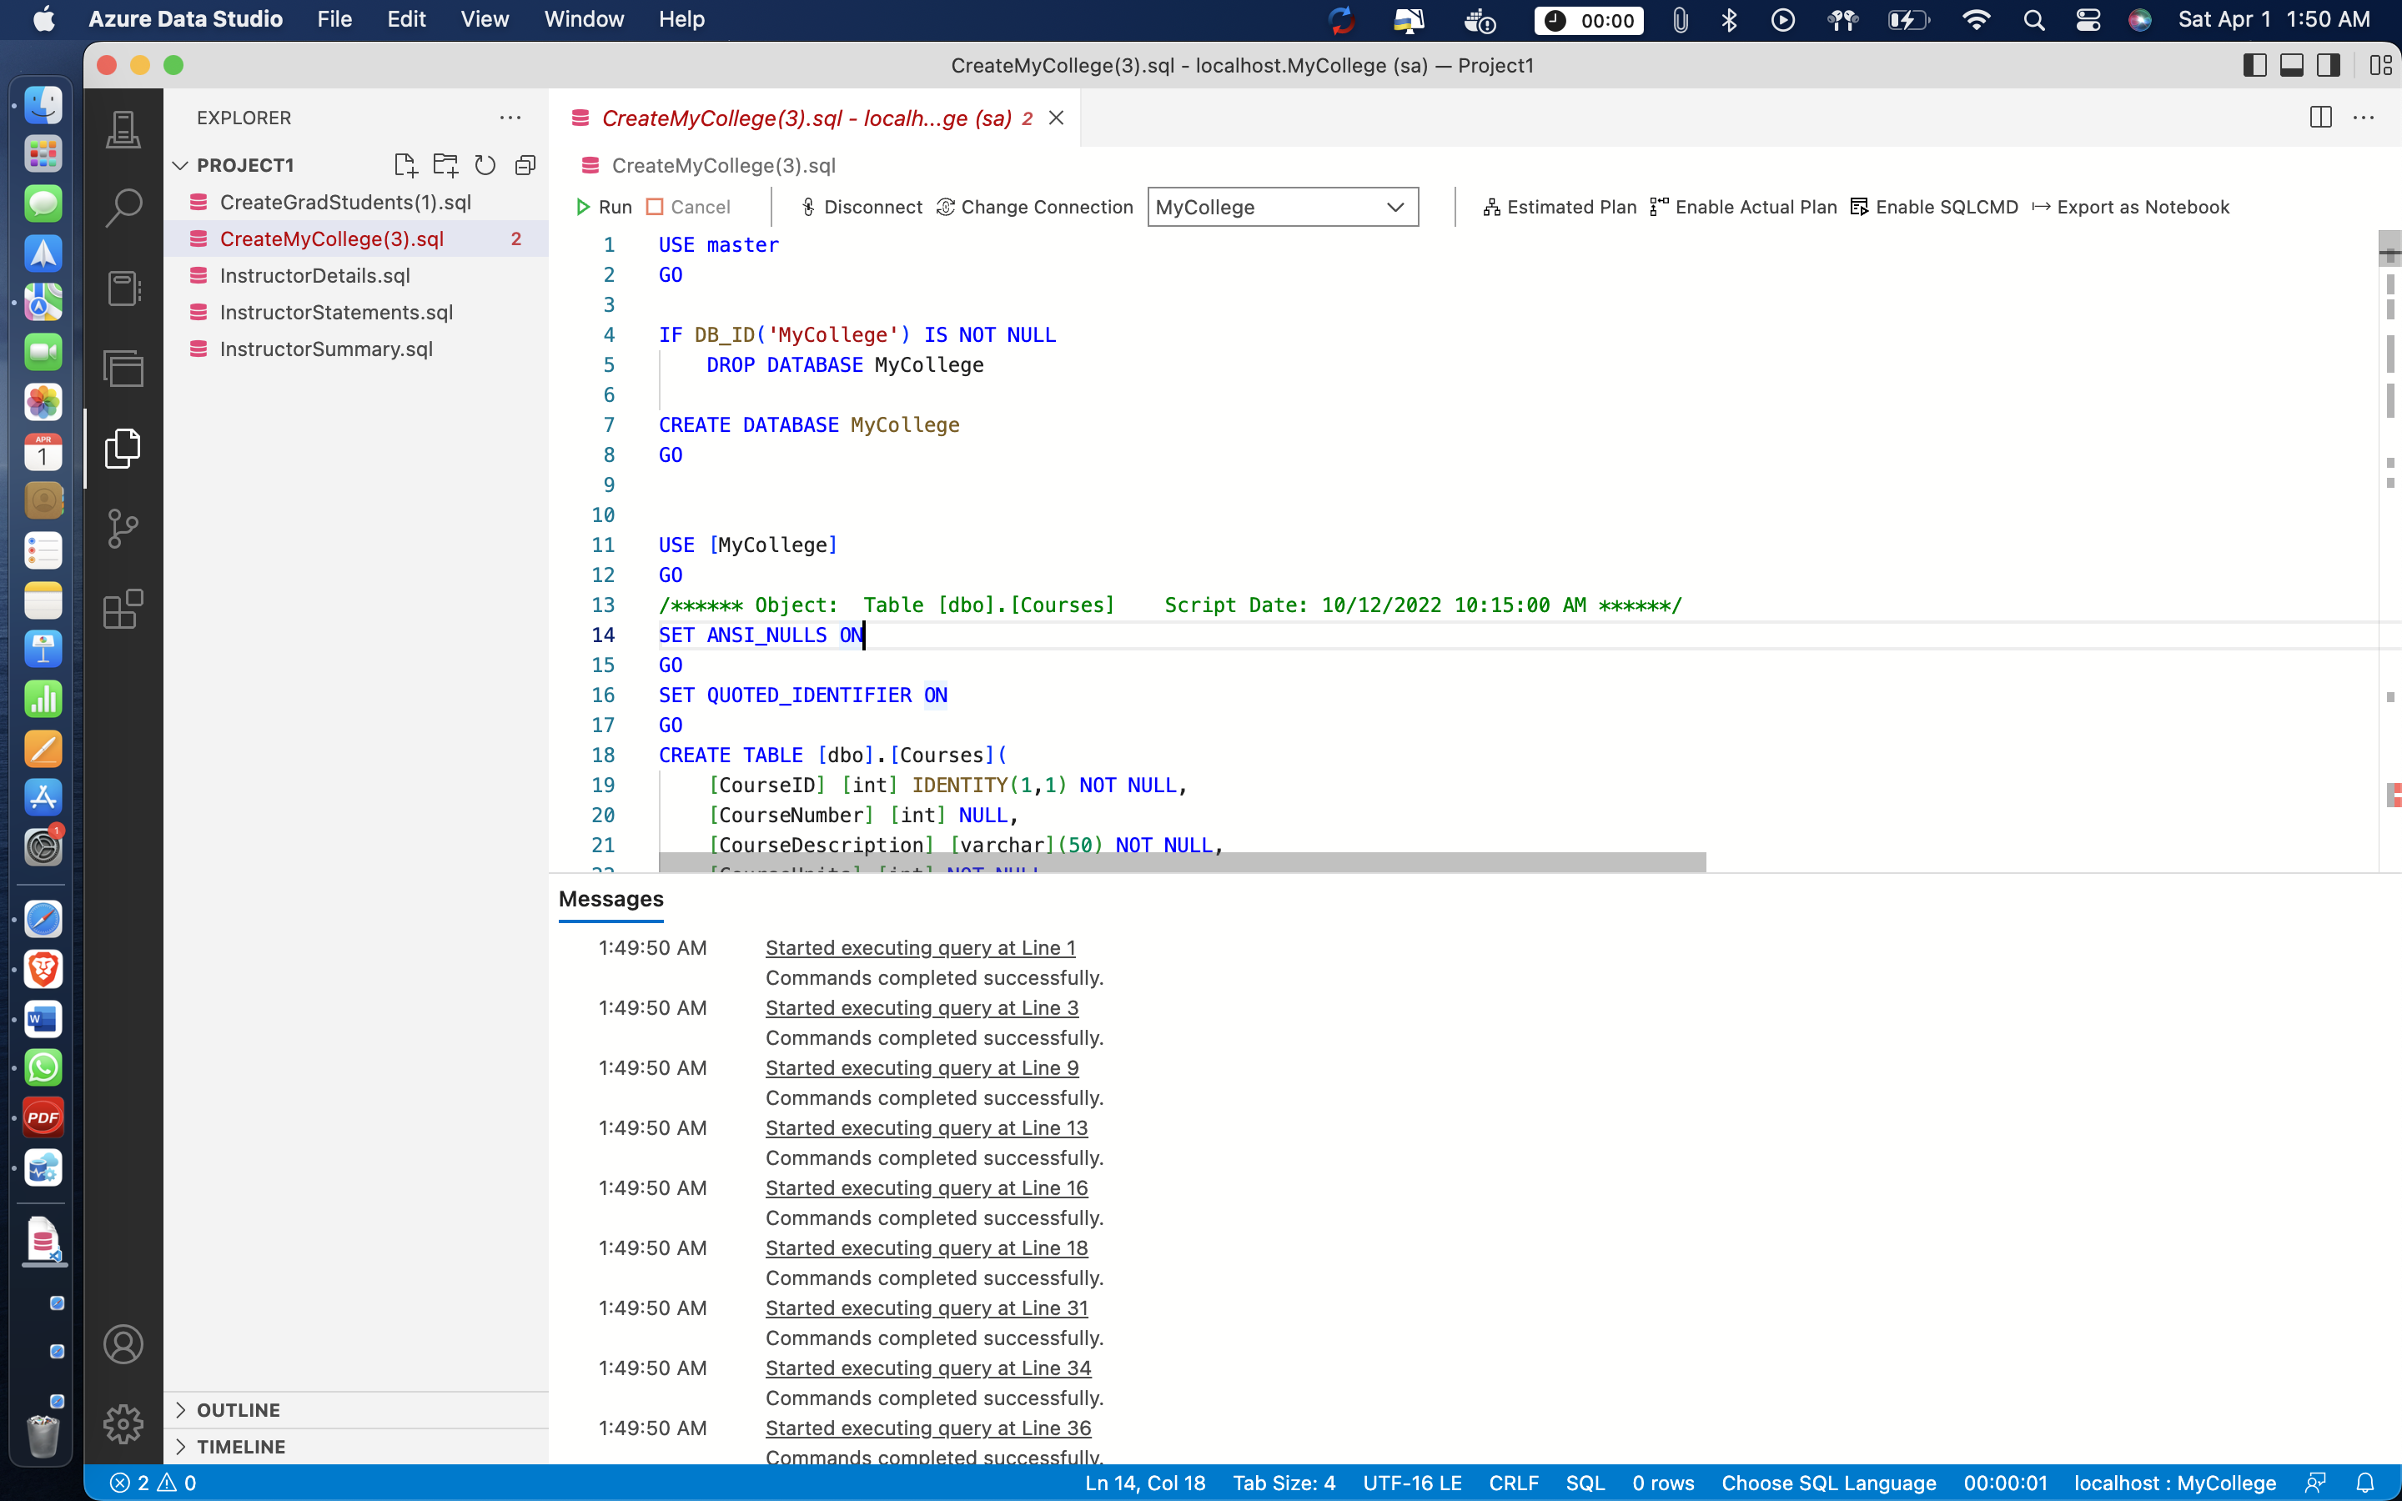

1. Navigate through the database objects and view the column definitions for each table. Open a new Query Editor window. Show details in Courses table and Instructors table using SELECT statement.

**Answer 2: -**

**Remark: -** The given screenshots below displays the column definition for each table in the MyCollege database. With the help of select * command it displays all of the Courses and Instructors.

**Output: -**

**Courses Table in MyCollege DB: -**

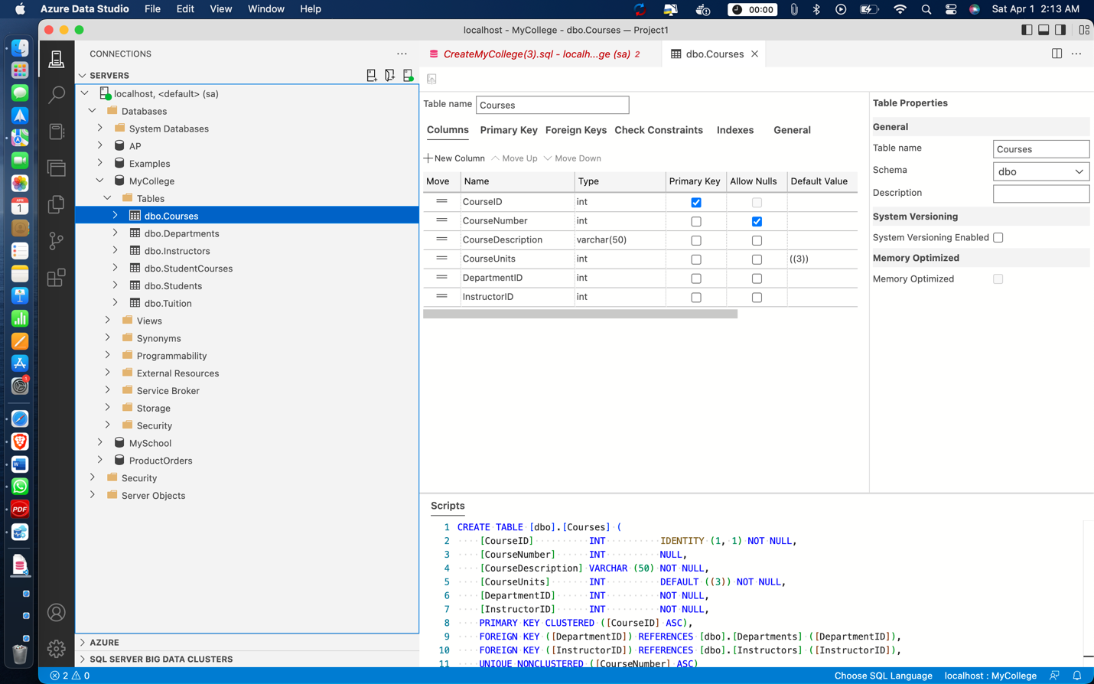

**Departments Table in MyCollege DB:** -

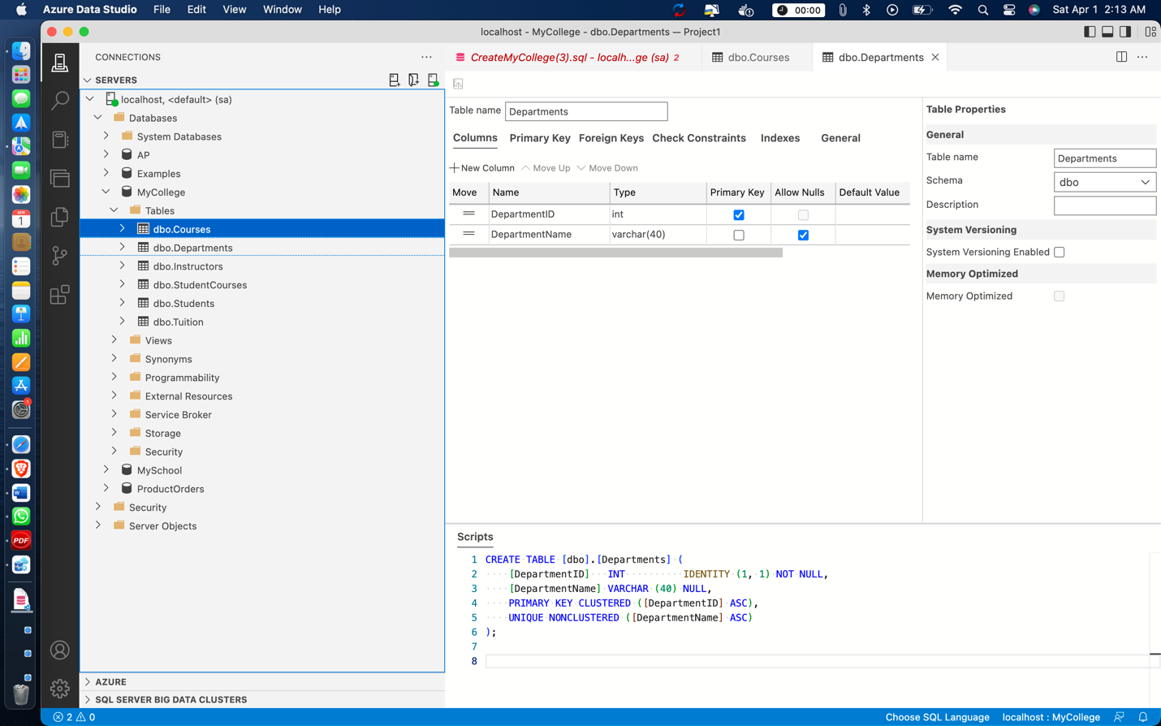

**Instructors Table in MyCollege DB: -**

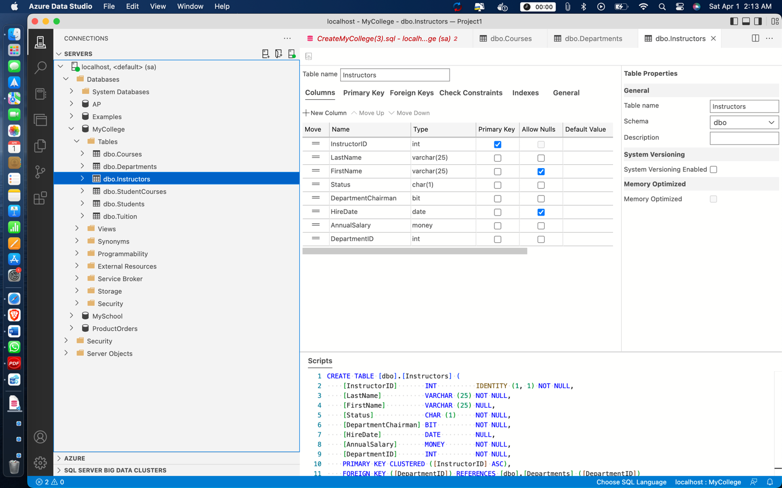

**StudentCourses Table In MyCollege DB: -**

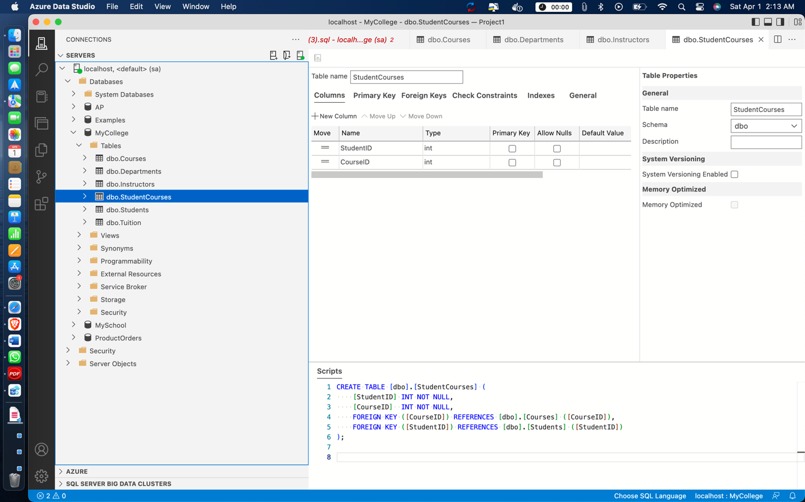

**Students Table In MyCollege DB: -**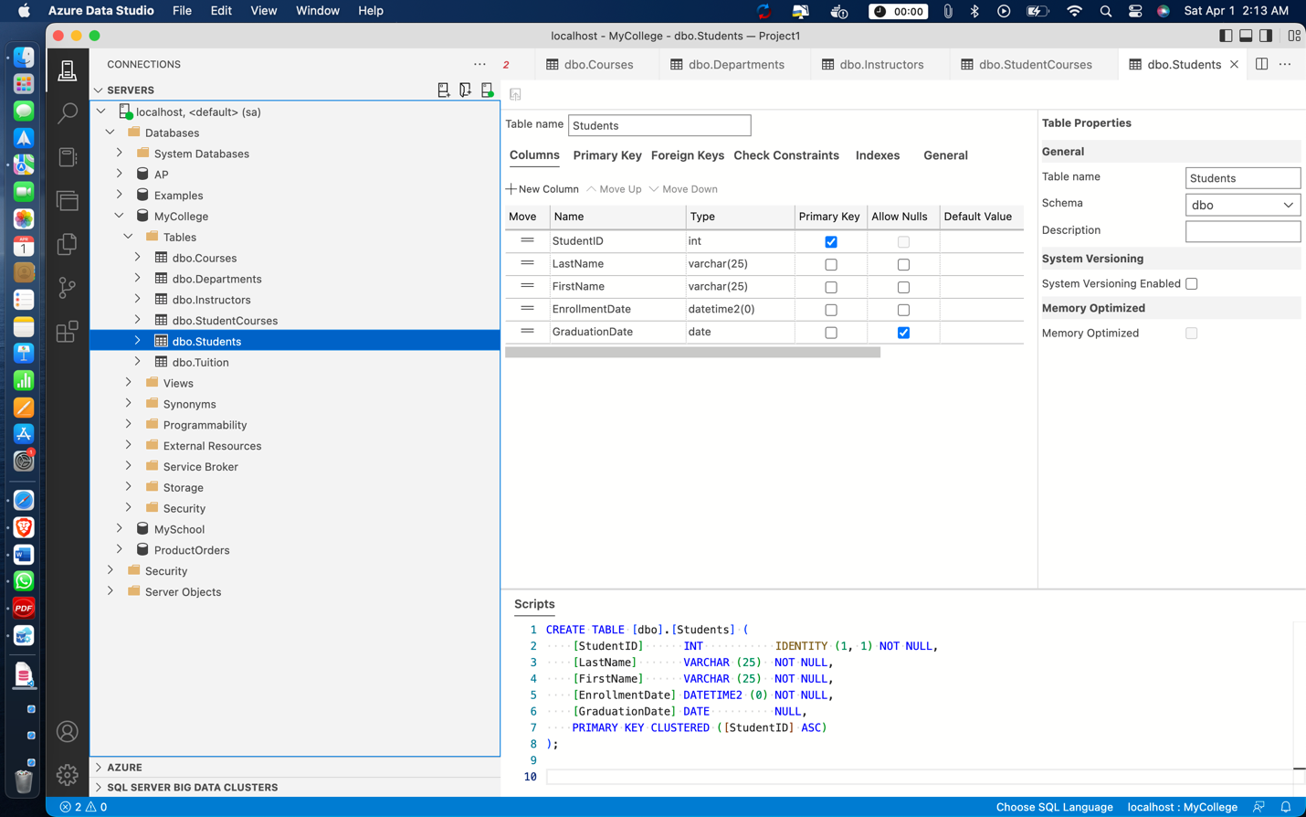

**Tuition Table in MyCollege DB:** -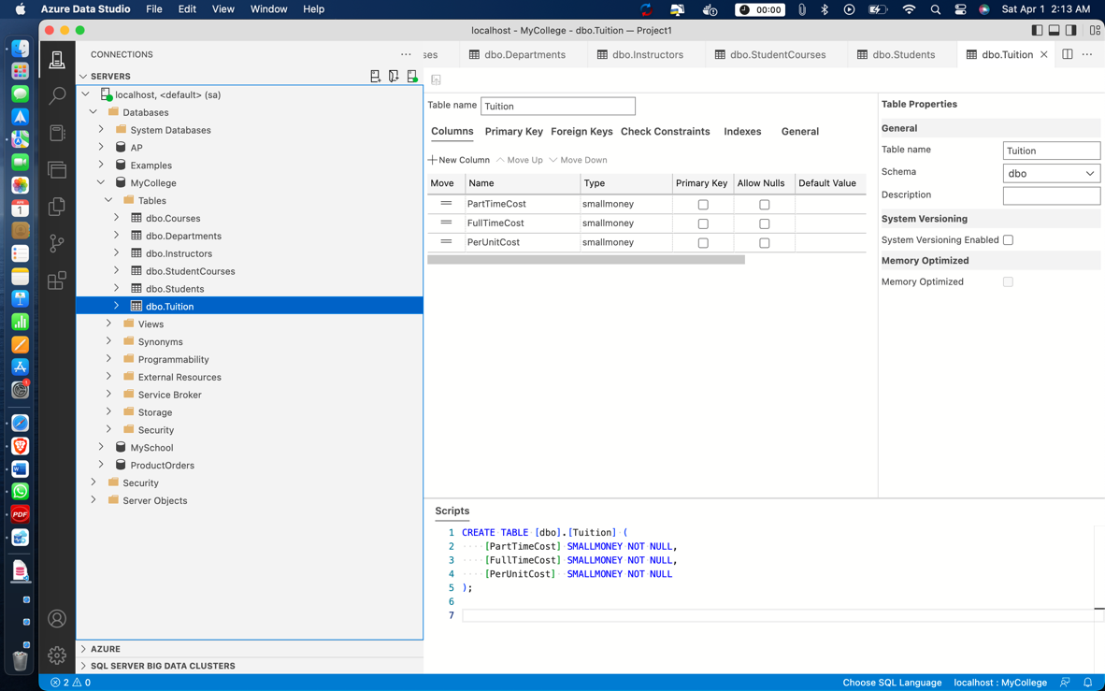

**Query: -**

Select * From Courses;

Select * From Instructors;

**Output: -**

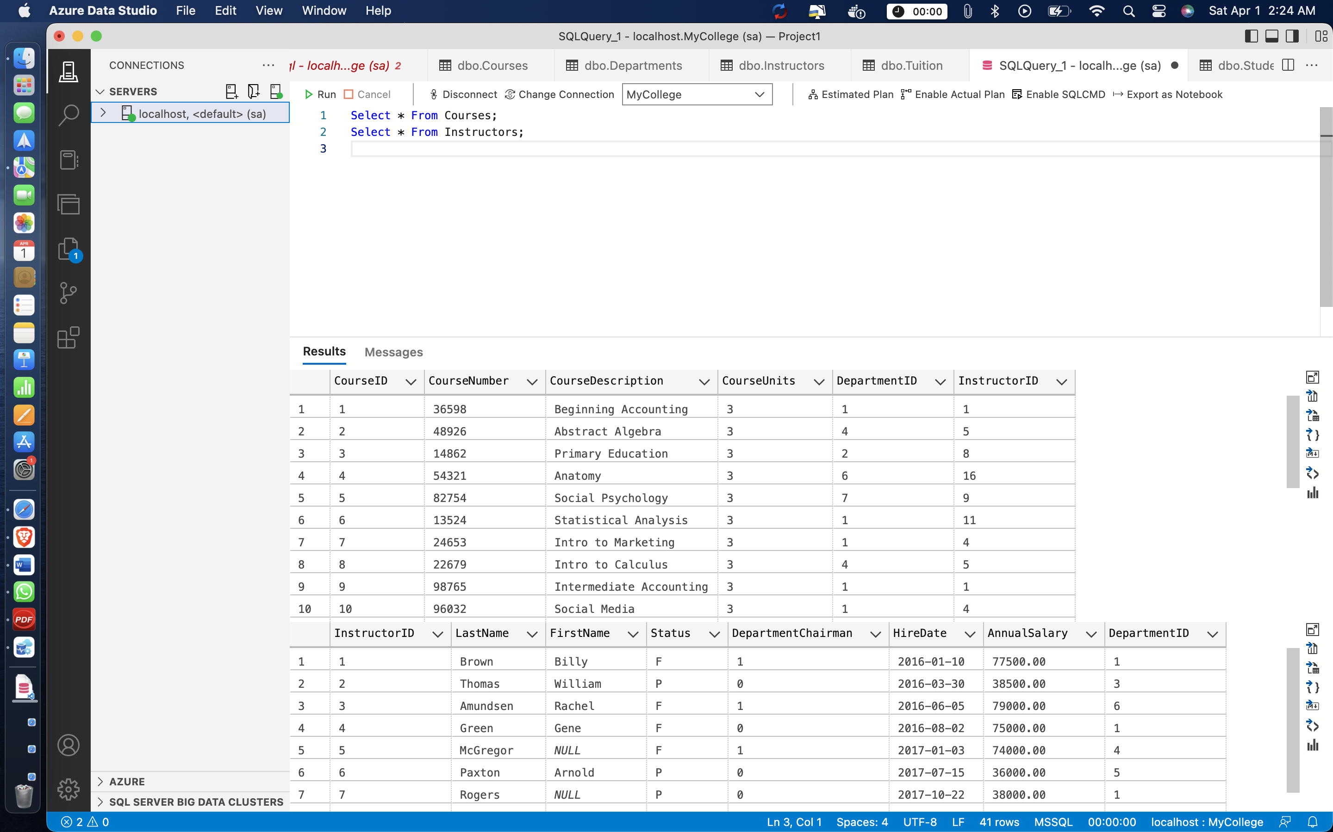

1. Open another Query Editor window and then enter and run this statement:

SELECT COUNT(*) AS NumberOfInstructors FROM Instructors

**Answer 3: -**

**Output: -**

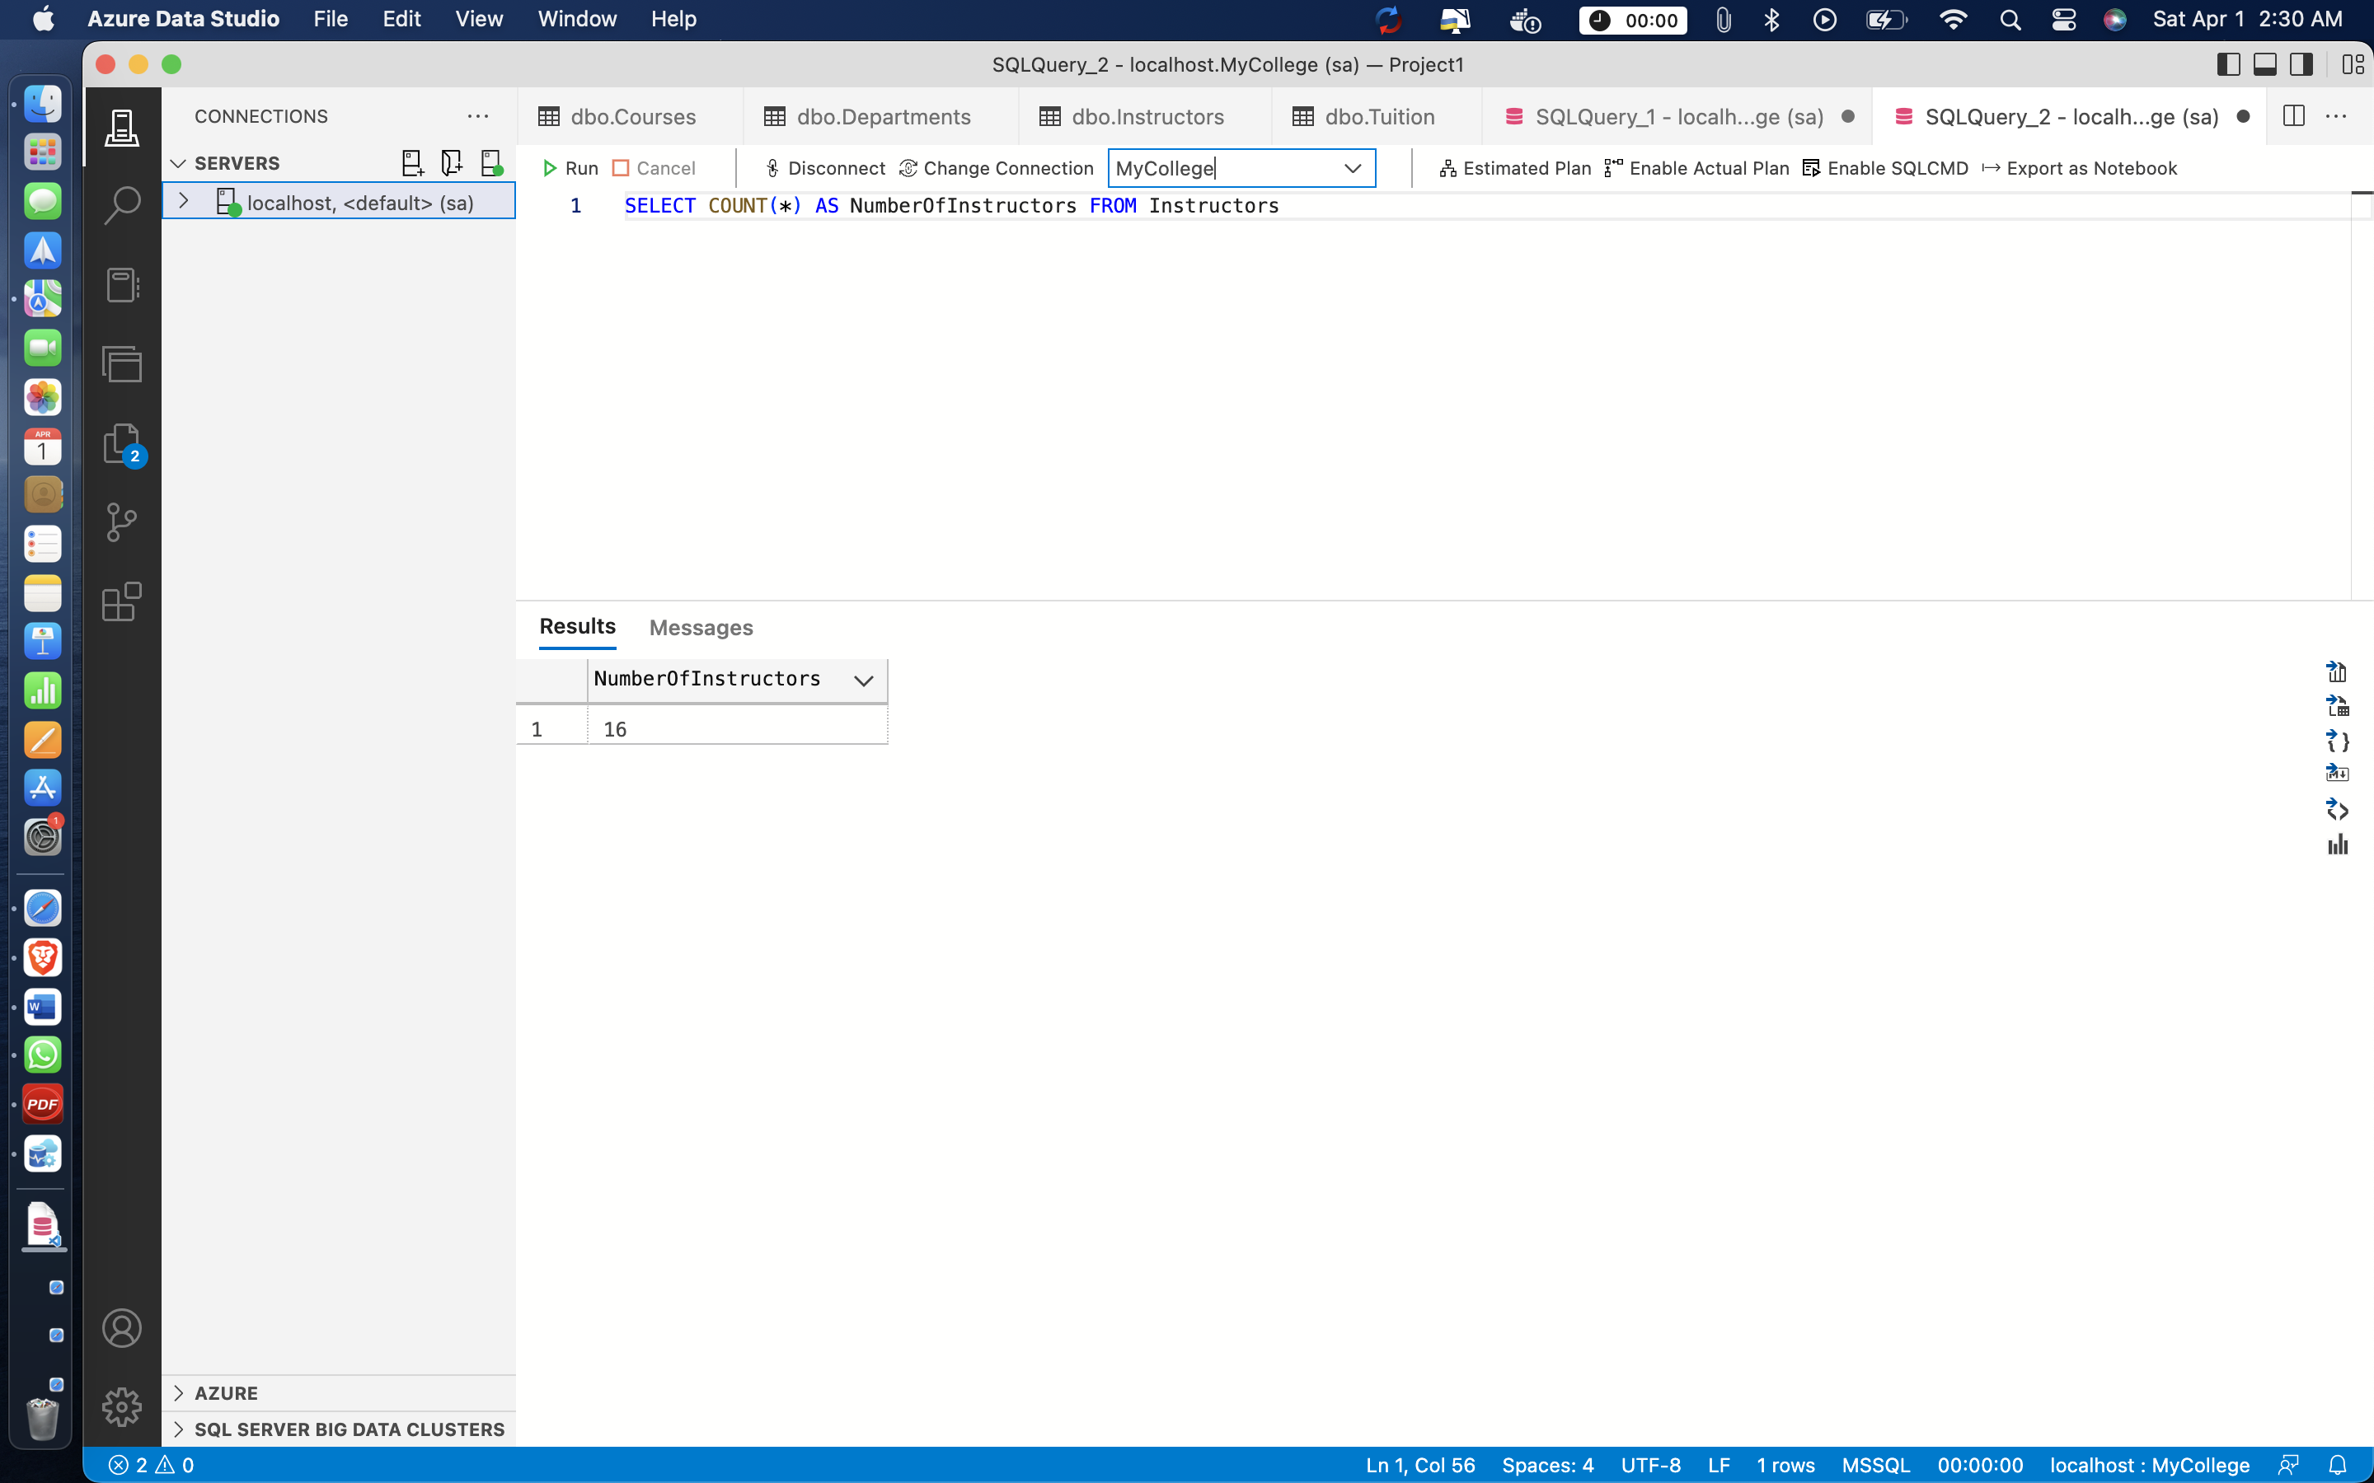

**Remarks: -** The above query is executed and the total number of rows in the table, including null values is returned.The COUNT(*) function given in the above query returns the total number of rows in the table, including null values.

1. Open the script named InstructorDetails.sql. Note that this script contains just one SQL statement. Then, run the statement.

**Answer 4: -**

**Output: -**

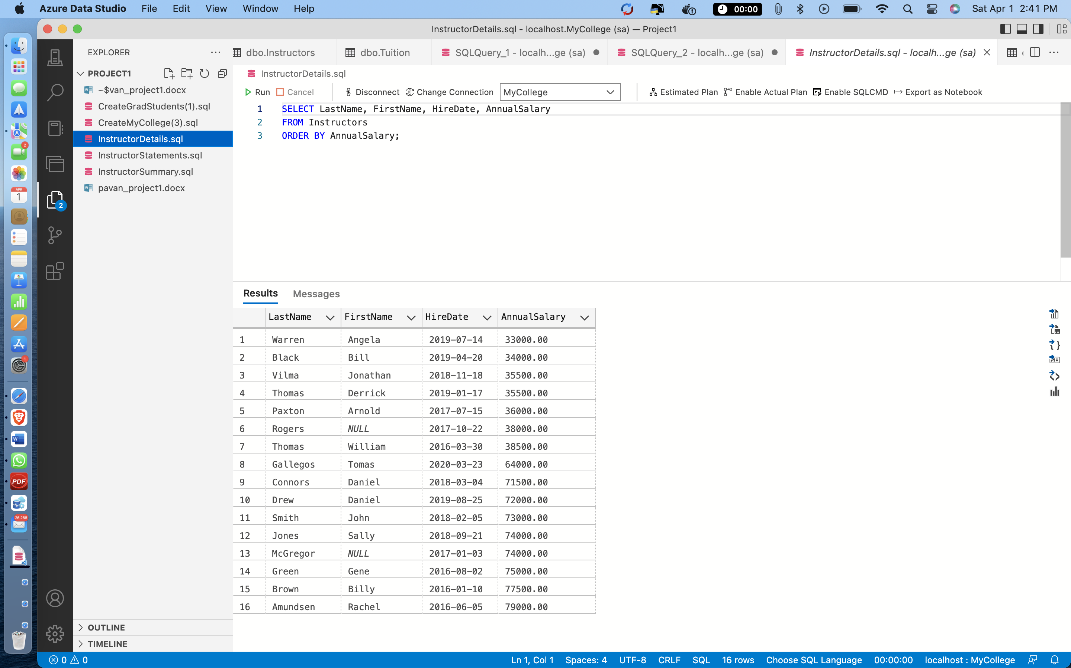

**Remarks: -**

* I have opened the script called InstructorDetails.sql, I ran this SQL query script, and it returned 16 rows as output.
* The select statement which was given the SQL script returns LastName, FirstName, HireDate, and AnnualSalary from the Instructors database using the FROM keyword, and the ORDER BY keyword arranges the result set in ascending order on the AnnualSalary column.

1. Open the script named InstructorSummary.sql. Note that this opens another Query Editor window.

**Answer 5: -**

**Output: -**

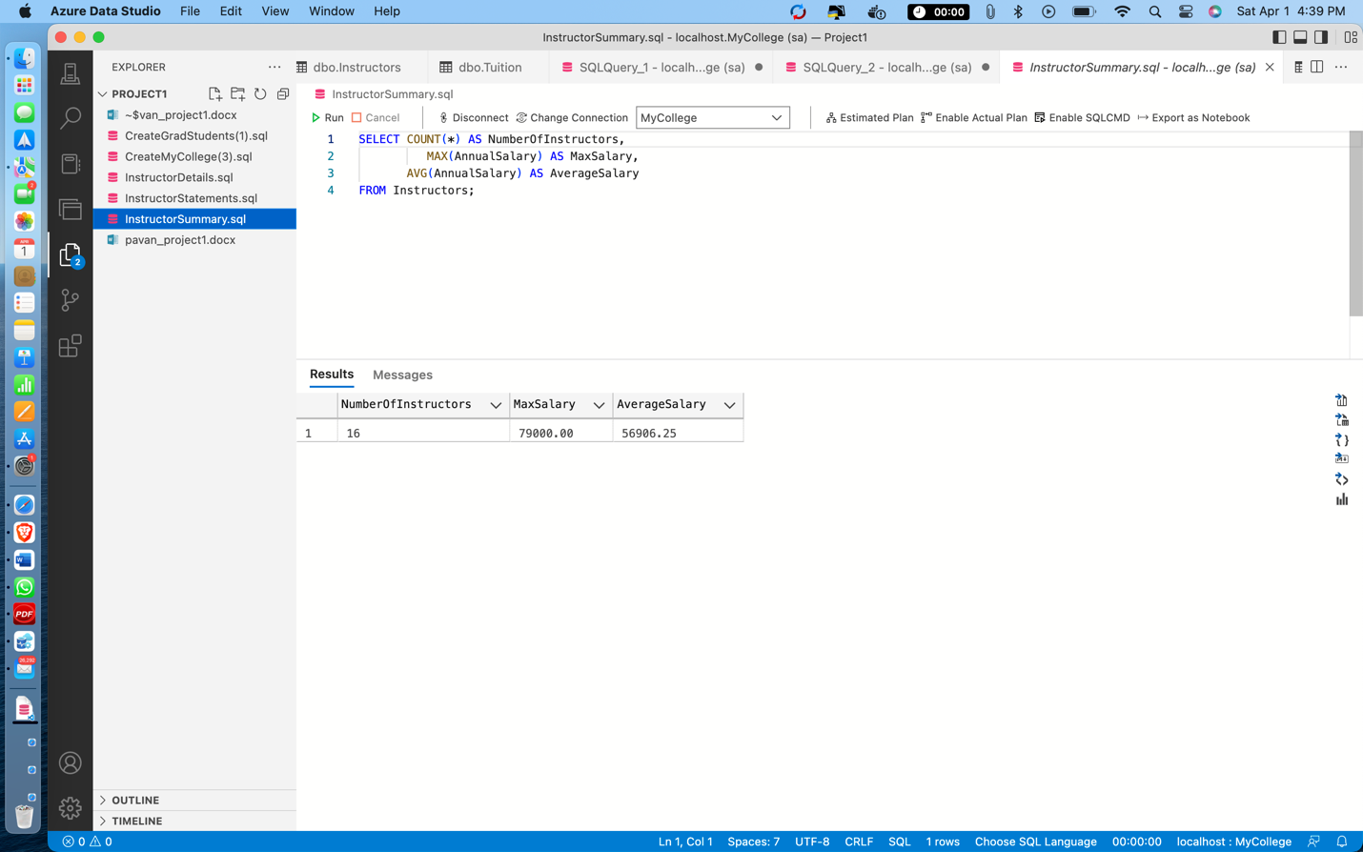

**Remarks: -**

* Opened the script named InstructorSummary.sql and I executed it. I ran the the SQL query specified in the script and it returned 1 row as output.
* The SELECT statement used in this SQL query is used to return the total number of instructors by using COUNT(*) and identifying the column NumberOfInstructors with the AS keyword.
* The MAX() aggregate function is used to calculate the maximum of the AnnualSalary column, which is named MaxSalary and the AVG() aggregate function is used to get the average of the AnnualSalary column, which is named AverageSalary.

1. Open the script named InstructorStatements.sql. Note that this script contains two SQL statements that end with semicolons.
2. Press the F5 key or click the Execute button to run both statements in this script. Note that this displays the results in two Results tabs. Make sure to view the results of both SELECT statements.
3. Exit from SQL Server Management Studio.

**Answers for questions 6th and 7th are: -**

The result of running InstructorsStatements.sql is a total of 17 rows.

**Output: -**

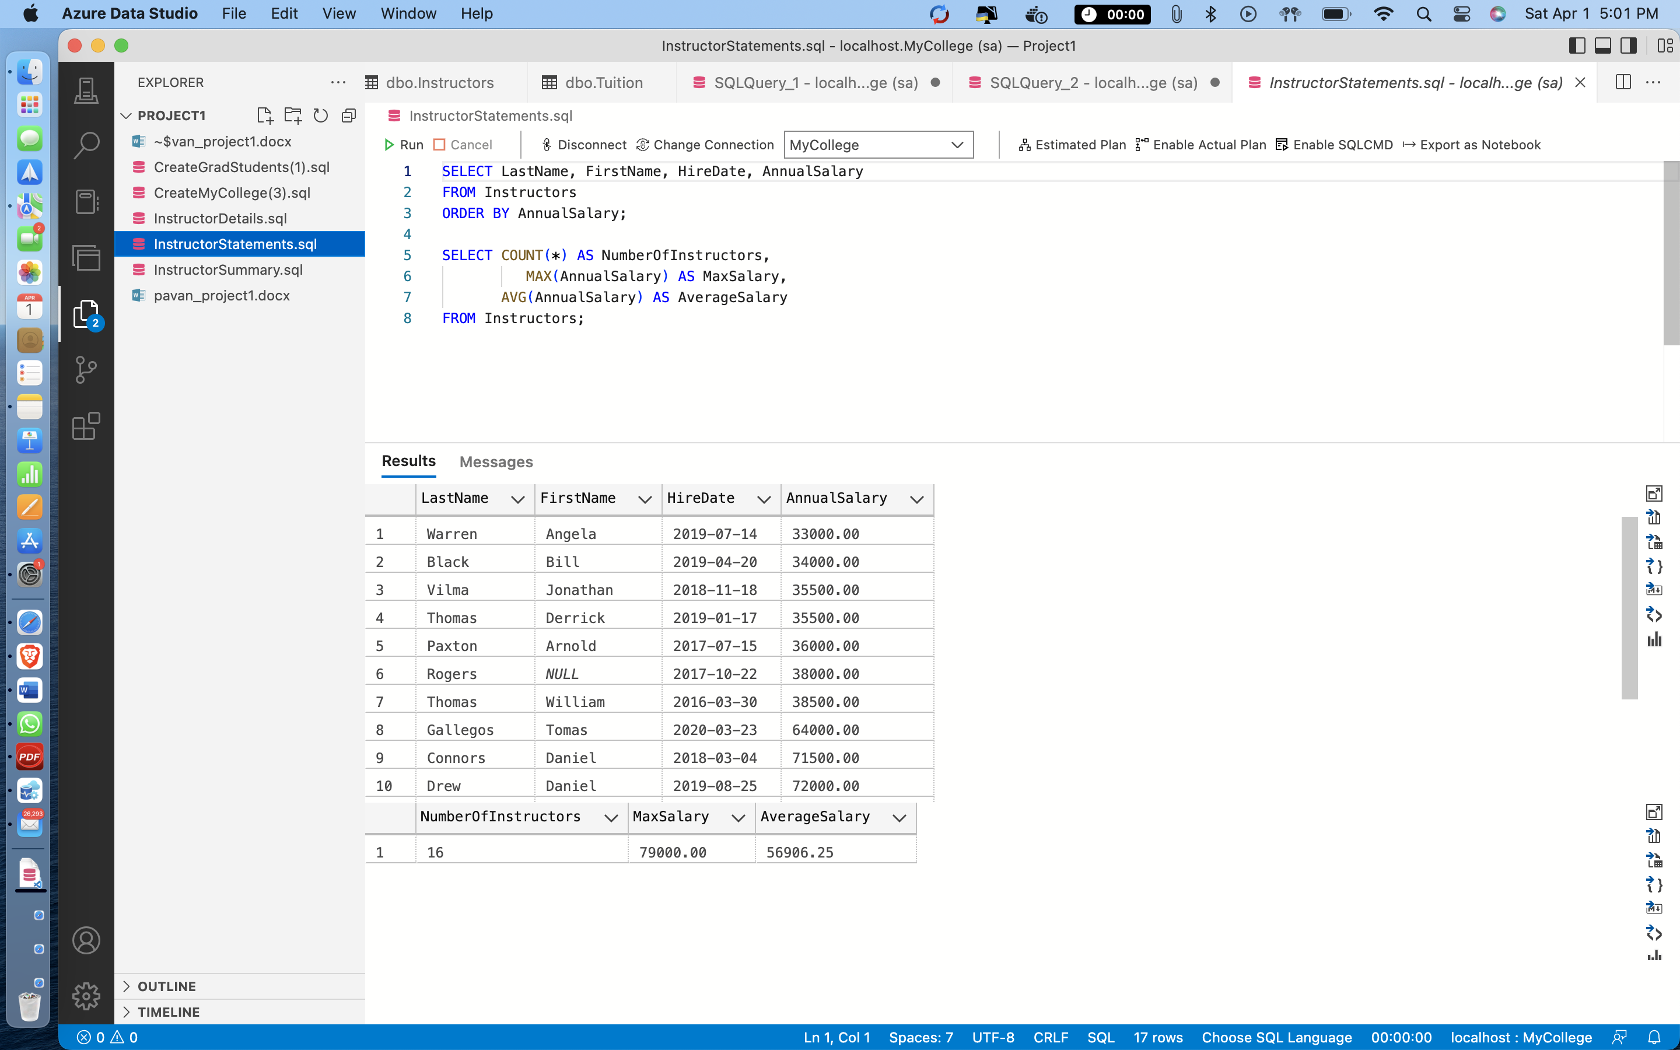

SECTION B: -

ESSENTIAL SQL SKILLS

1. Write a SELECT statement that returns all of the columns from the Courses table. Then, run this statement to make sure it works correctly

**Answer 1: -**

**Query: -** Select * From Courses;

**Output: -**

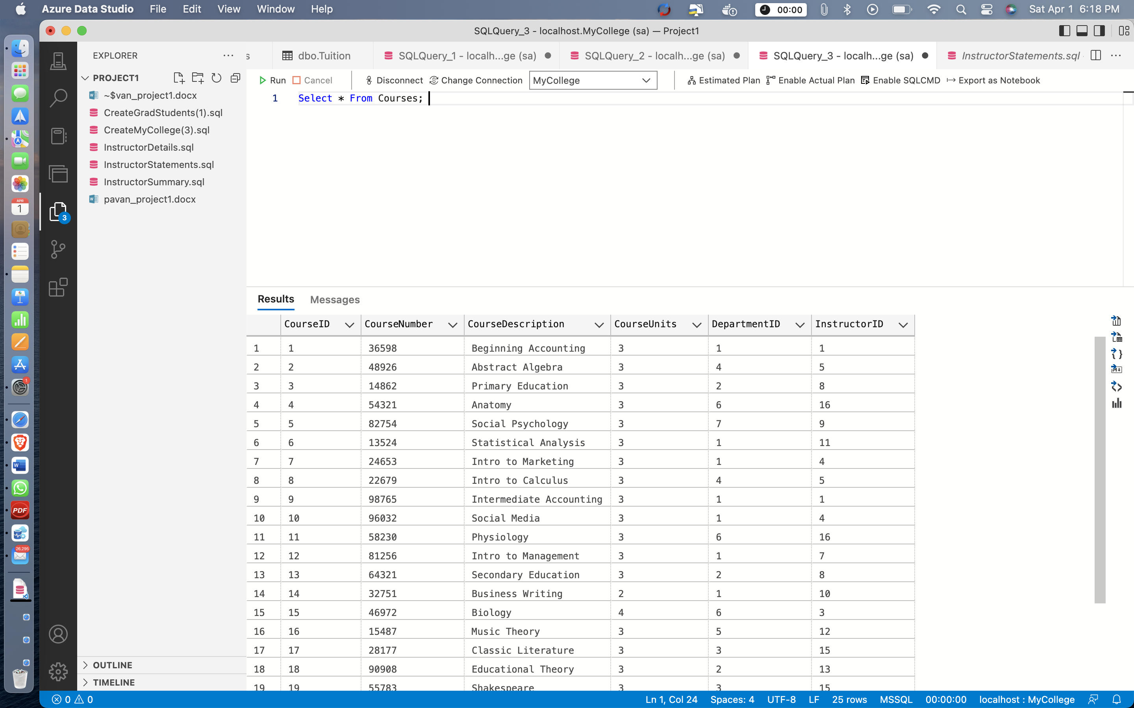

**Remarks: -** The SELECT * query is used in this case to display all of the records from the Courses table. You can see all the code and the output above in the given screenshot.

1. Write a SELECT statement that returns one column from the Students table named FullName that joins the LastName and FirstName columns. Format this column with the last name, a comma, a space, and the first name. Sort the result set by last name in ascending sequence. Return only the students whose last name begins with a letter from A to M.

**Answer 2: -**

**Query: -** Select LastName + ', ' + FirstName From Students Where Substring(LastName,1,1) >= 'A' And

Substring(LastName,1,1) <= 'M' Order By LastName Asc;

**Output: -**

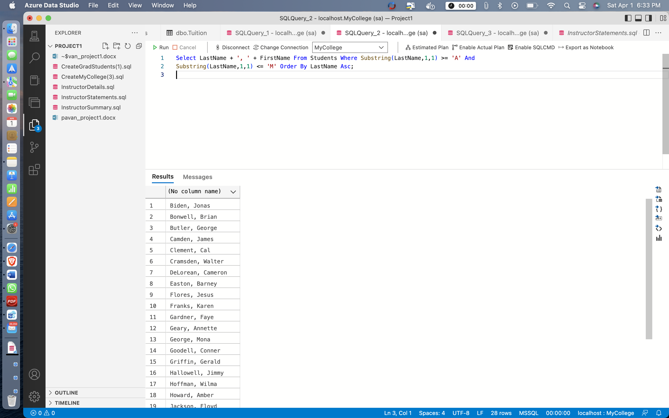

**Remarks: -**

* In the below query, the SELECT statement is used to display a column called FullName, which is produced by concatenating the LastName and FirstName columns with the '+' operator.
* Only entries where the LastName begins with A to M are to be displayed, which is done using the SUBSTRING operator, and the condition from A to M is written using the WHERE clause.
* The result set is then sorted in ascending order by using the ORDER BY keyword.

1. Write a SELECT statement that returns these column names and data from the Instructor table:

● LastName The LastName colum

● FirstName The FirstName column

● HireDate The HireDate column

Return only the rows with a hire date that’s in 2019. Sort the result set in ascending sequence by the HireDate column.

**Answer 3: -**

**Query: -** Select LastName, FirstName, HireDate From Instructors Where HireDate Like '2019%' Order By HireDate;

**Output: -**

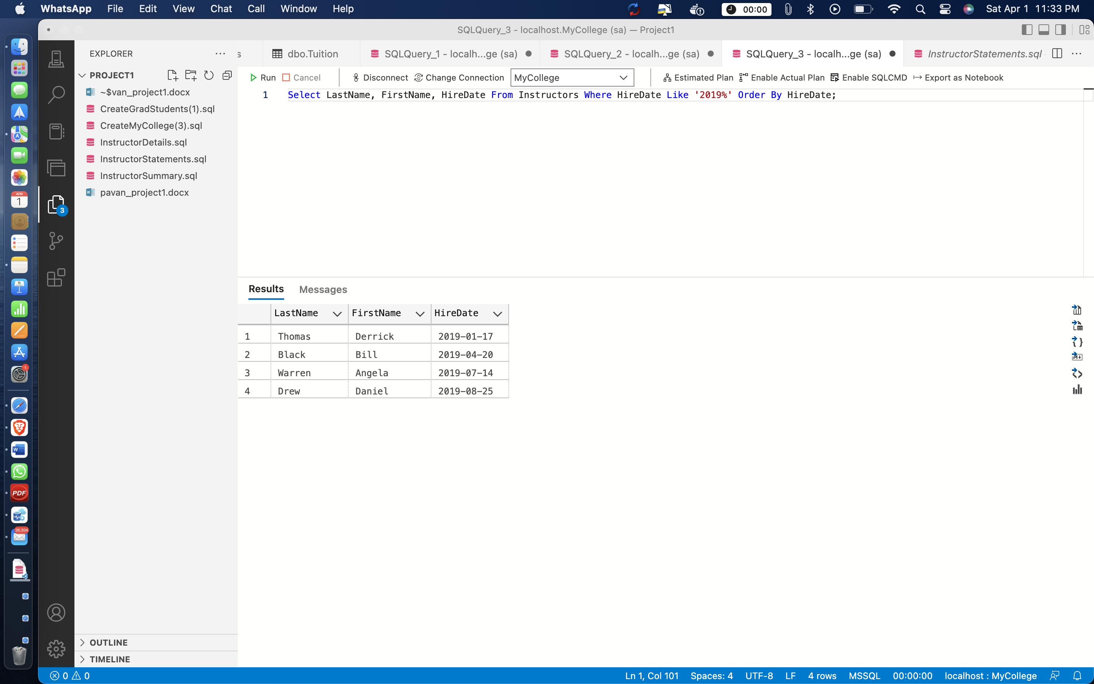

**Remarks: -**

* In the below query, SELECT statement is used to display three columns namelyLastName, FirstName and HireDate from Instructors table.
* The condition to display those instructors who were hired in the year 2019 is satisfied by using the LIKE operator.
* The LIKE command is used in a WHERE clause to search for a specified pattern in a column.
* You can see all the code and the output above in the given screenshot.
* *4 rows* are retrieved by executing the query.

1. Write a SELECT statement that returns these column names and data from the Students

table:

FirstName The FirstName column

LastName The LastName column

EnrollmentDate The EnrollmentDate column

CurrentDate The current date

MonthsAttended A column that’s calculated by getting the difference between the

enrollment date and the current date

Sort the result set in ascending sequence by the MonthsAttended column.

**Answer 4: -**

**Query: -**

Select FirstName, LastName, EnrollmentDate, GetDate() As CurrentDate,

DateDiff(MONTH, EnrollmentDate,GetDate()) As MonthsAttended from Students;

**Output: -**

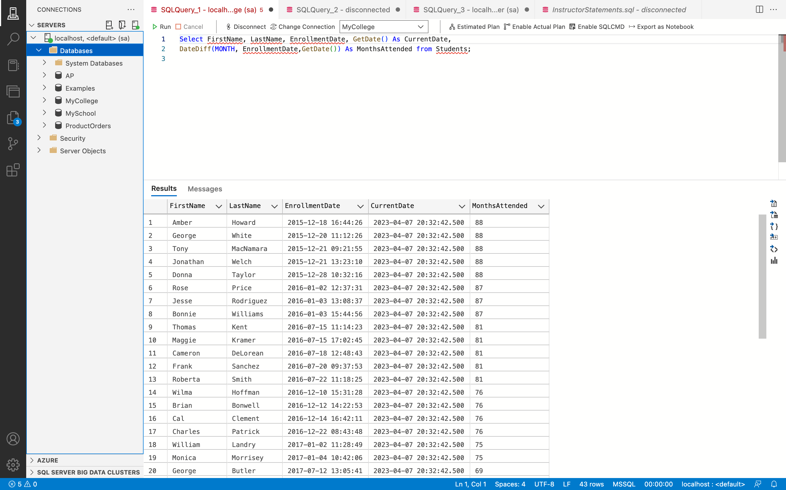

**Remarks: -**

* In this scenario, the columns FirstName, LastName, EnrollmentDate, and CurrentDate are shown using the SELECT query.
* The current date is passed to the GETDATE() function, which returns the CurrentDate column.
* The MonthsAttended column is calculated by deducting the EnrollmentDate from the current date using the DATEDIFF() function.
* The outcomes are arranged in ascending order in the MonthsAttended column.
* The query below is executed to return 43 rows.
* You can see all the code and the output above in the given screenshot.

1. Write a SELECT statement that returns these column names and data from the Instructors

table:

FirstName The FirstName column

LastName The LastName column

AnnualSalary The AnnualSalary column

Return only the top 20 percent of instructors based on annual salary.

**Answer 5: -**

**Query: -**

Select Top 20 Percent FirstName, LastName, AnnualSalary From Instructors;

**Output: -**

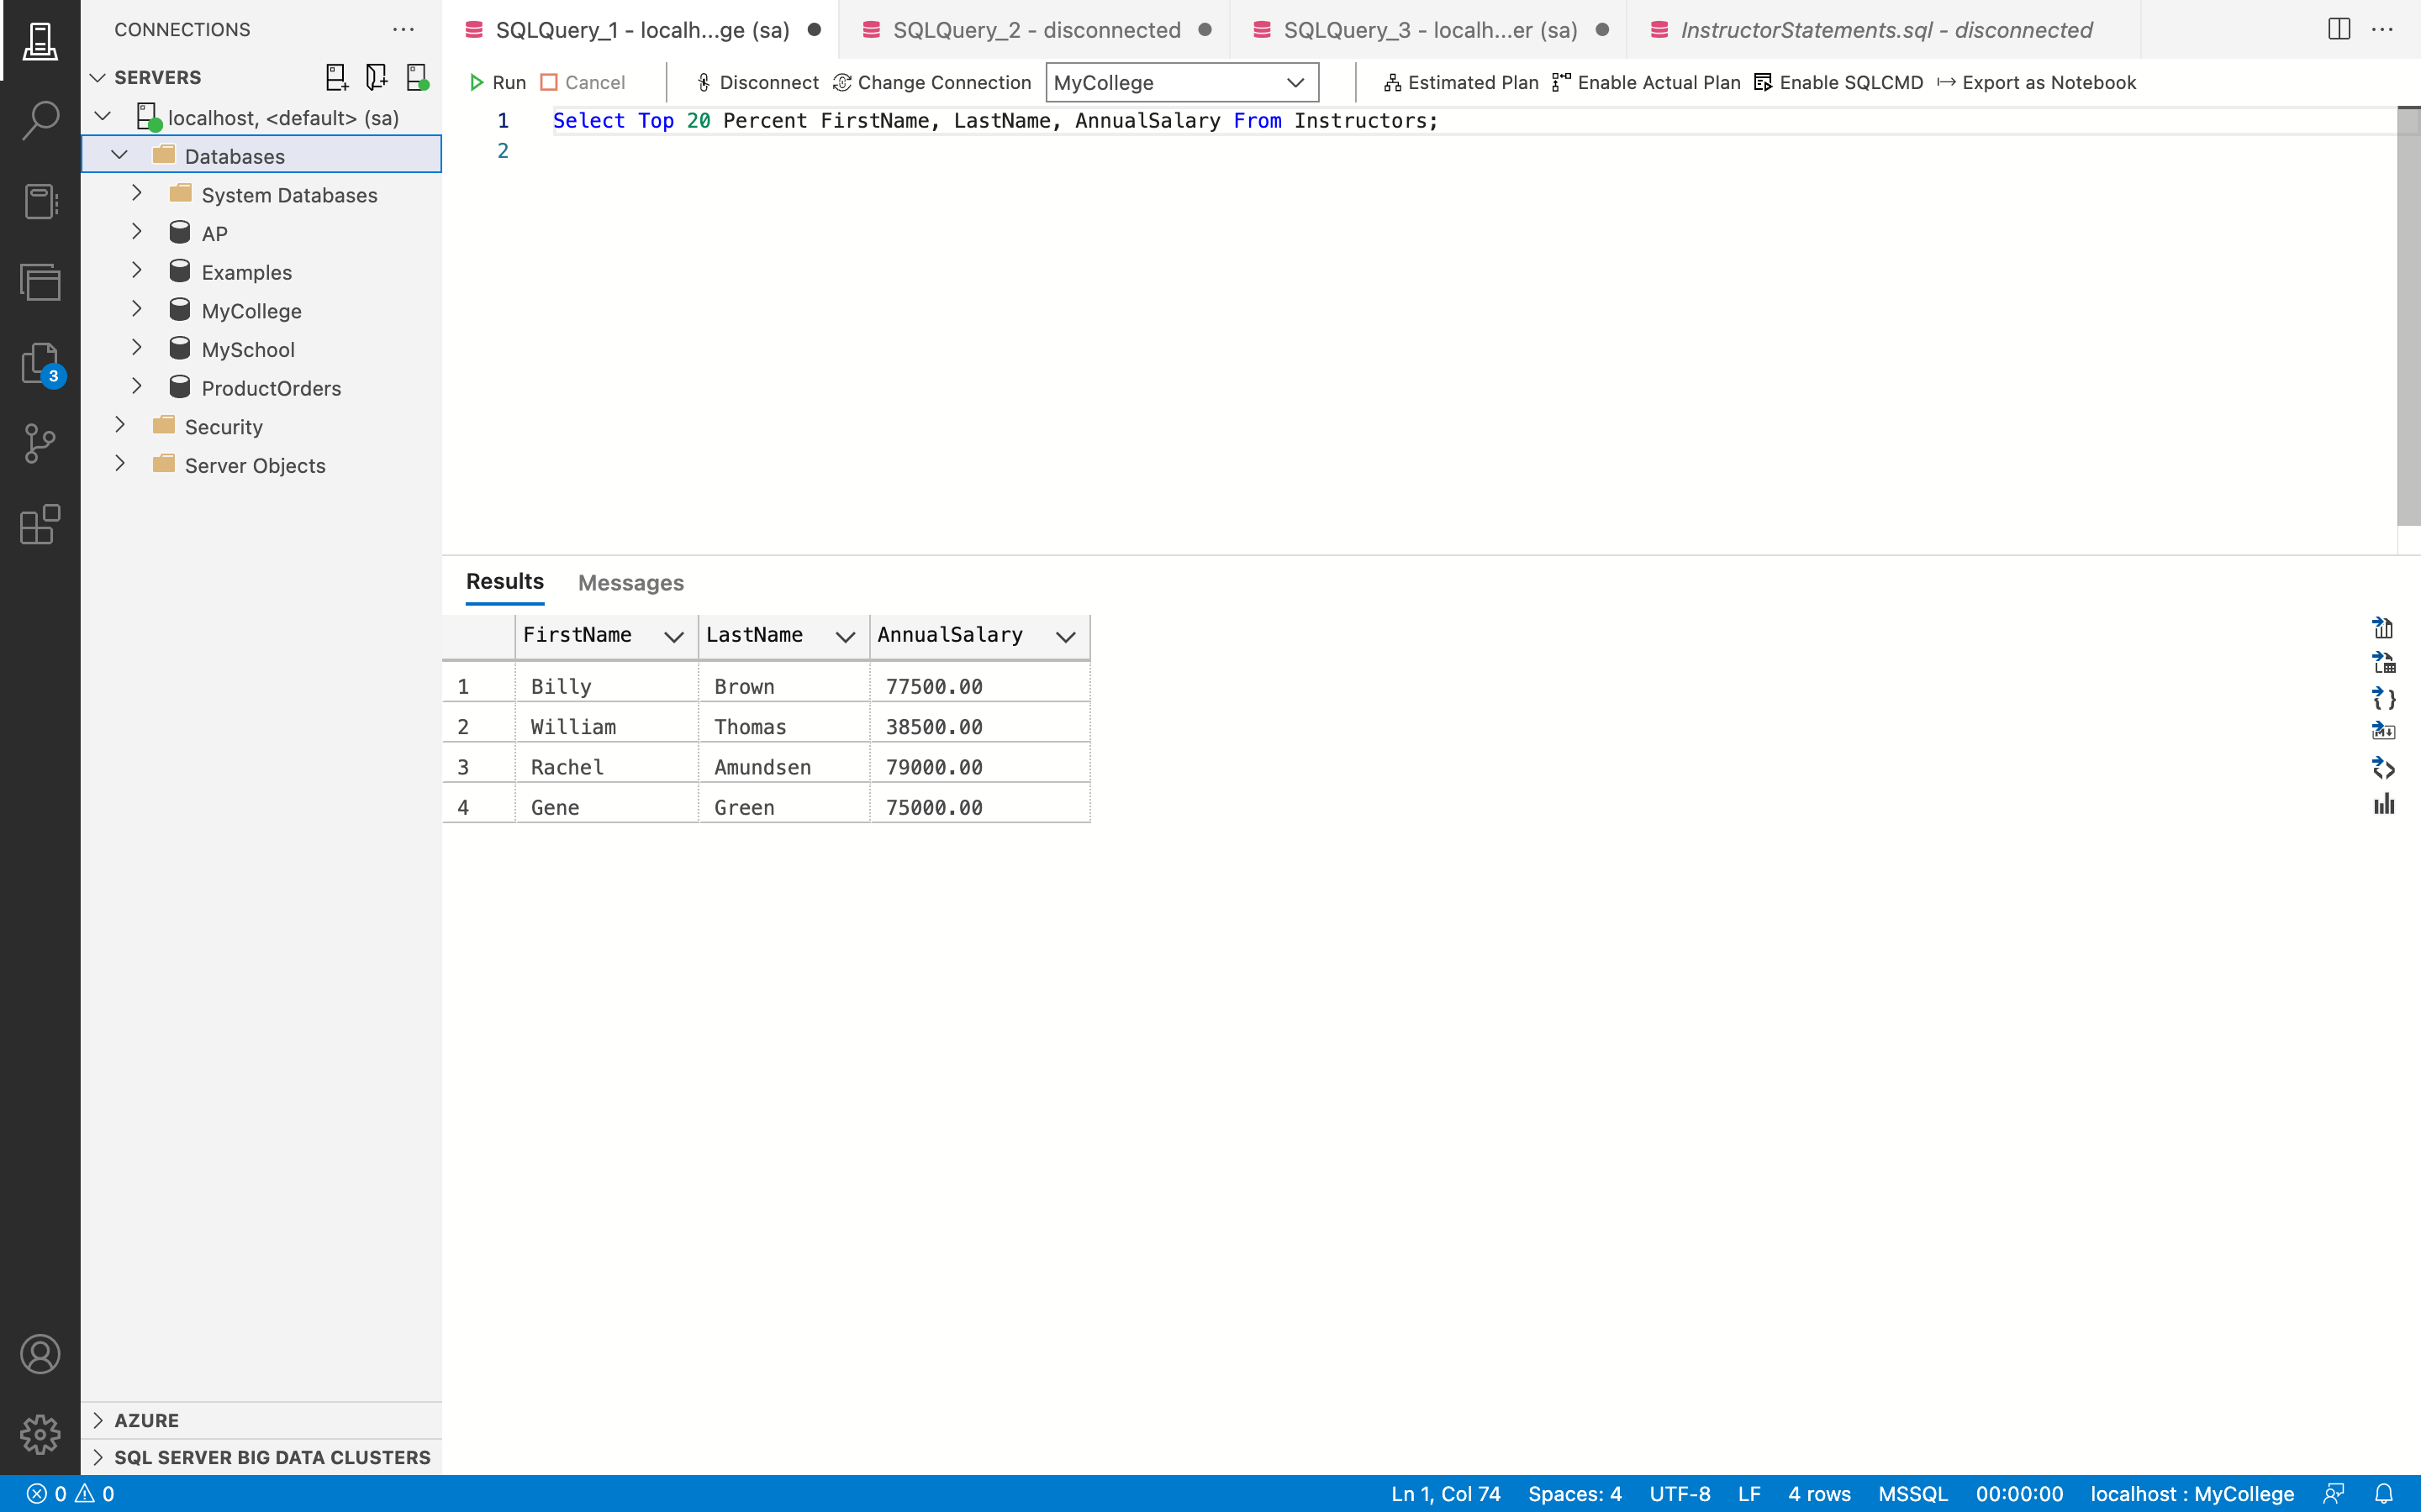

**Remarks: -**

* The SELECT TOP statement is used in this query to display 20% of the total number of statements.
* The FirstName, LastName, and AnnualSalary columns of the Teachers table are shown, and the AnnualSalary column's ORDER BY clause has been used to sort the columns in descending order.
* The query listed below will return 4 rows.
* You can see all the code and the output above in the given screenshot.

1. Write a SELECT statement that returns these columns and data from the Tuition table,

along with a constant value and two calculated values:

FullTimeCost The FullTimeCost column

PerUnitCost The PerUnitCost column

Units 12

TotalPerUnitCost A column that’s calculated by multiplying the per unit cost by the units

TotalTuition A column that’s calculated by adding the full time cost to the total per unit cost

**Answer 6: -**

**Query: -**

Select FullTimeCost, PerUnitCost, 12 As Units , PerUnitCost * 12 As TotalPerUnitCost,

FullTimeCost + (PerUnitCost * 12) from Tuition;

**Output: -**

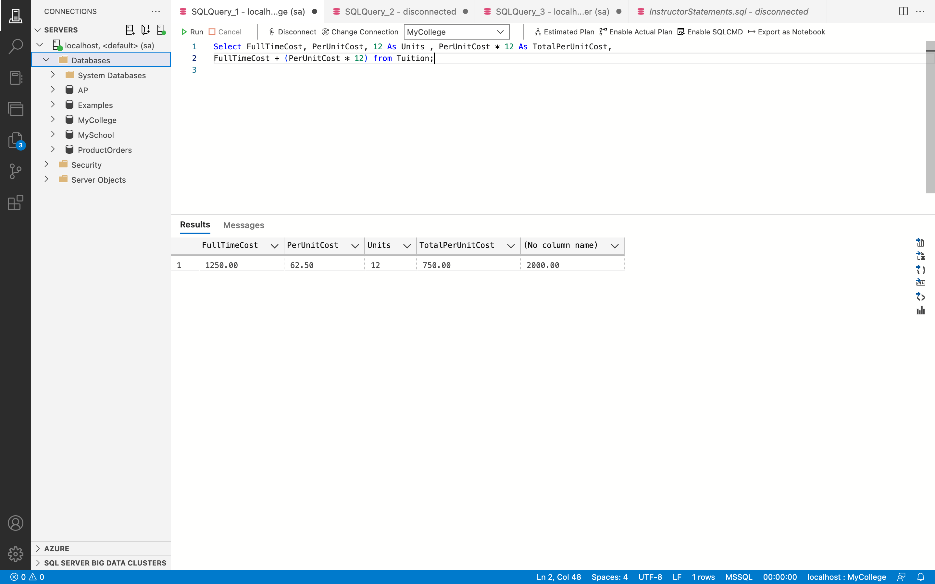

**Remarks: -**

* The FullTimeCost column, PerUnitCost, Units column (which has a constant value of 12), TotalPerUnitCost (which is the result of multiplying PerUnitCost by 12), and TotalTuition (which is the result of multiplying FullTimeCost by (PerUnitCost * 12)) are all displayed using the SELECT command.
* You can see all the code and the output above in the given screenshot.

1. Write a SELECT statement that joins the Courses table to the Departments table and

returns these columns: CourseNumber, CourseDescription, DepartmentName. Sort the result set by DepartmentName and then by CourseNumber in ascending order.

**Answer 7: -**

**Query: -**

Select CourseNumber, CourseDescription, DepartmentName from Courses Join Departments On

Courses.DepartmentID = Departments.DepartmentID Order By DepartmentName, CourseNumber;

**Output: -**

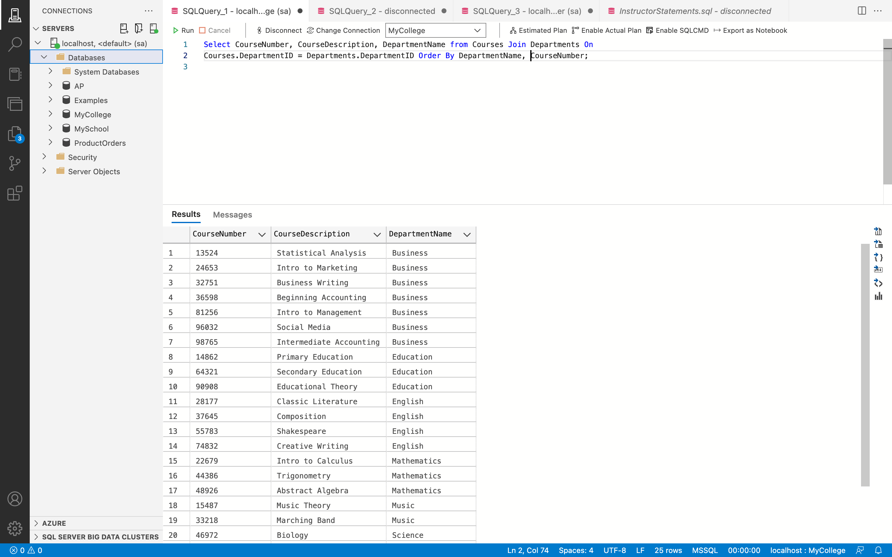

**Remarks: -**

* The DepartmentName column from the Departments table and the CourseNumber and CourseDescription columns from the Courses table are displayed using the SELECT statement. The two tables are joined on the DepartmentID using the ON keyword.
* The results are then arranged by DepartmentName and CourseNumber in increasing order.
* The query below is executed to return 25 rows.
* You can see all the code and the output above in the given screenshot.

1. Write a SELECT statement that joins the Instructors table to the Courses table and returns these columns: LastName, FirstName, CourseNumber, CourseDescription. Return all courses for each instructor with a status of “P” (part time). Sort the result set by LastName and then by FirstName in ascending order.

**Answer 8: -**

**Query: -**

Select LastName, FirstName, CourseNumber, CourseDescription From Instructors As I Join

Courses As C On I.InstructorID = C.InstructorID Where I.Status = 'P' Order By LastName, FirstName;

**Output: -**

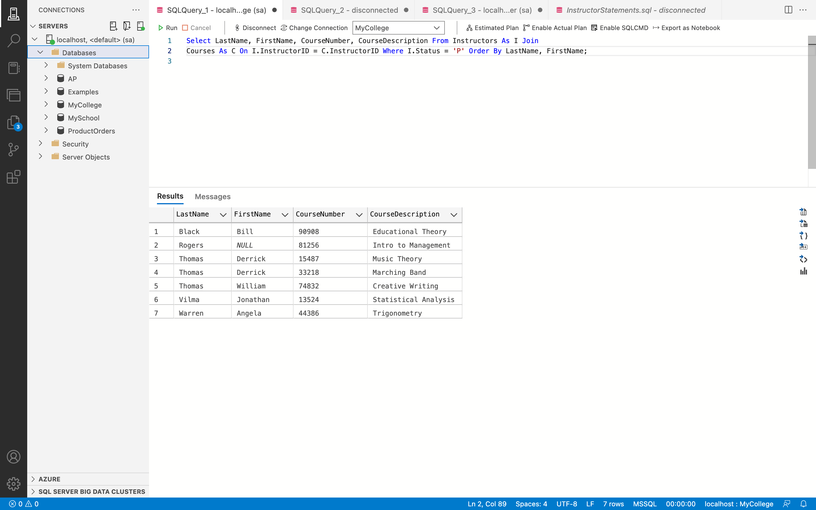

**Remarks: -**

* By joining the two tables using the JOIN keyword on InstructorID using the ON keyword, the SELECT statement is used to display the LastName and FirstName columns from the Instructors database and the CourseNumber and CourseDescription columns from the Courses table.
* The WHERE clause limits the display to records having the Status 'P'.
* The ORDER BY phrase is then used to organize the result set in ascending order.
* The query listed below returns 7 rows.
* You can see all the code and the output above in the given screenshot.

1. Use the UNION operator to generate a result set consisting of five columns from the Students table:

● Status A calculated column that contains a value of UNDERGRAD or GRADUATED

● FirstName The FirstName column

● LastName The LastName column

● EnrollmentDate The EnrollmentDate column

● GraduationDate The GraduationDate column

**Answer 9: -**

**Query: -**

Select 'UNDERGRAD' As Status, FirstName, LastName, EnrollmentDate, GraduationDate From

Students Where GraduationDate Is Null

Union

Select 'GRADUATED' As Status, FirstName, LastName, EnrollmentDate, GraduationDate From

Students Where GraduationDate Is Not Null

Order By EnrollmentDate;

**Output: -**

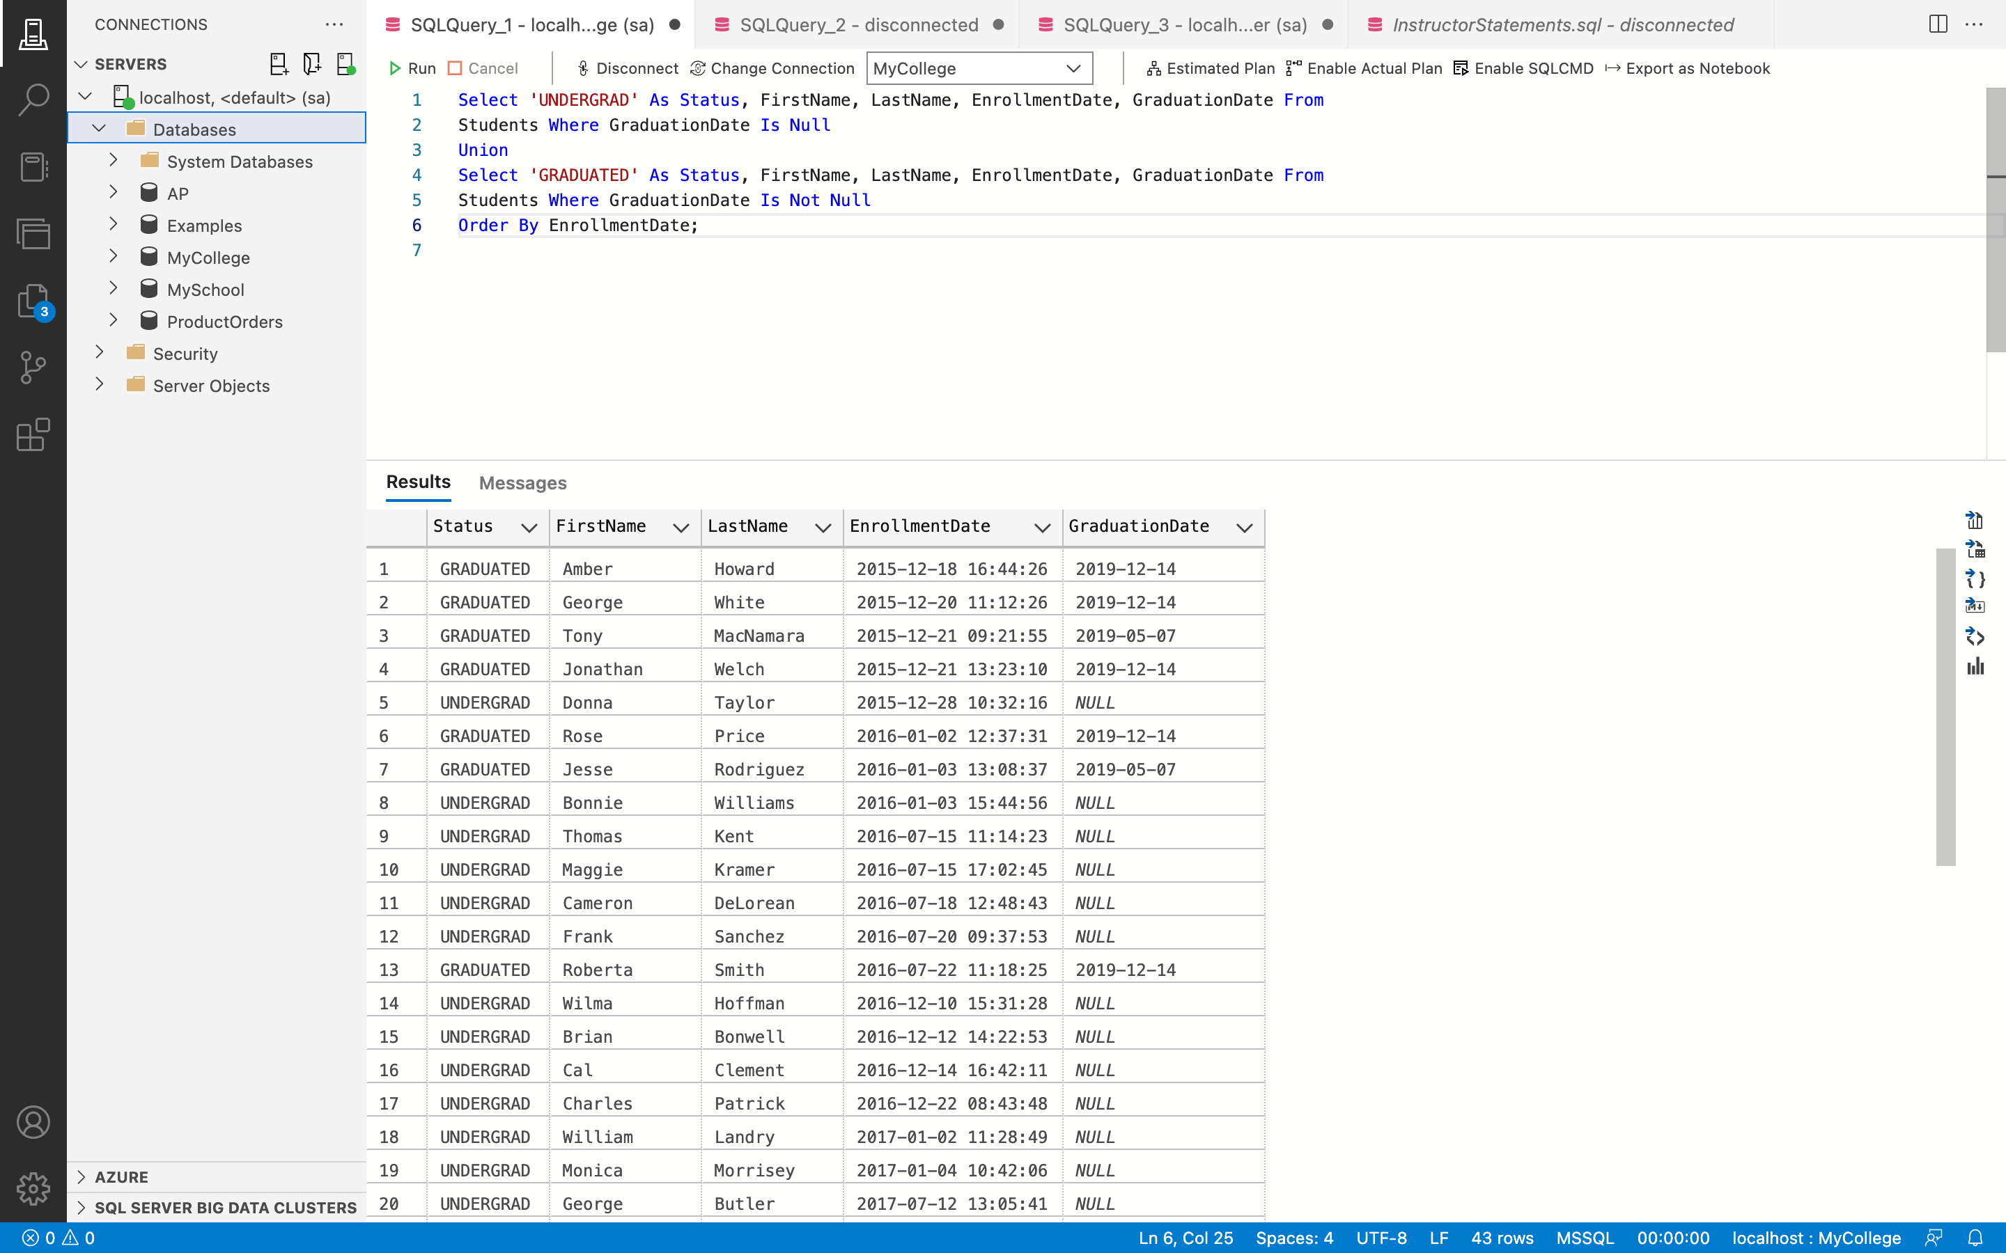

**Remarks: -**

* The SELECT statement is used in this query to display the FirstName, LastName, EnrollmentDate, and GraduationDate columns from the record Students, as well as Status, which has the value "GRADUATED."
* Moreover, records are chosen using the WHERE clause and the IS NOT NULL operator so that the GraduationDate values are not null.
* The columns Status, which has the value "GRADUATED," FirstName, LastName, EnrollmentDate, and GraduationDate from the table Students are displayed in the second result set using the SELECT command.
* Entries are also chosen so that the GraduationDate values are NULL using the WHERE clause and the IS NULL operator.
* Lastly, both of these result sets are merged together using the UNION operator, and the resulting result set is sorted according to enrollment date.
* There are retrieved 43 rows.
* •You can see all the code and the output above in the given screenshot.

1. Write a SELECT statement that returns these columns:

● InstructorDept The DepartmentName column from the Departments table for a

related instructor

● LastName The LastName column from the Instructors table

● FirstName The FirstName column from the Instructors table

● CourseDescription The CourseDescription column from the Courses table

● CourseDept The DepartmentName column from the Departments table for a

related instructor

**Answer 10: -**

**Query: -**

Select DS.DepartmentName As 'InsDept', I.LastName, I.FirstName, C.CourseDescription,

D.DepartmentName As 'CDept' From Courses As C Inner Join Departments As D On

C.DepartmentID = D.DepartmentID Inner Join Instructors as I On C.InstructorID =

I.InstructorID Inner Join Departments As DS On I.DepartmentID = DS.DepartmentID

Where D.DepartmentID != DS.DepartmentID;

**Output: -**

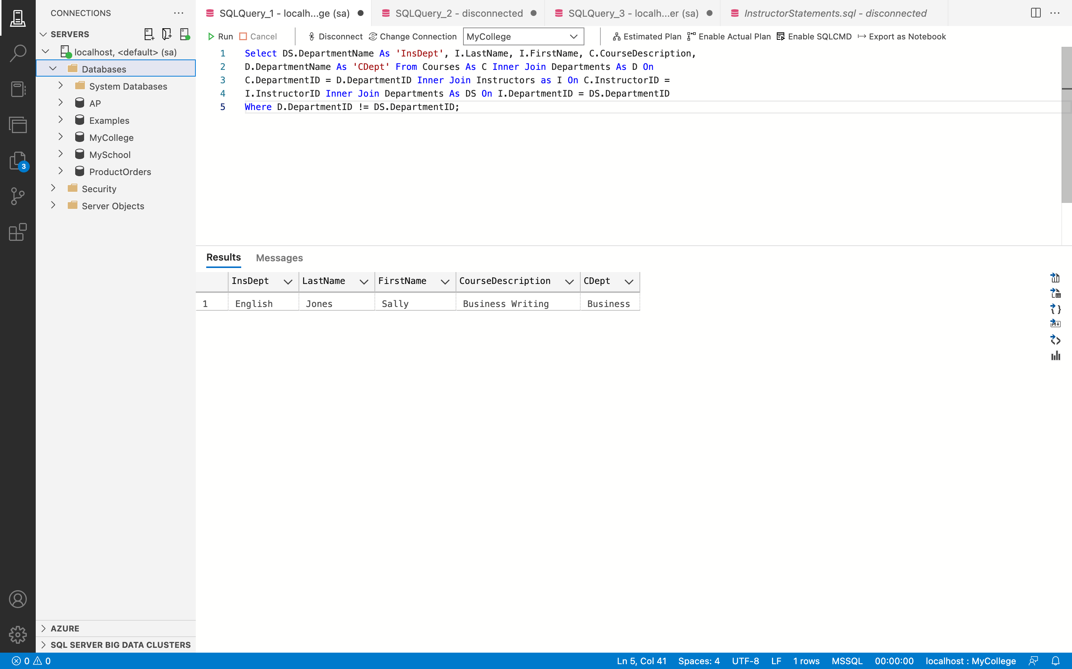

**Remarks: -**

* executed a SELECT query that returns the following columns: LastName, FirstName, CourseDescription, and CourseDept for linked instructors, which contains the DepartmentName field from the Departments table.
* Using an INNER JOIN, the FirstName and LastName columns from the Instructors table, the CourseDescription column from the Courses table, the DepartmentName column from the Departments dataset, and the CourseDept column are all brought together.
* One row is retrieved for each course in a department other than the one of the instructor tasked with instructing that course.
* Furthermore, the Departments table was linked to the Instructors and Courses tables, necessitating the use of table aliases to distinguish between the two tables.
* You can see all the code and the output above in the given screenshot.

1. Write a SELECT statement that returns one row for each instructor that has courses with these columns:

* The instructor first and last names from the Instructors table in this format: John Doe (Note: If the instructor first name has a null value, the concatenation of the first and last name will result in a null value.)
* A count of the number of courses in the Courses table
* The sum of the course units in the Courses table

(Hint: You will need to concatenate the instructor first and last names again in the GROUP BY clause.)

Sort the result set in descending sequence by the total course units for each instructor.

**Answer 11: -**

**Query: -**

Select FirstName + ' ' + LastName As FullName, Count(CourseID) As NoOfCourses,

Sum(CourseUnits) As SumOfUnits From Instructors As I Join Courses As C

On I.InstructorID = C.InstructorID Group By FirstName + ' ' + LastName Order By

SumOfUnits Desc;

**Output: -**

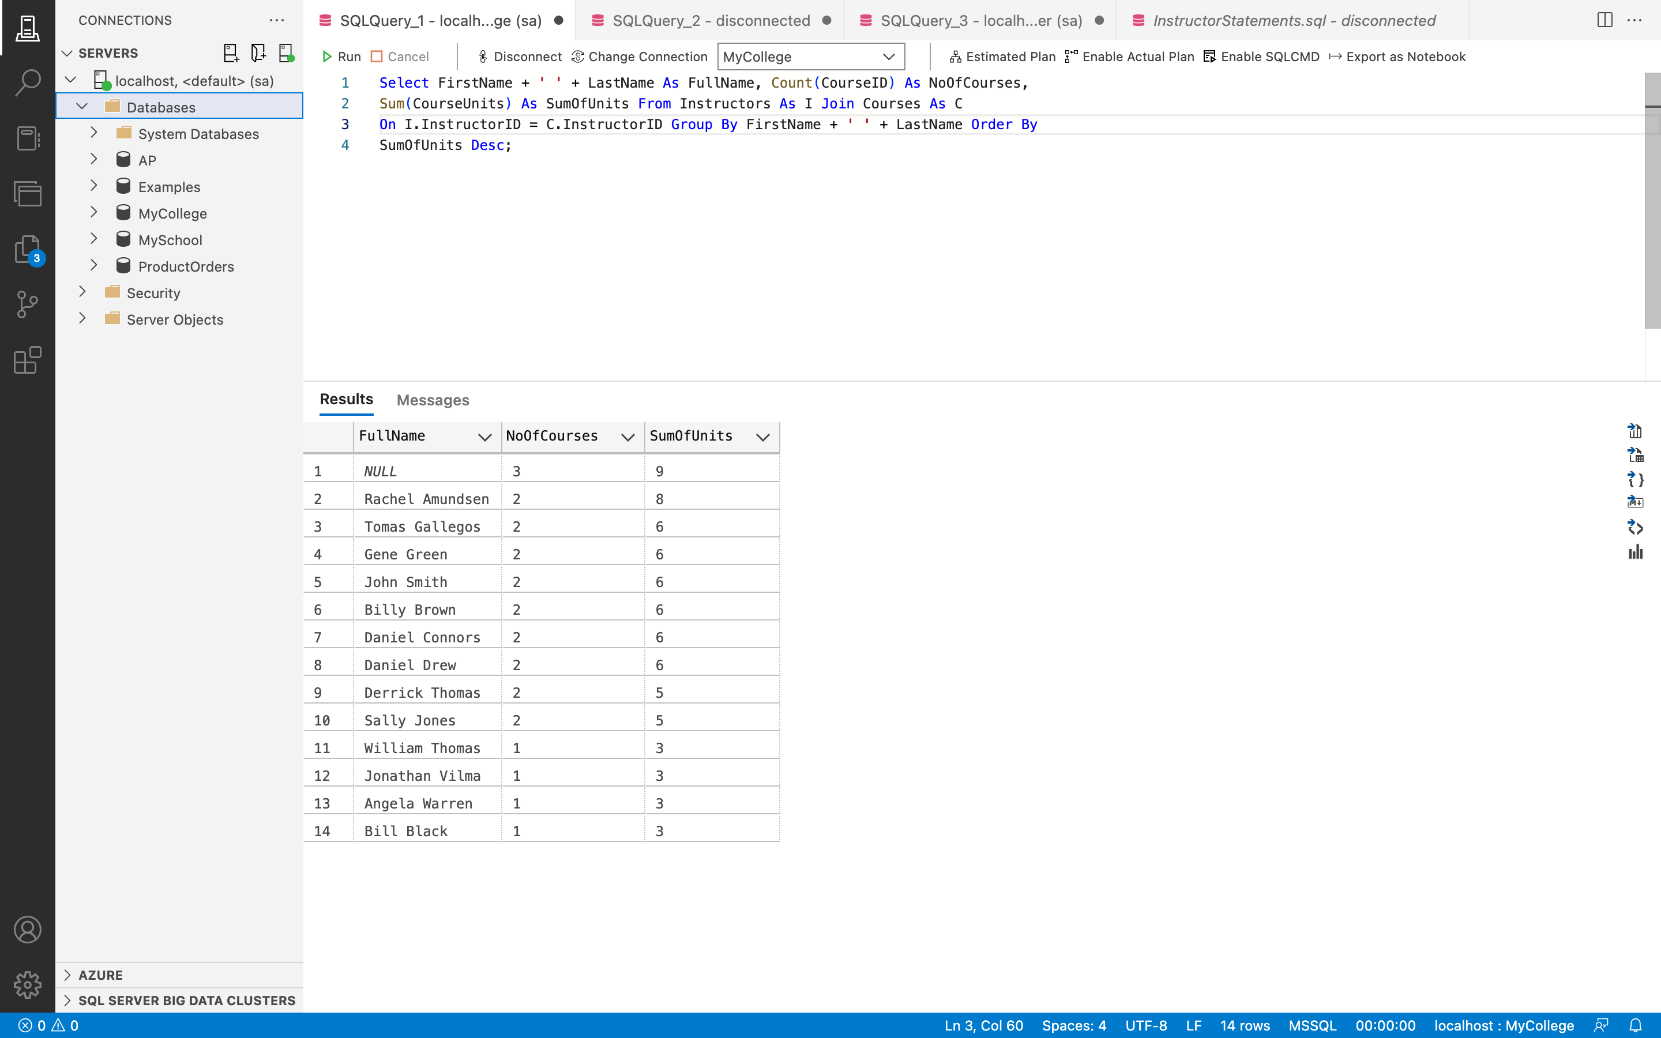

**Remarks: -**

* To display the COUNT(*) aggregate function on the Courses table and count the number of courses provided by a certain instructor, use the SELECT command.
* The instructor's name, which is created by adding the FirstName and LastName fields together in the Instructors table using the "+" operator.
* The aggregate function SUM() was used to add up the CourseUnits that each instructor had provided from the Courses table.
* The JOIN keyword is used to join the tables Instructors and Courses, while the ON keyword is used to join the InstructorID column.
* After being grouped by the union of FirstName and LastName, the result set is sorted in decreasing order on the TotaLCourseUnits column using the ORDER BY keyword.
* There are 14 rows returned.
* You can see all the code and the output above in the given screenshot.

1. Write a SELECT statement that answers this question: What is the total number of courses taught by parttime instructors? Return these columns:
   * The instructor last name and first name from the Instructors table in this format: Doe, John (Note: If the instructor first name has a null value, the concatenation of the first and last name will result in a null value.)
   * The total number of courses taught for each instructor in the Courses table

Use the ROLLUP operator to include a row that gives the grand total.

**Answer 12: -**

**Query: -**

Select LastName + ', ' + FirstName As FullName, Count(CourseId) As TotalCoursesTaught From

Instructors As I Join Courses As C On I.InstructorID = C.InstructorID Where I.Status = 'P'

Group By Rollup( LastName + ', ' + FirstName);

**Output: -**

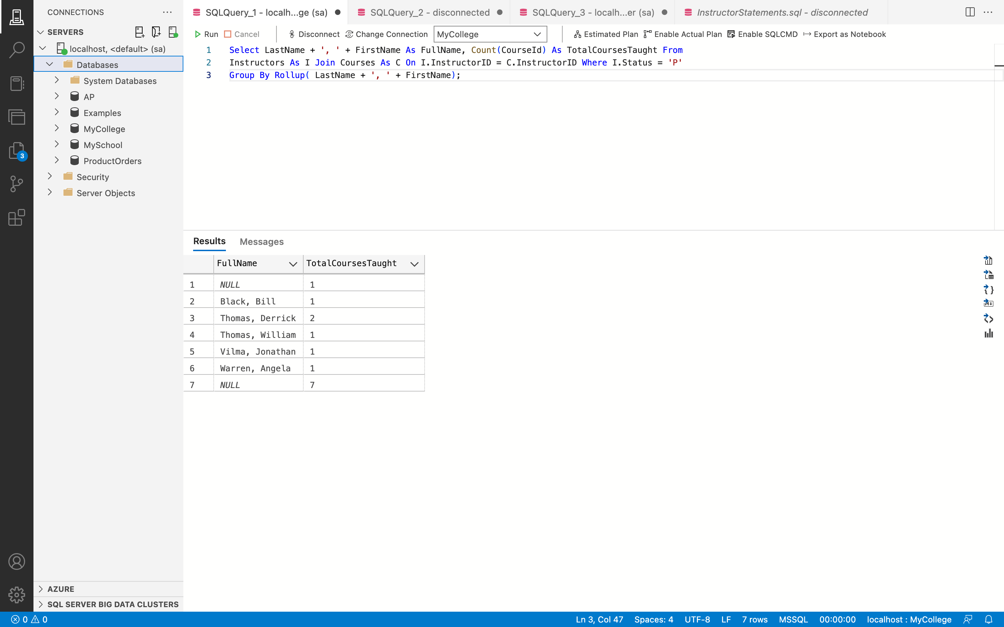

**Remarks: -**

* The InstructorName, which is the concatenation of the LastName and FirstName values from the Instructors table, is displayed in the provided query using the SELECT statement.
* The Instructors and Courses tables are combined with the JOIN keyword on the InstructorID column with the ON keyword. The COUNT(*) aggregate function is used to count the total number of courses, which is designated TotalCourses and is referred to by the AS keyword.
* The Instructors table only shows records whose Status is "P" when the WHERE clause is used. The result set is grouped by the union of LastName and FirstName, and the ROLLBACK operator is added to the GROUP BY clause in order to display the overall number of courses.
* We Retrieved 7 rows in total.
* You can see all the code and the output above in the given screenshot.

1. Write a SELECT statement that returns the same result set as this SELECT statement, but don’t use a join. Instead, use a subquery in a WHERE clause that uses the IN keyword. SELECT DISTINCT LastName, FirstName

FROM Instructors i JOIN Courses c

ON i.InstructorID = c.InstructorID

ORDER BY LastName, FirstName.

**Answer 13: -**

**BEFORE UPDATE:**

**Query: -**

SELECT DISTINCT LastName, FirstName FROM Instructors i JOIN Courses c ON

i.InstructorID = c.InstructorID ORDER BY LastName, FirstName;

**Output: -**

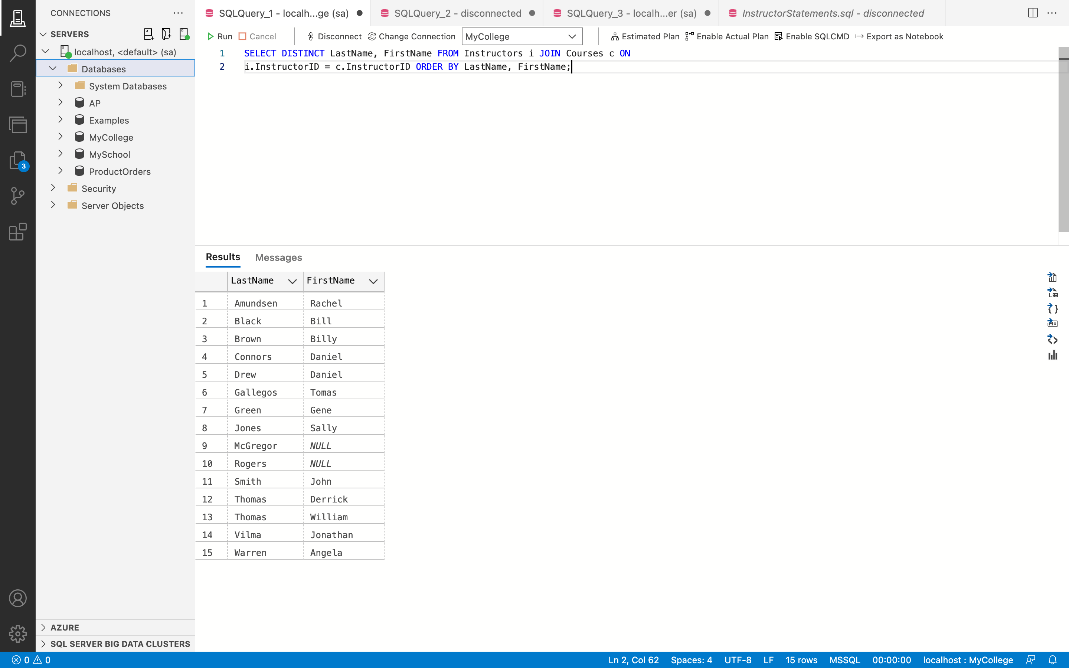

**WITHOUT USING JOIN:**

**Query: -**

Select Distinct LastName, FirstName From Instructors Where InstructorID In (Select

InstructorID From Courses) Order By LastName, FirstName;

**Output: -**

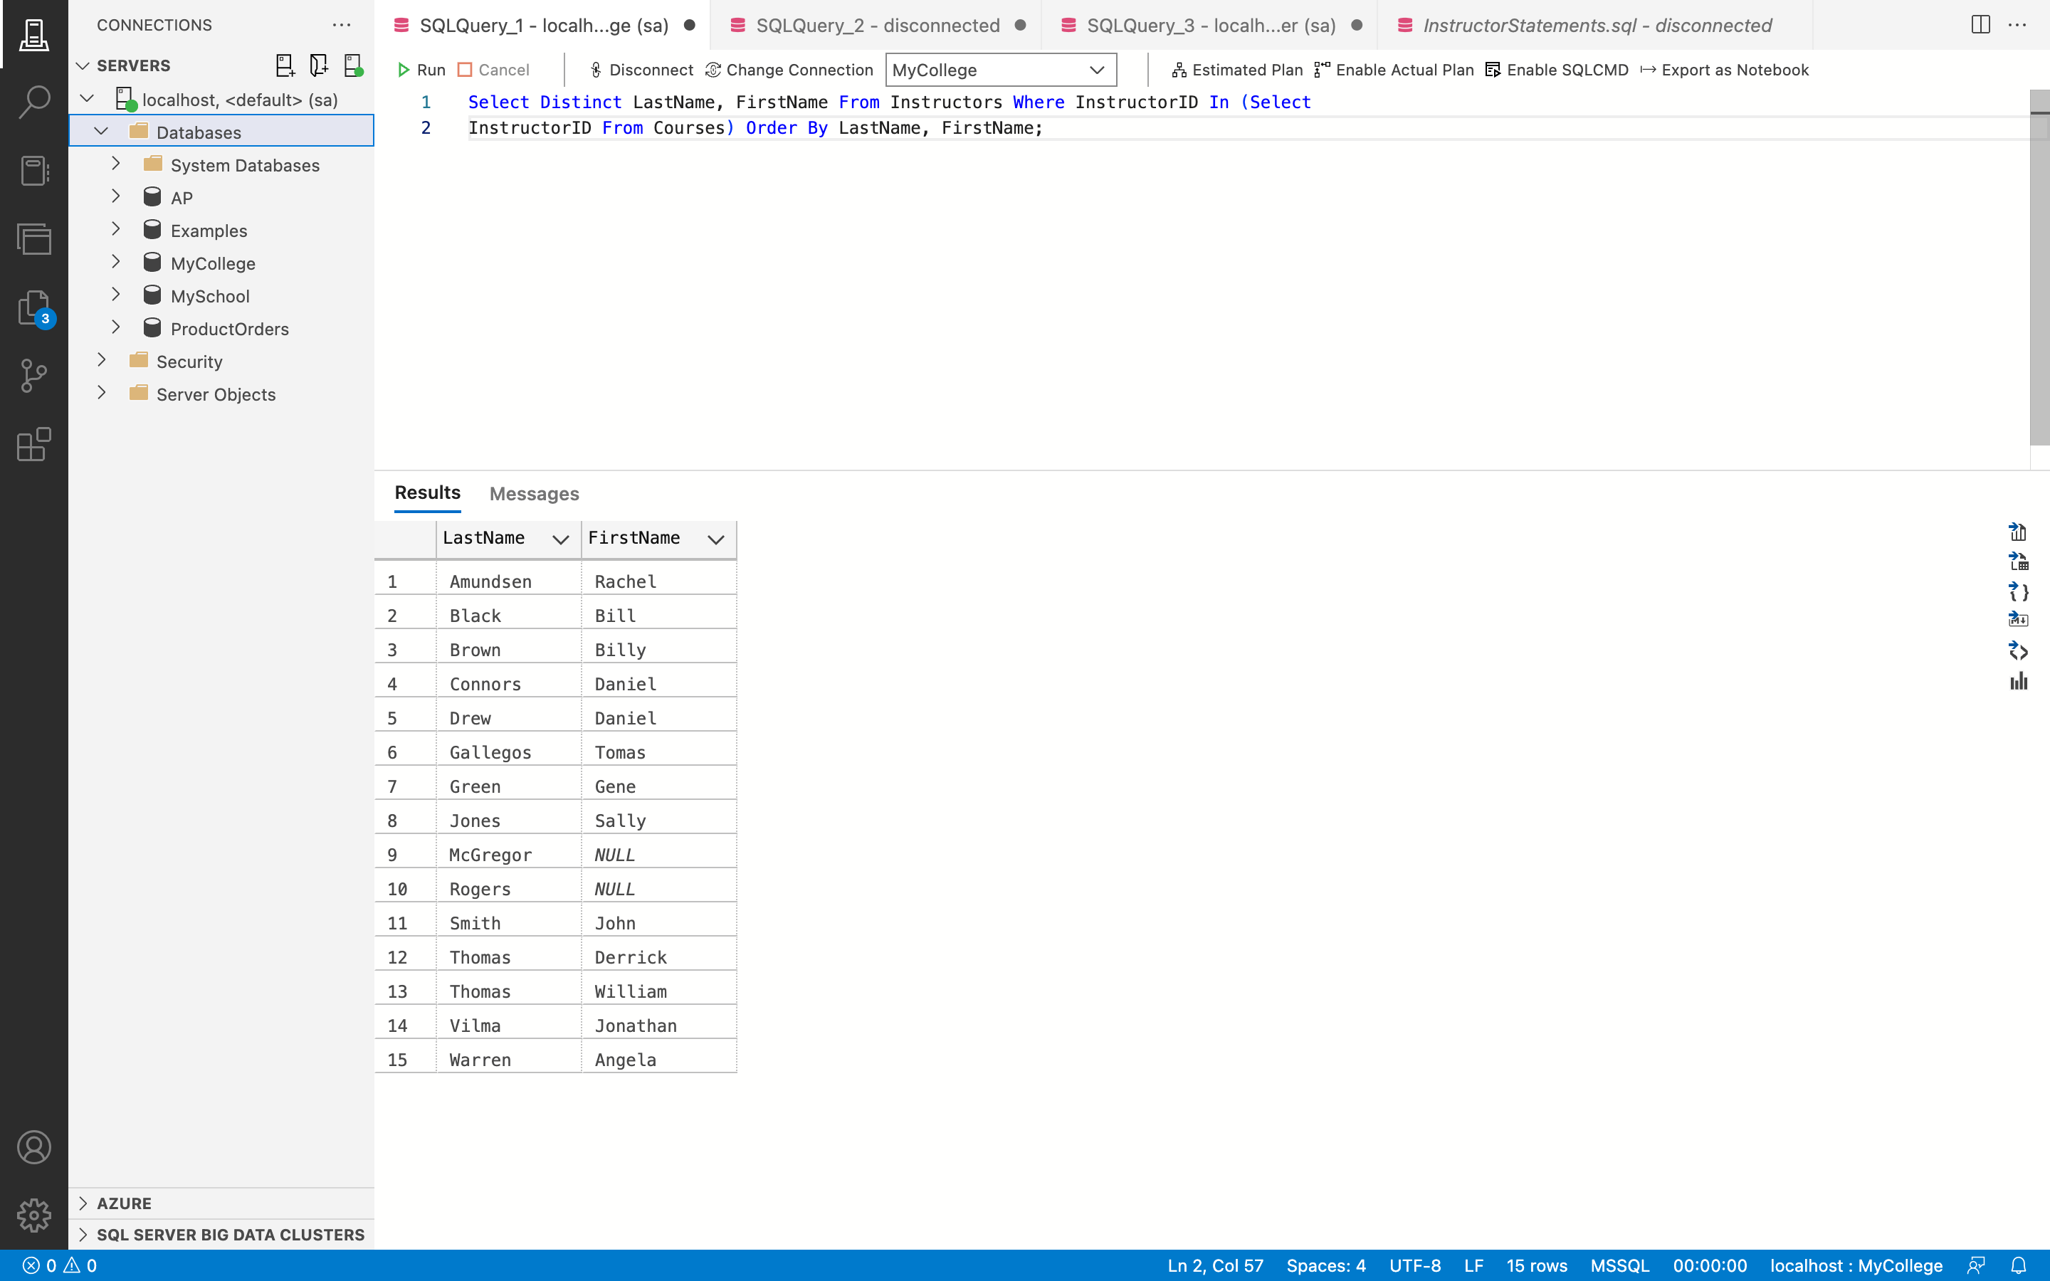

**Remarks: -**

* The SELECT statement is used to display just those LastName and FirstName from the Instructors table that are in the Courses table using the WHERE clause and a subquery.
* The distinct InstructorID is obtained from the Courses table using the SELECT statement, and the Instructors table entries whose InstructorID are in the subquery result set are retrieved using the IN operator.
* The result set is sorted ascendingly using the ORDER BY keyword on LastName, FirstName.
* There are retrieved 15 rows.
* You can see all the code and the output above in the given screenshot.

1. Write a SELECT statement that returns one row for each course with these columns:

● The CourseID column from the Courses table

● The most recent enrollment date for that course from the Students table

Change the SELECT statement to a CTE. Then, write a SELECT statement that returns one row per course that shows the CourseDescription for the course and the LastName, FirstName, and EnrollmentDate for the student with the most recent enrollment data.

**Answer 14: -**

**Query: -**

With CourseDetails As (Select Courses.CourseID, Max(EnrollmentDate) As MaxOfEnDate

From Courses Join StudentCourses ON Courses.CourseID = StudentCourses.CourseID Join

Students On StudentCourses.StudentID = Students.StudentID Group By Courses.CourseID)

Select CourseDescription, LastName, FirstName, EnrollmentDate From Courses Join

StudentCourses On Courses.CourseID = StudentCourses.CourseID Join Students On

StudentCourses.StudentID = Students.StudentID Join CourseDetails On Courses.CourseID =

CourseDetails.CourseID And Students.EnrollmentDate = CourseDetails.MaxOfEnDate;

**Output: -**

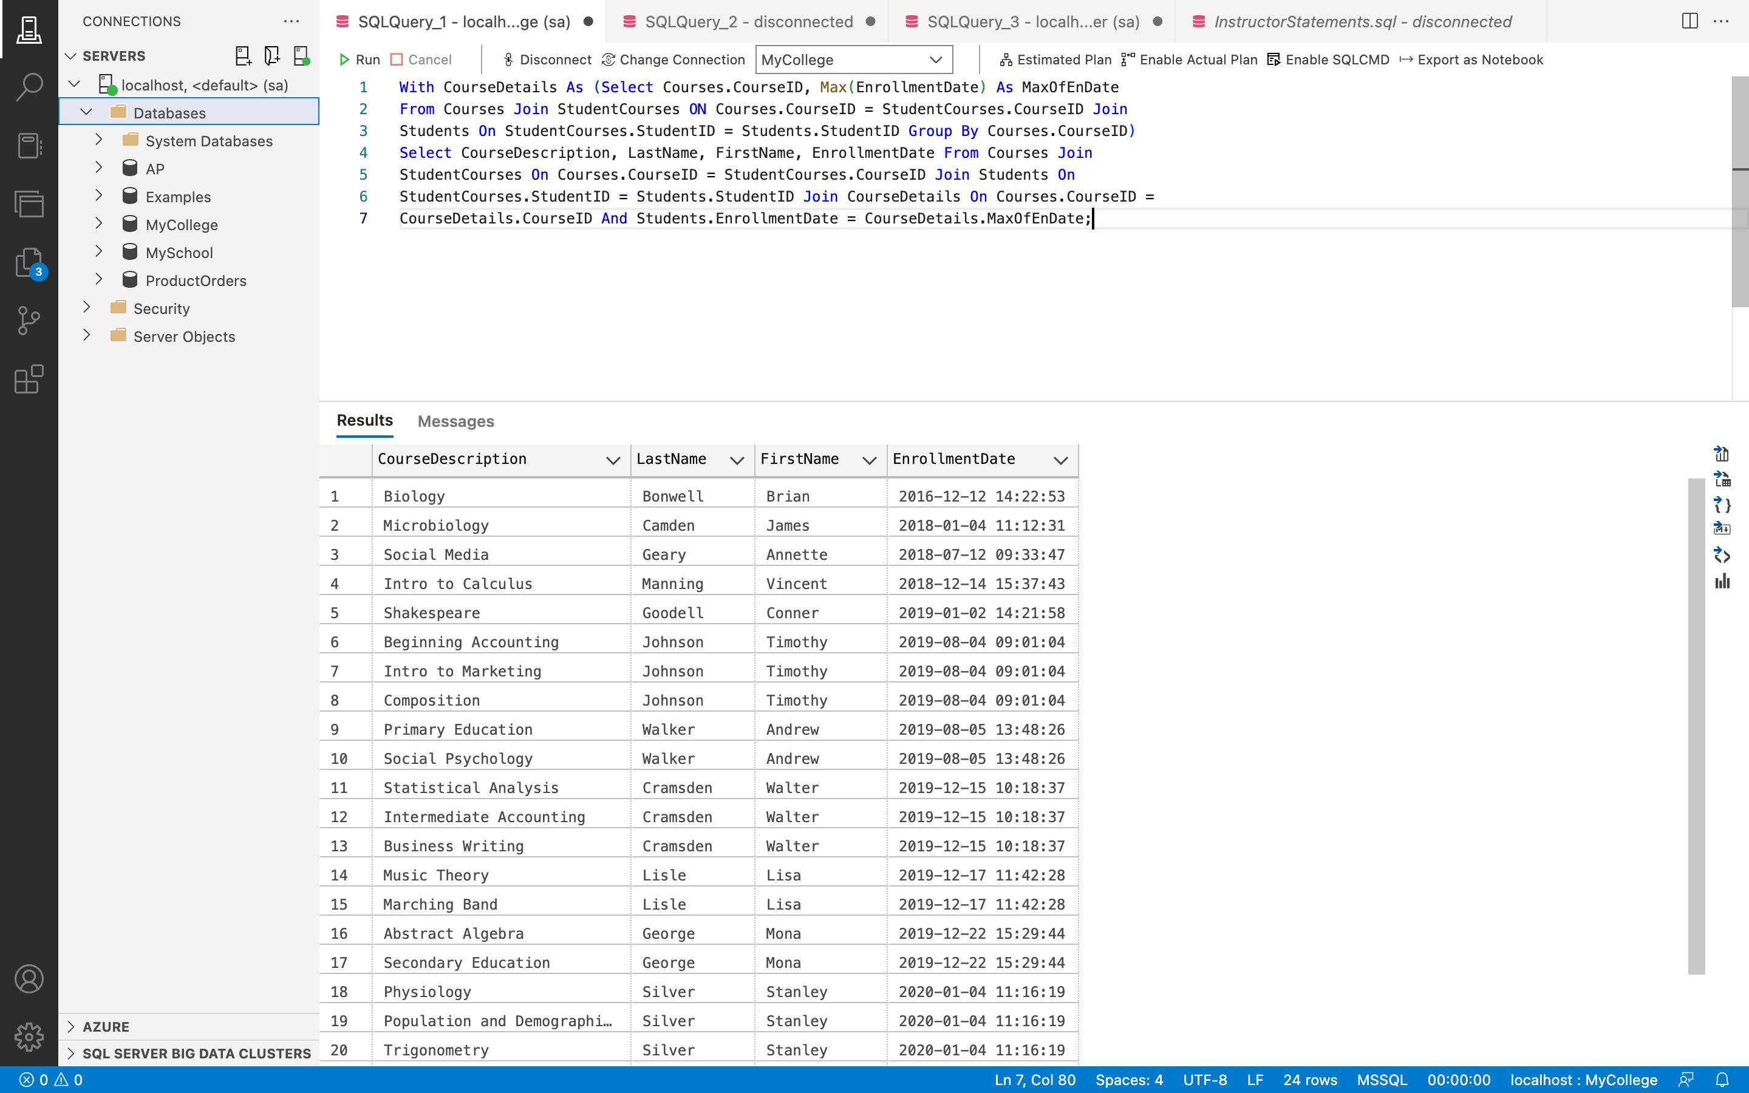

**Remarks: -**

* The CourseDescription, LastName, FirstName, and EnrollmentDate fields for students with the most recent enrollment date were displayed using the SELECT command.
* The select query's result set is contained in the CTE with the name CourseDetails.
* This SELECT statement chooses the CourseID column from the Courses table and the MaxOfEnrollmentDate column from the Students table, which is the maximum of the EnrollmentDate column using the MAX() aggregate function.
* The JOIN keyword is used to join the tables Courses and StudentCourse together on the CourseID column, which is then connected to the Students database on StudenID.
* The GROUP BY phrase is then used to group this result set.
* The StudentCourses table is attached to the Courses table on CourseID, and the Student table is then joined to the Courses table on StudentID.
* which is then joined with the CTE CourseDetails CourseID and MaxOfEnrollmentDate.
* You can see all the code and the output above in the given screenshot.

1. Write an INSERT statement that adds this row to the Departments table:

* DepartmentName: History

Code the INSERT statement so SQL Server automatically generates the value for the

DepartmentID column.

**Answer 15: -**

**Query: -**

Insert Into Departments (DepartmentName) Values ('History');

**Output: -**

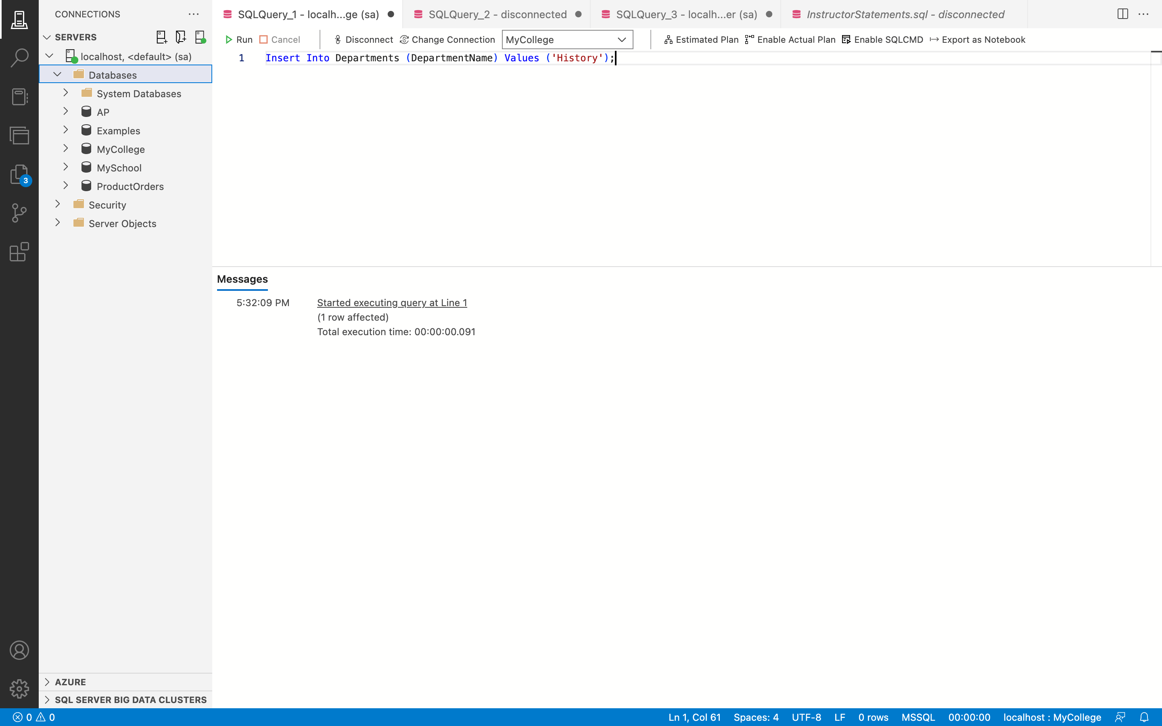

**Query: -**

Select * From Departments;

**Output: -**

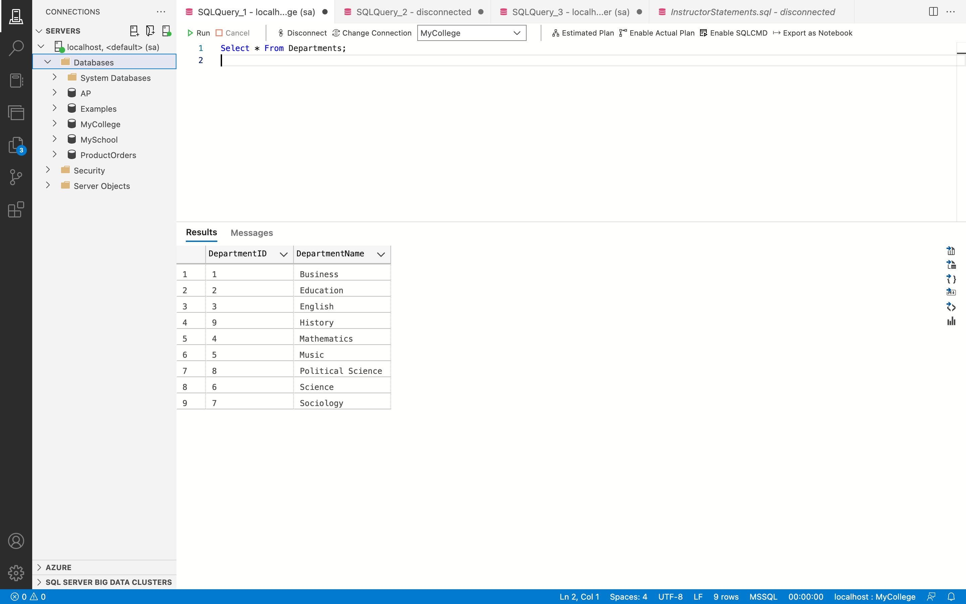

**Remarks: -**

* The DepartmentName field is used in this situation, and the value "History" is typed into it.
* Here, new values are added to the Departments table using the INSERT INTO statement.
* The values that should be added to each column are listed after the column list.
* This will construct a new record, and SQL Server will automatically generate the new DepartmentID for this record.
* You can see all the code and the output above in the given screenshot.

1. Write a single INSERT statement that adds these rows to the Instructors table:

* InstructorID: The next automatically generated ID

LastName: Benedict

FirstName: Susan

Status: P

DepartmentChairman: 0

HireDate: Today’s date

AnnualSalary: 34000.00

DepartmentID: 9

* + InstructorID: The next automatically generated ID

LastName: Adams

FirstName: null

Status: F

DepartmentChairman: 1

HireDate: Today’s date

AnnualSalary: 66000.00

DepartmentID: 9

Write this statement without using a column list.

**Answer 16: -**

**Query: -**

Insert Into Instructors Values ('Benedict', 'Susan', 'P', 0, GETDATE(), 34000.00, 9), ('Adams', Null, 'F', 1, GETDATE(), 66000.00, 9);

**Output: -**

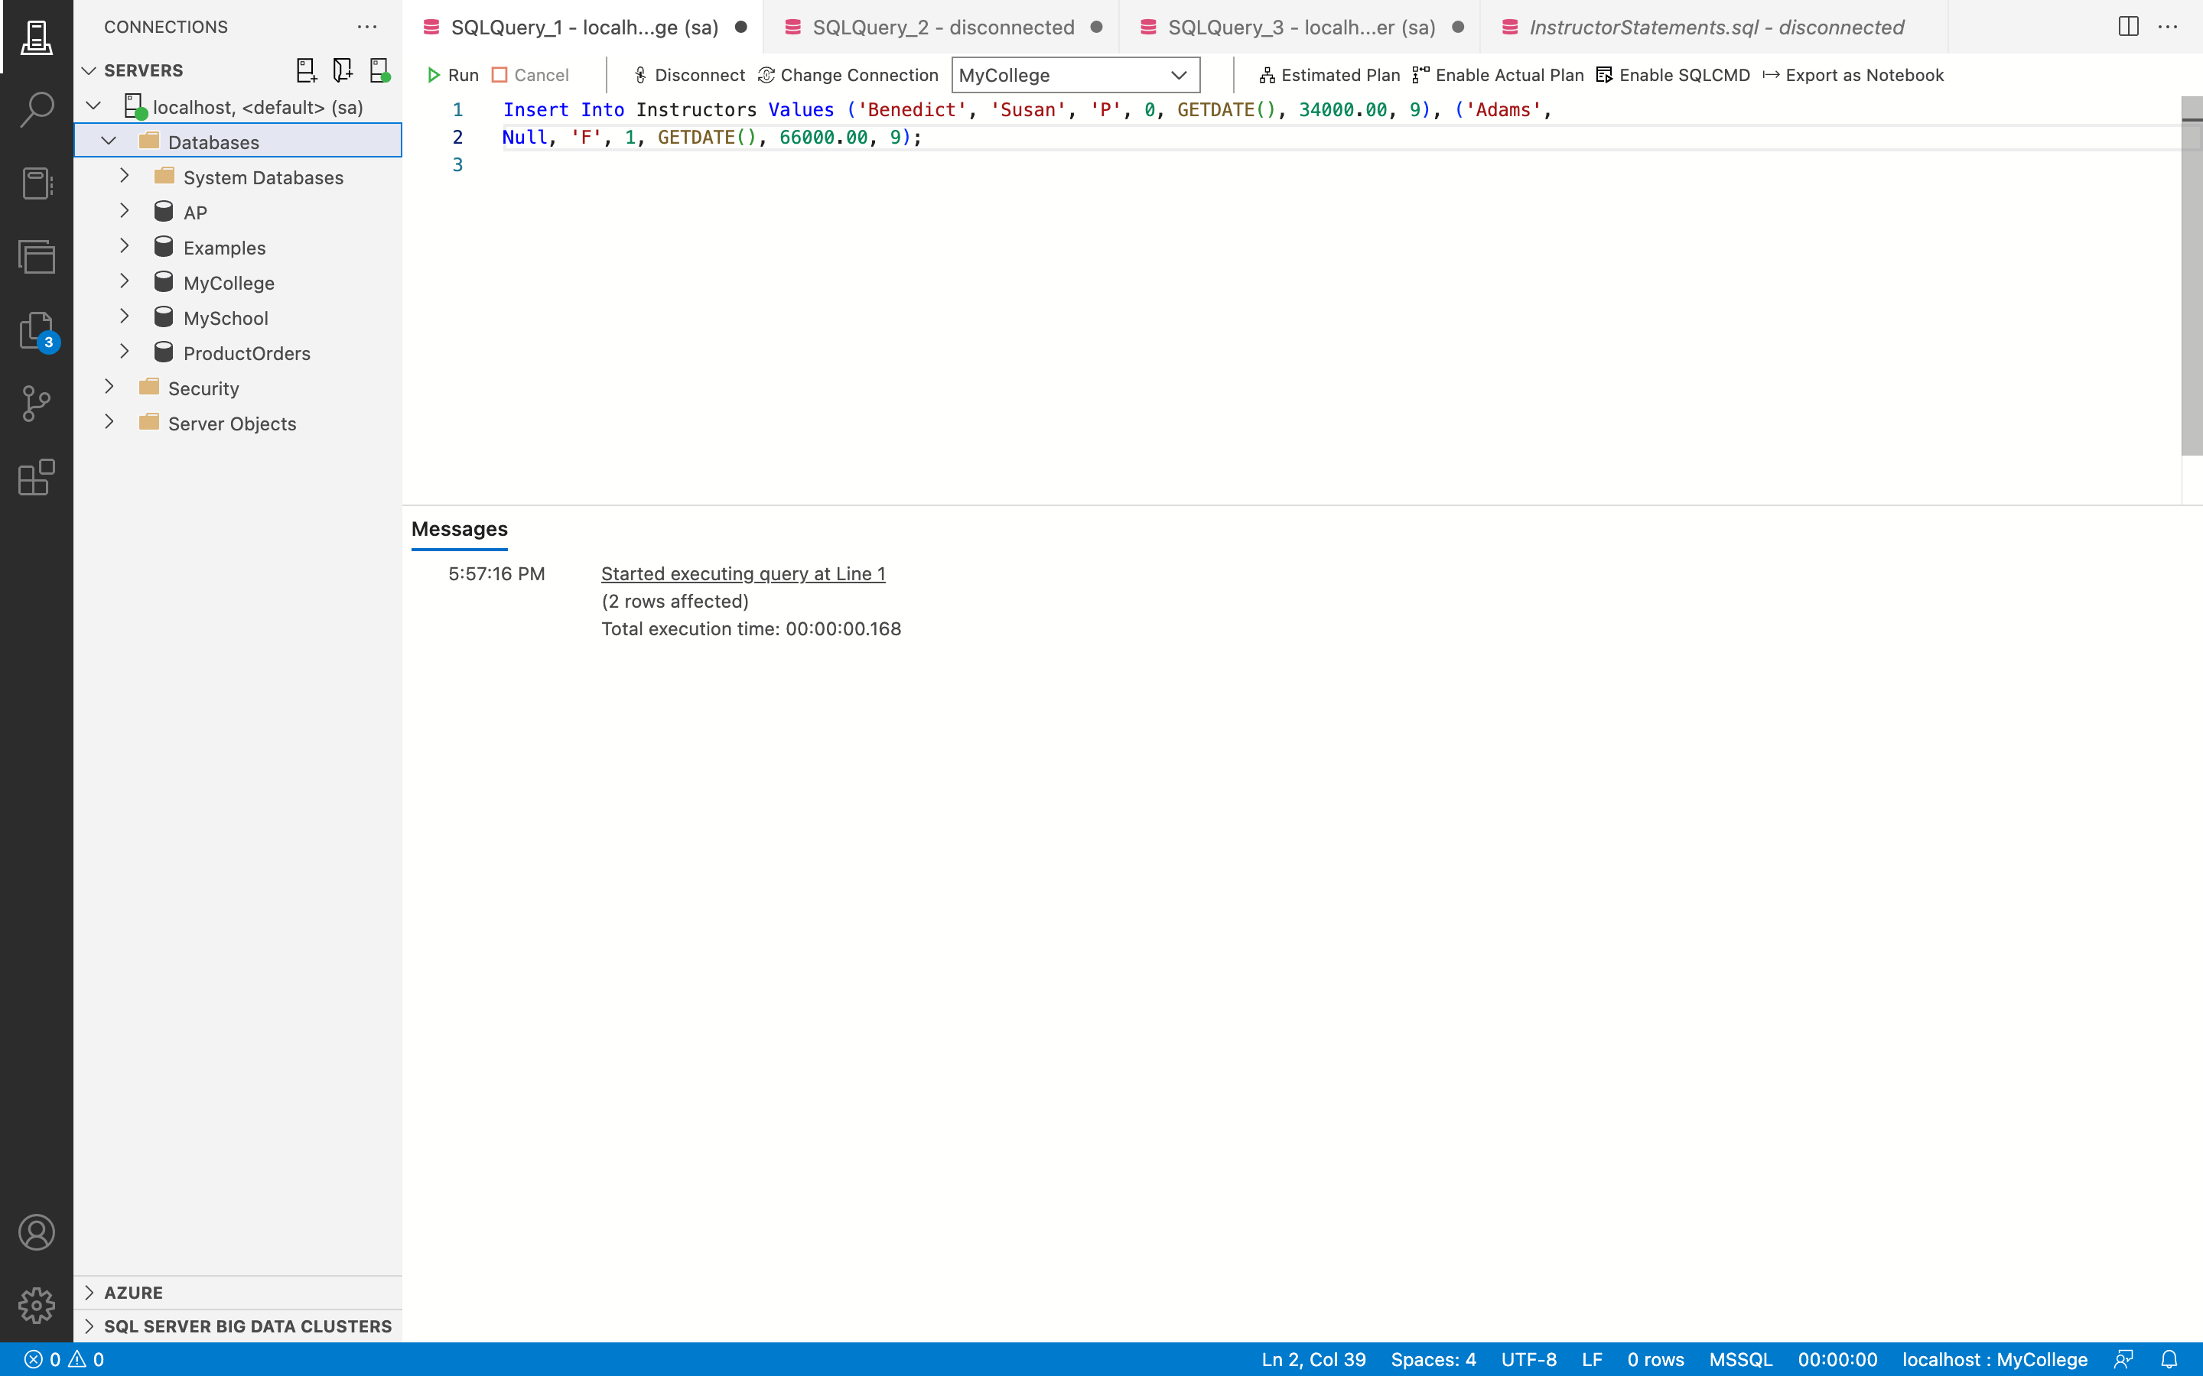

**Remarks: -**

* + To add records to the current Instructors table, use the INSERT INTO command.
  + Because the values to be added can be supplied in the correct column order, the column list is not necessary.
  + All of the values are listed for the first and second records to be added in the same order as the column in the table, followed by VALUES.
  + You can see all the code and the output above in the given screenshot.

1. Write an UPDATE statement that modifies the first instructor you added in the above question. This statement should change the AnnualSalary column from 34,000 to 35,0000, and it should use the InstructorID column to identify the row.

**Answer 17: -**

**Before: -**

**Query: -**

Select * From Instructors Where LastName = 'Benedict';

**Output: -**

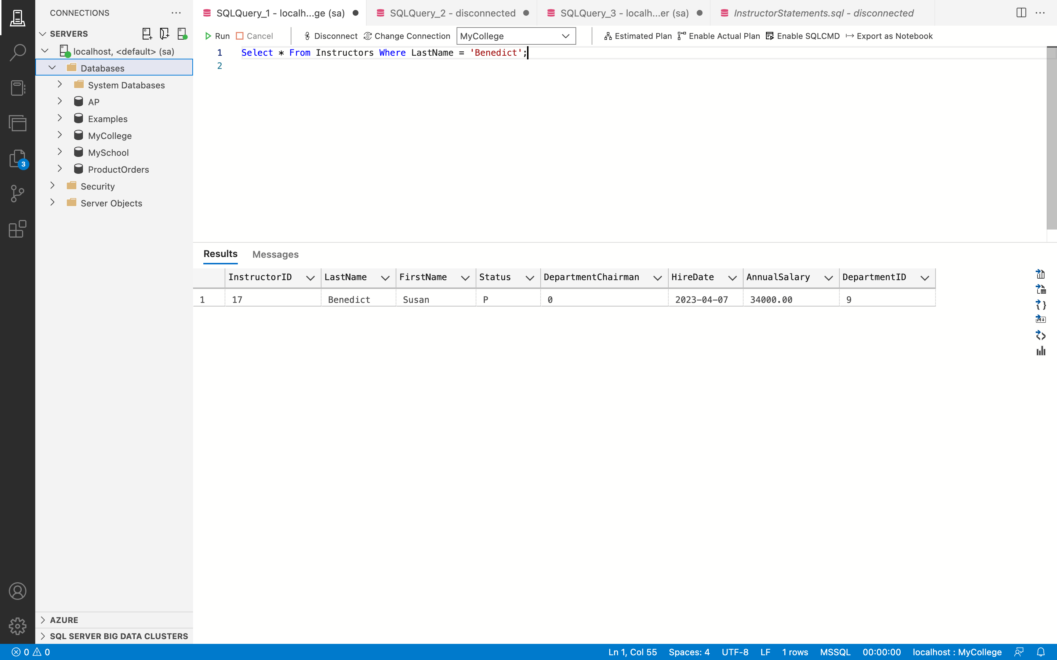

**Query: -**

Update Instructors Set AnnualSalary = 350000 Where InstructorID = 17;

**Output: -**

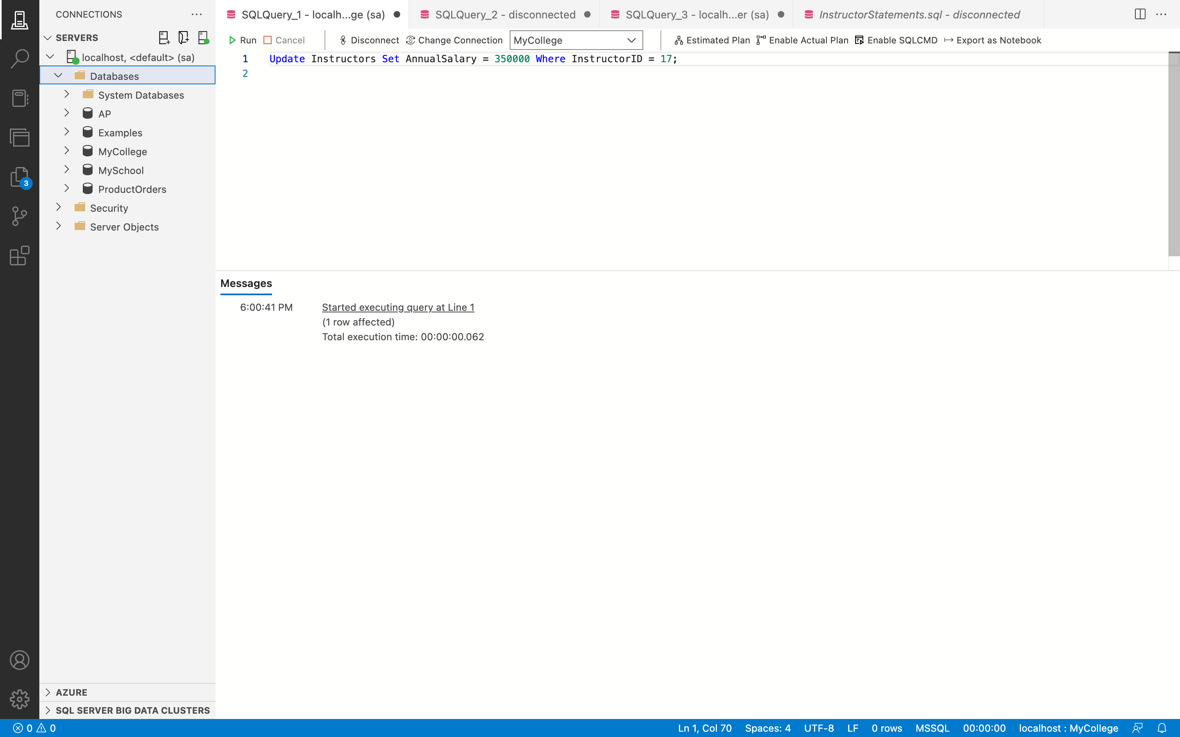

**After:-**

**Query: -**

Select * From Instructors Where LastName = 'Benedict';

**Output: -**

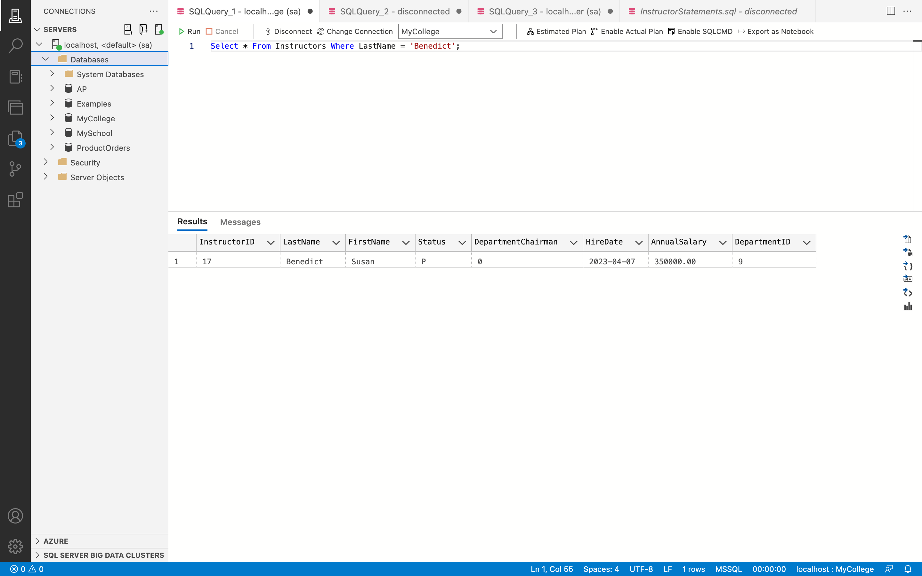

**Remarks: -**

* In this scenario, the current Instructors table is updated using the UPDATE line.
* Using the WHERE clause, AnnualSalary is set to 35000 for the record with InstructorID 17.
* You can see all the code and the output above in the given screenshot.

1. Write a DELETE statement that deletes the second instructor you added in question 21. This statement should use the InstructorID column to identify the row.

**Answer 18: -**

**Before:**

**Query: -**

Select * From Instructors Where LastName = 'Adams';

**Output: -**

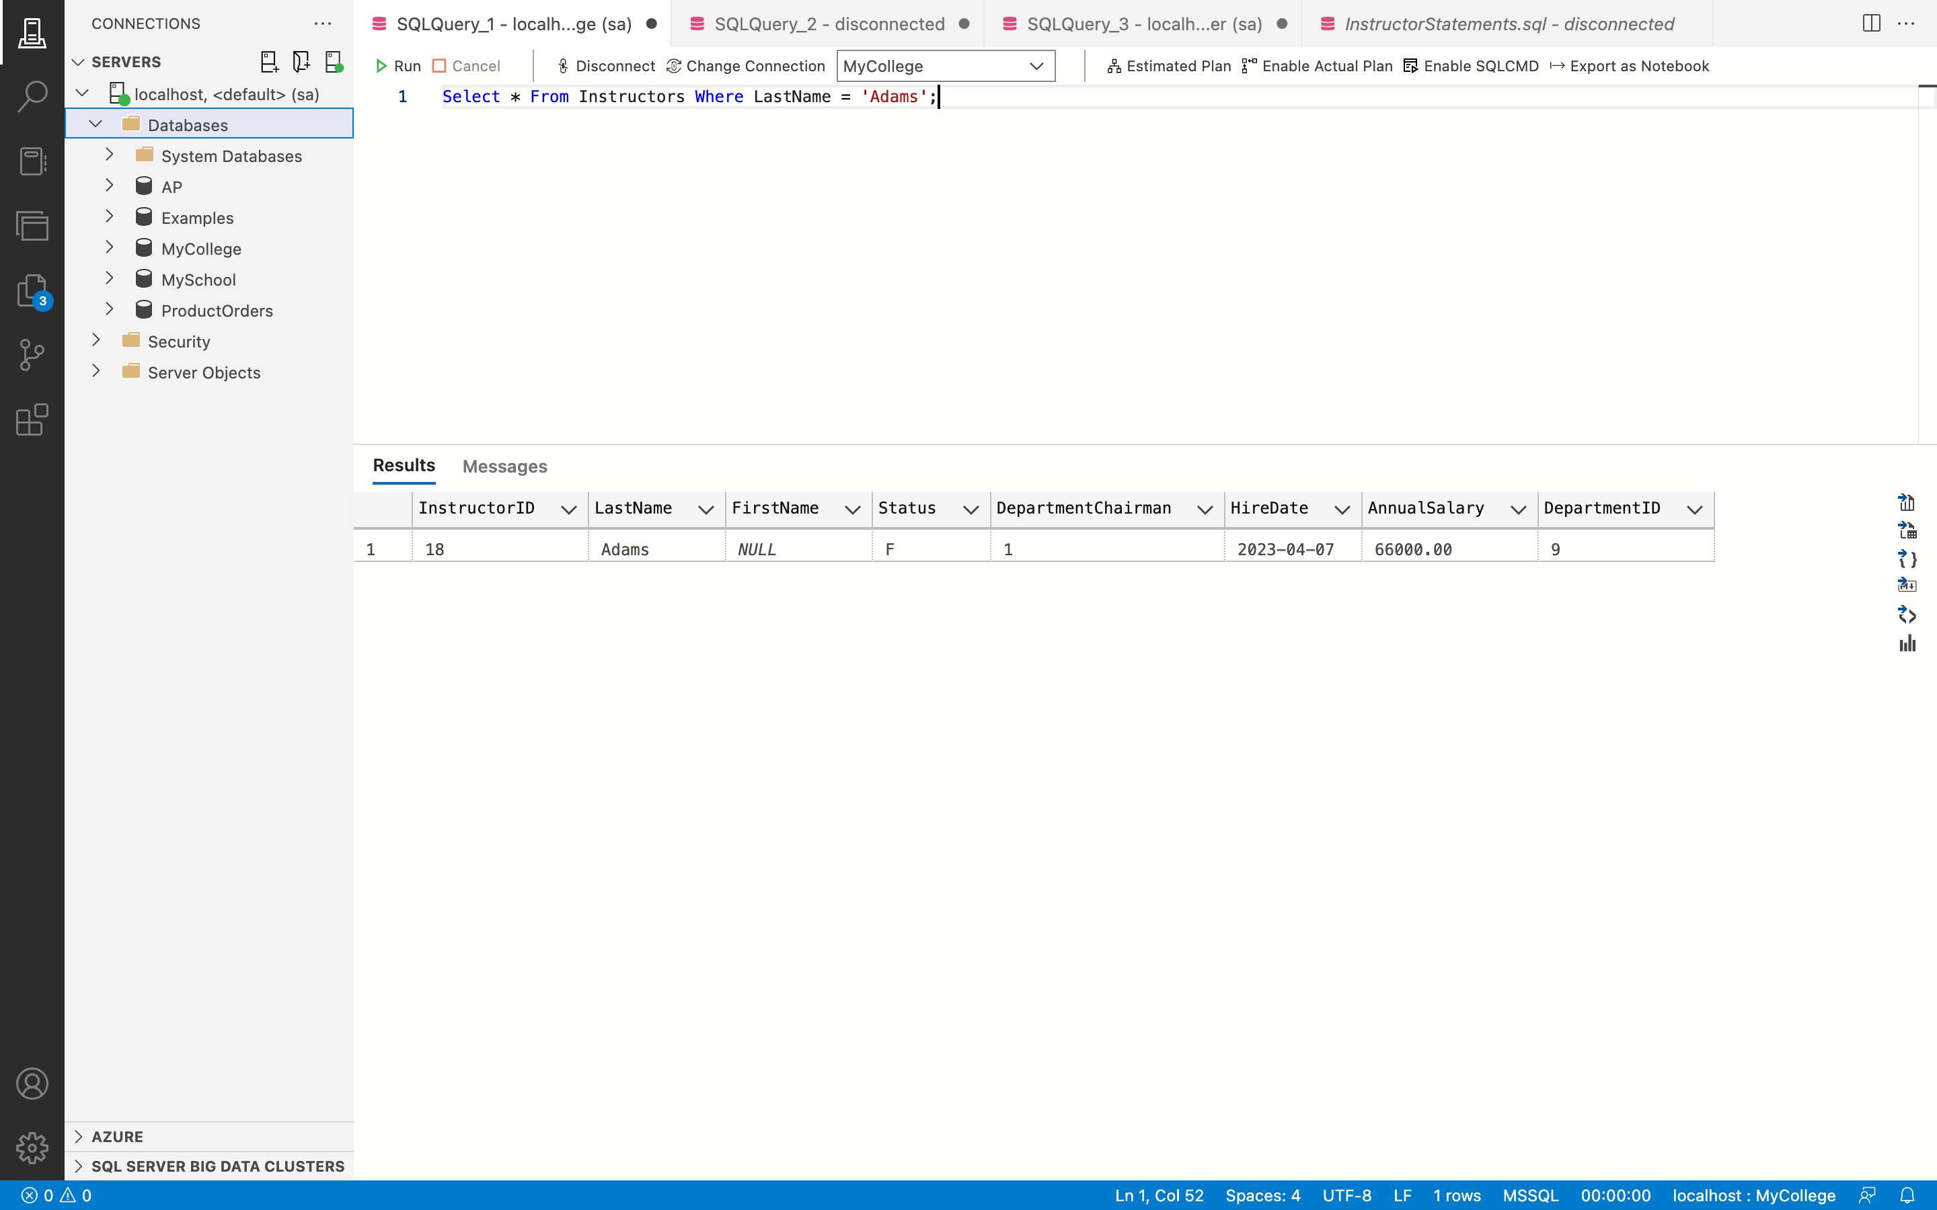

**Query: -**

Delete From Instructors Where InstructorID = 18;

**Output: -**

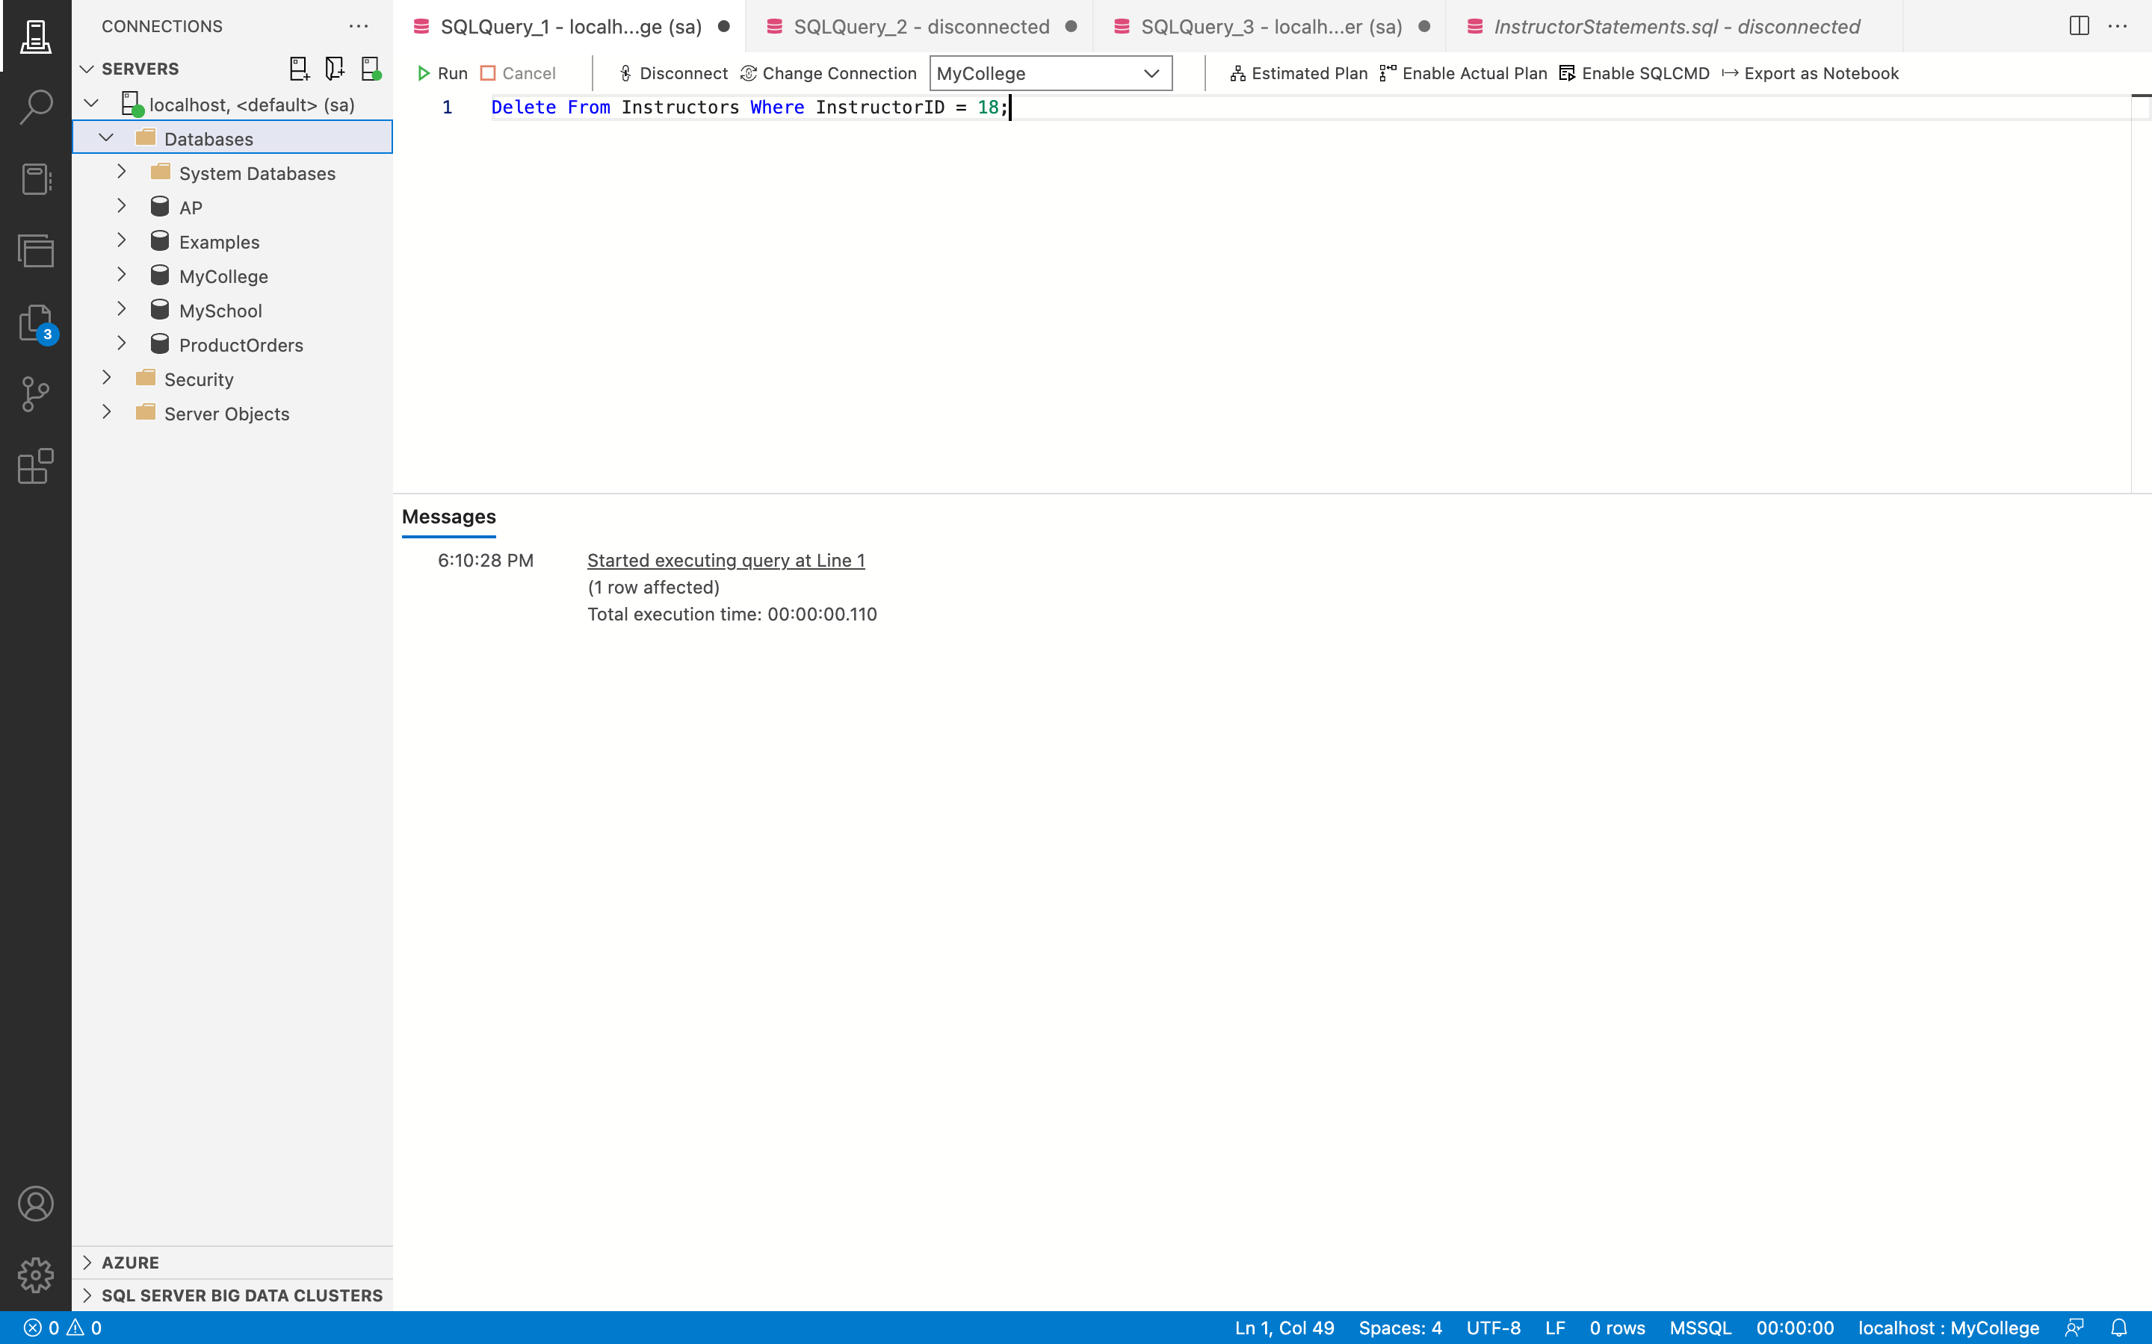

**After:**

**Query: -**

Select * From Instructors Where LastName = 'Adams';

**Output: -**

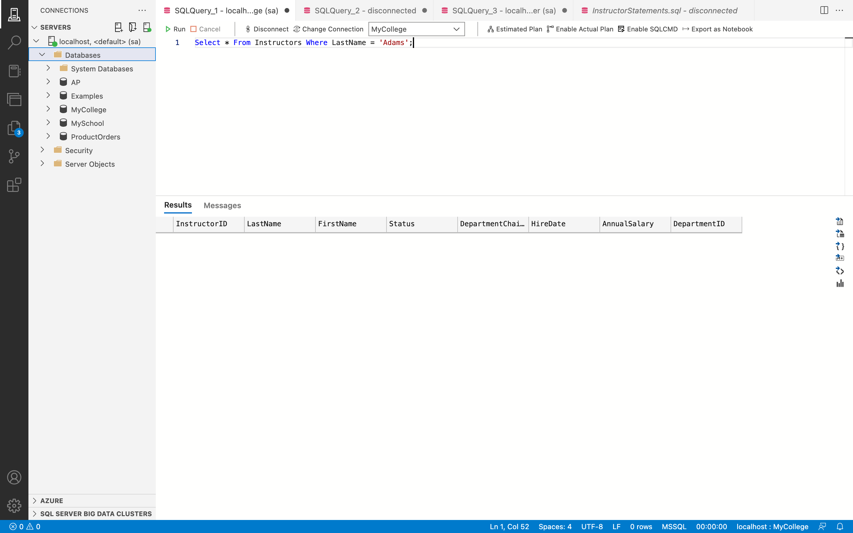

**Remarks: -**

* Using the WHERE clause, DELETE FROM is used to delete a record from the Instructors table whose InstructorID is 18.
* You can see all the code and the output above in the given screenshot.

1. Write a DELETE statement that deletes the row in the Departments table that has an ID of 9. When you execute this statement, it will produce an error since the department has related rows in the Instructors table. To fix that, precede the DELETE statement with another DELETE statement that deletes all instructors in this department.

**Answer 19: -**

**Before:**

**Query: -**

Select * from Departments where DepartmentID = 9;

**Output: -**

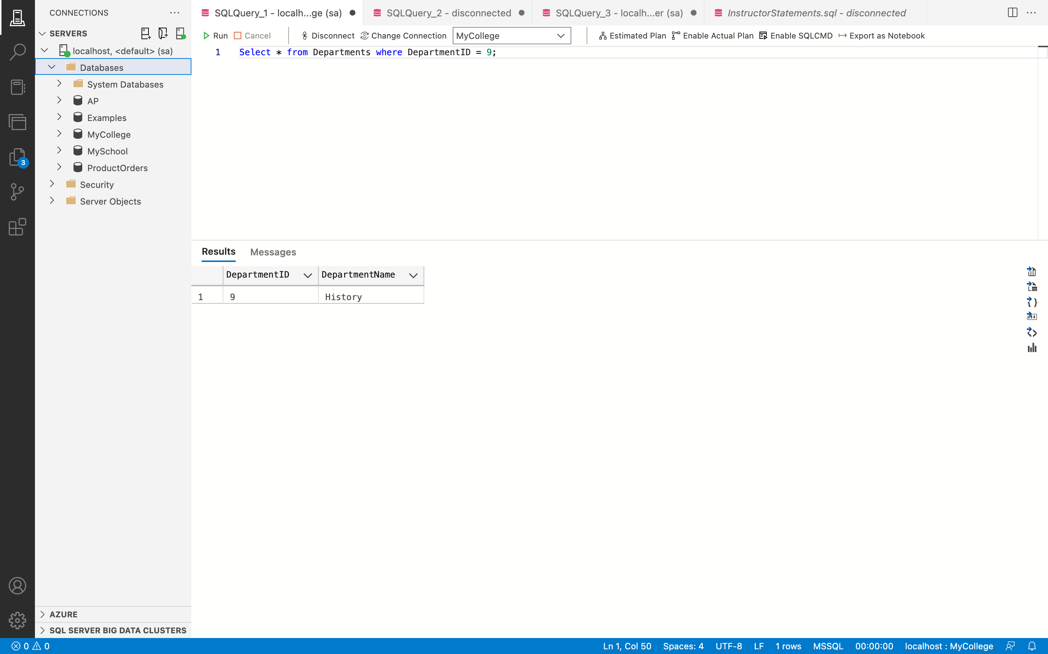

**Query: -**

Delete From Departments Where DepartmentID = 9;

**Output: -**

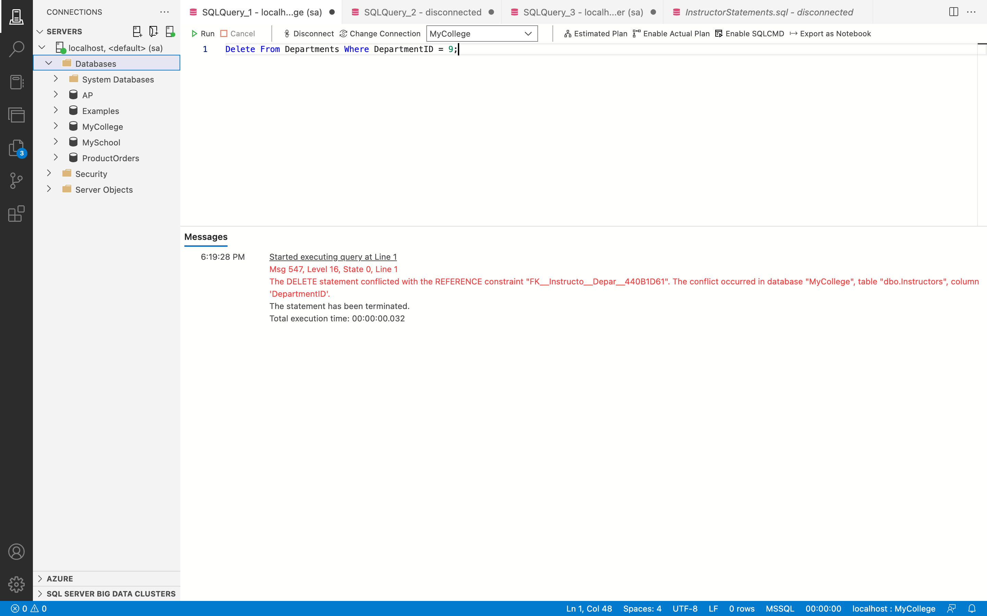

**Query: -**

Delete From Instructors Where DepartmentID = 9;

**Output: -**

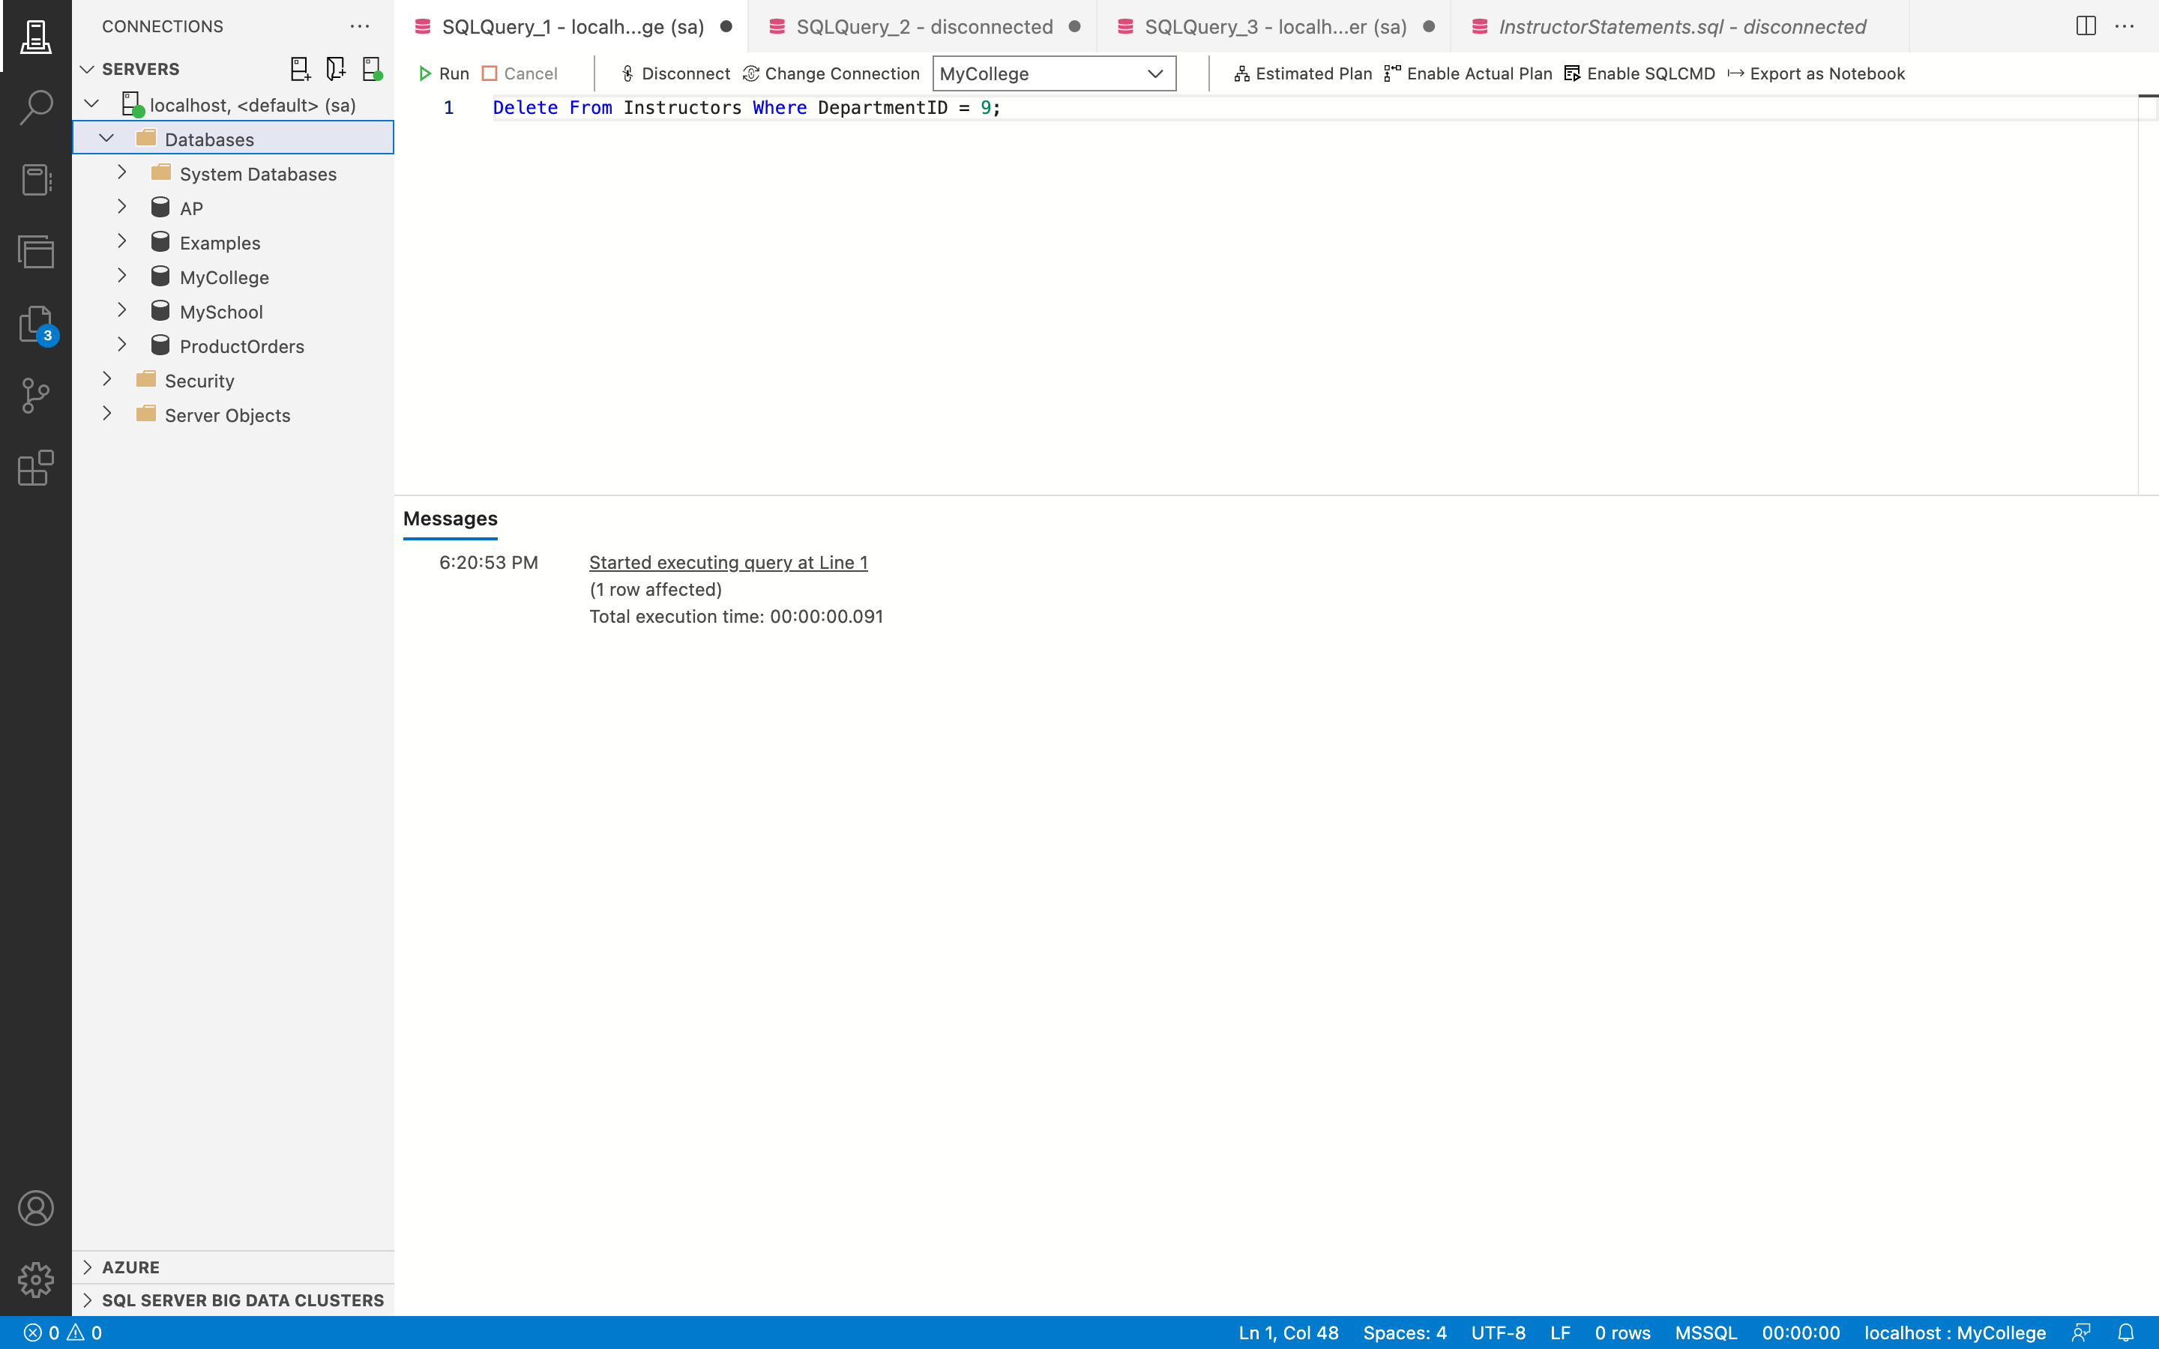

**After:**

**Query: -**

Delete From Departments Where DepartmentID = 9;

**Output: -**

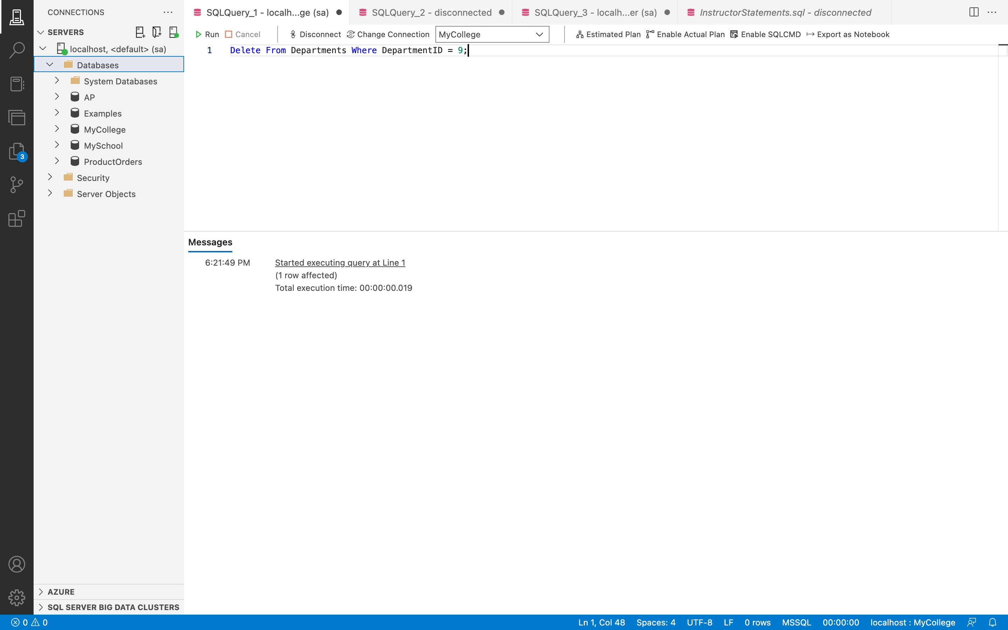

**Remarks: -**

* The first DELETE FROM statement is used to delete the record from the Instructors table with the DepartmentID 9 and the second DELETE FROM statement is used to delete the record from the Departments table with the same id.
* To delete the record from the Departments database, first delete the reference from the Instructors table of that specific DepartmentID.
* You can see all the code and the output above in the given screenshot.

1. Write an UPDATE statement that increases the annual salary for all instructors in the Education department by 5%. To do that, join the Departments and Instructors tables and then filter the rows by the department name.

**Answer 20: -**

**Before:**

**Query: -**

Select * from Departments Where DepartmentName = 'Education';

Select * from Instructors Where DepartmentID = 2;

**Output: -**

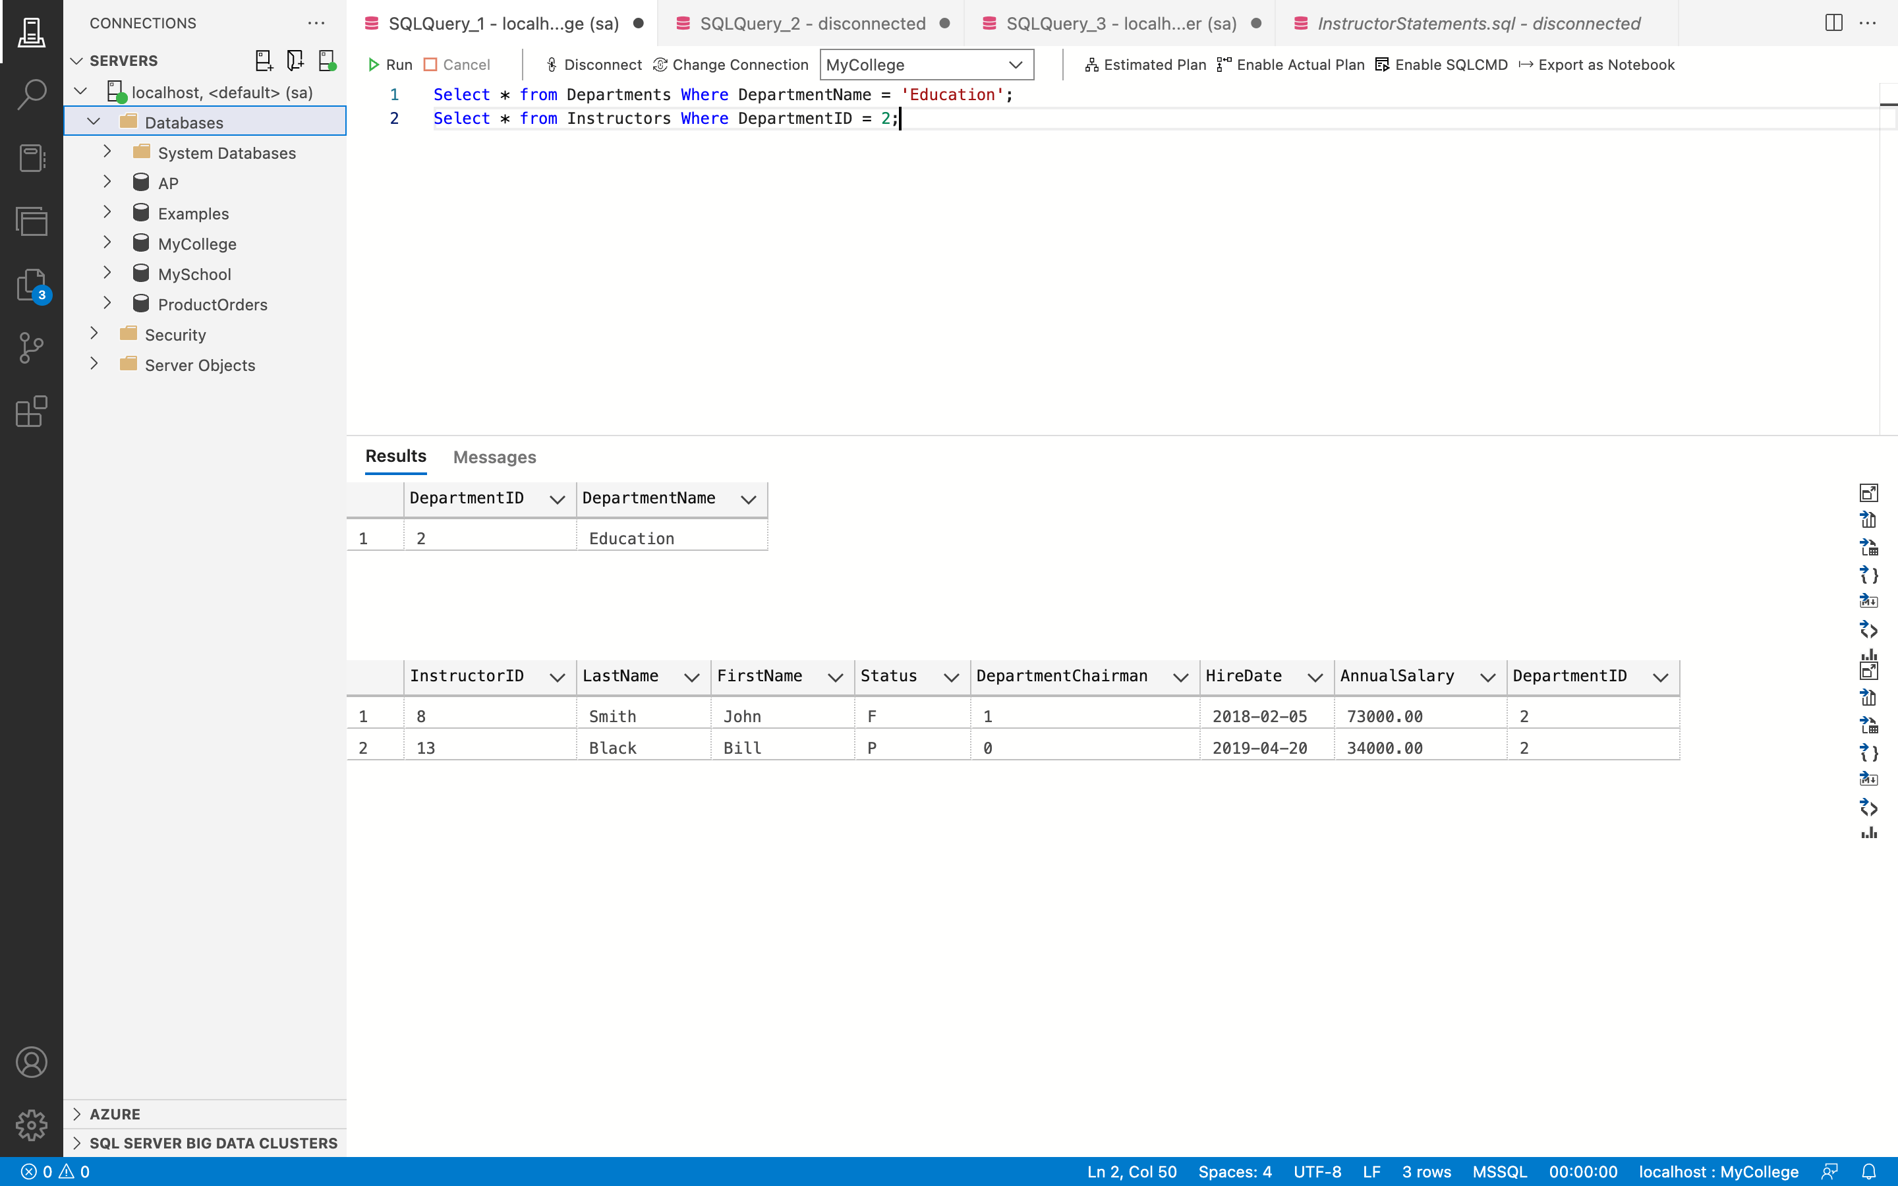

**Query: -**

Update Instructors Set AnnualSalary = AnnualSalary + (AnnualSalary * 0.5) From Instructors As I Join Departments As D On I.DepartmentID = D.DepartmentID Where DepartmentName = 'Education';

**Output: -**

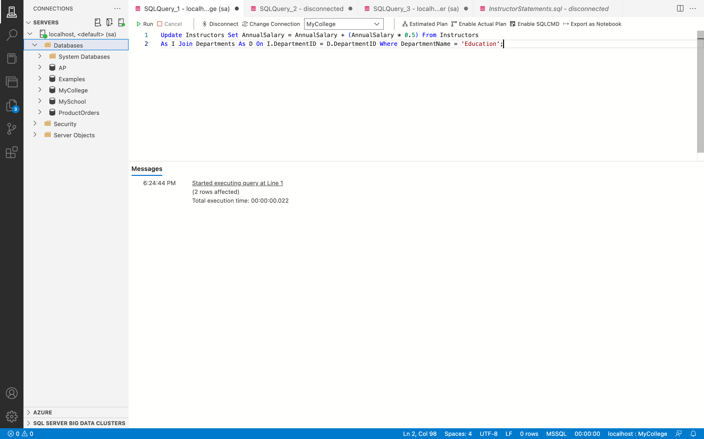

**After:**

**Query: -**

Select * from Instructors Where DepartmentID = 2;

**Output: -**

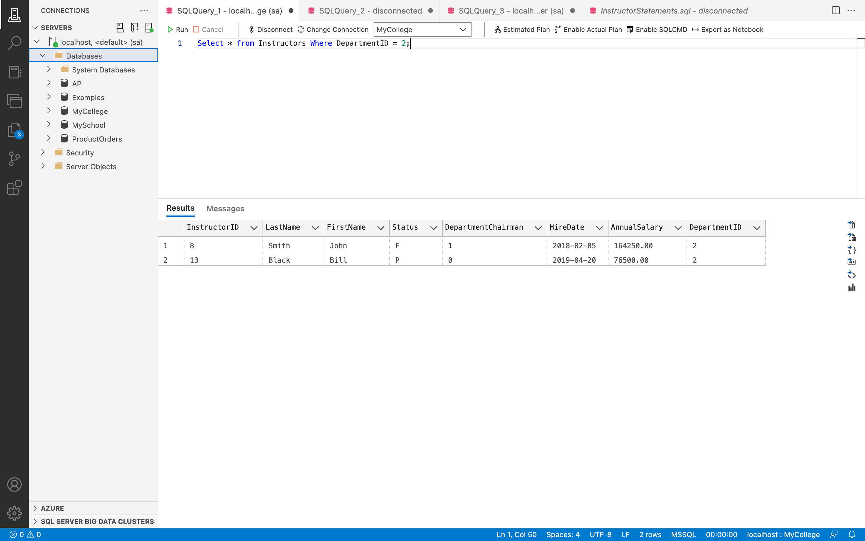

**Remarks: -**

* Here, the Instructors table is updated using the UPDATE line.
* This is done by joining the tables Instructors and Departments using the JOIN keyword on the DepartmentID column using the WHERE clause and specifying the constraint DepartmnetName = 'Education'. The AnnualSalary column is modified by increasing the value to 5% for records whose DepartmanetName is 'Education.
* You can see all the code and the output above in the given screenshot.

1. Write a DELETE statement that deletes instructors that aren’t teaching any courses. To do that, use a subquery in the WHERE clause.

**Answer 21: -**

**Before:**

**Query: -**

Select * From Instructors;

Select * From Courses;

**Output: -**

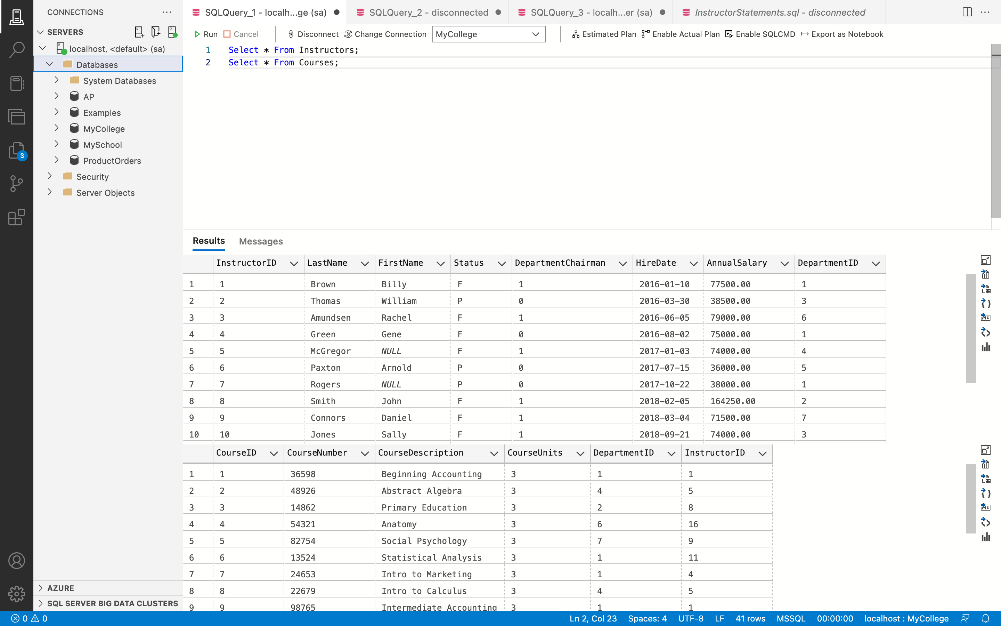

**After:**

**Query: -**

Delete From Instructors Where InstructorID Not In (Select InstructorID From Courses);

**Output: -**

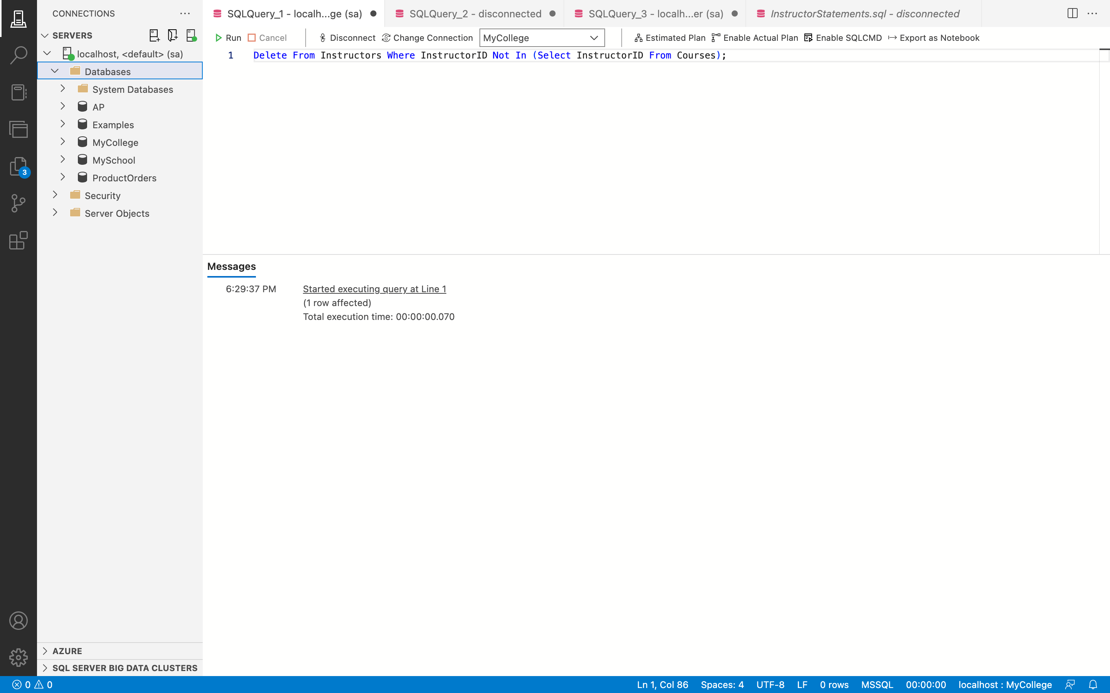

**Query: -**

Select * From Instructors;

**Output: -**

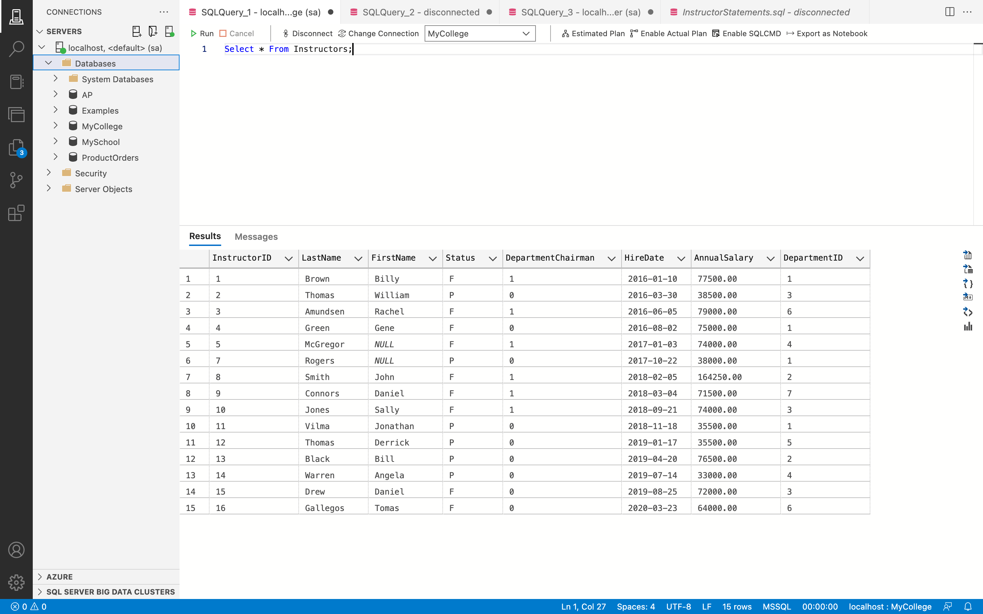

**Remarks: -**

* In this instance, the Teachers table entry is deleted using the DELETE FROM command.
* The Instructors table records whose InstructorID is not referred to in the Courses table are conditionally deleted using the WHERE clause.
* The NOT IN operator is used in conjunction with a subquery that uses a SELECT statement to retrieve all InstructorIDs from the Course table to achieve this.
* You can see all the code and the output above in the given screenshot.

1. Open the script named CreateGradStudents.sql that’s attached above. Run this file to create a table named GradStudents. This table has the same columns as the Students table, but the StudentID column isn’t defined as an identity column.

**Answer 22: -**

**Output: -**

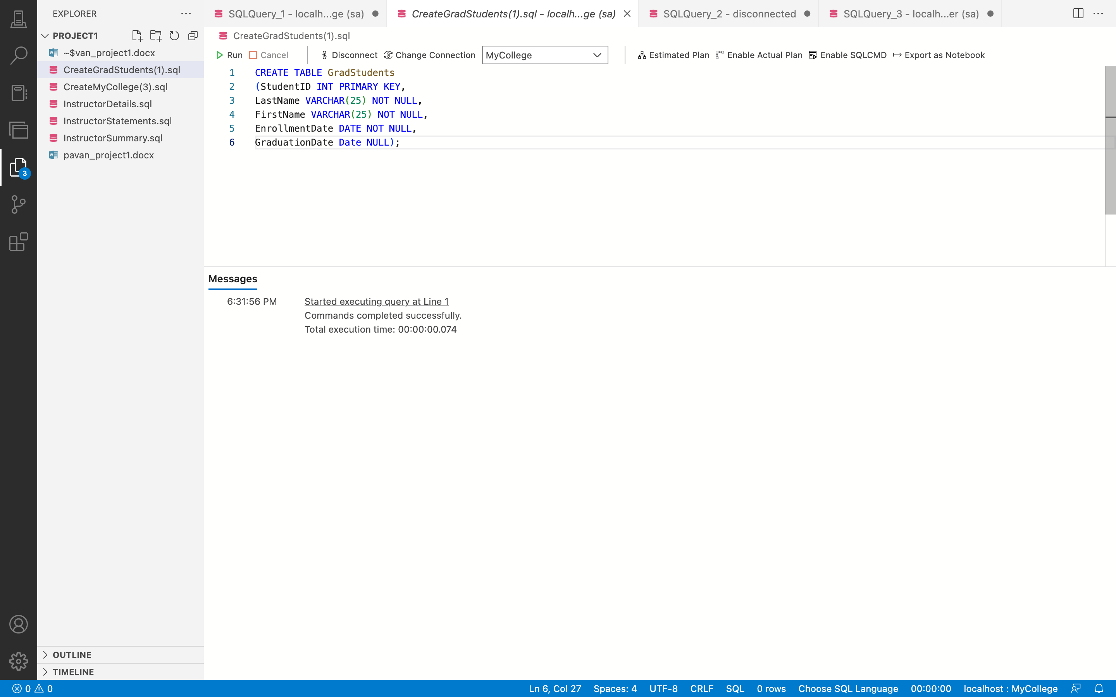

1. Write an INSERT statement that inserts rows from the Students table into the GradStudents table. Include only the rows for students that have graduated, and don’t use a column list.

**Answer 23: -**

**Query: -**

Select * From Students Where GraduationDate Is Not Null;

**Output: -**

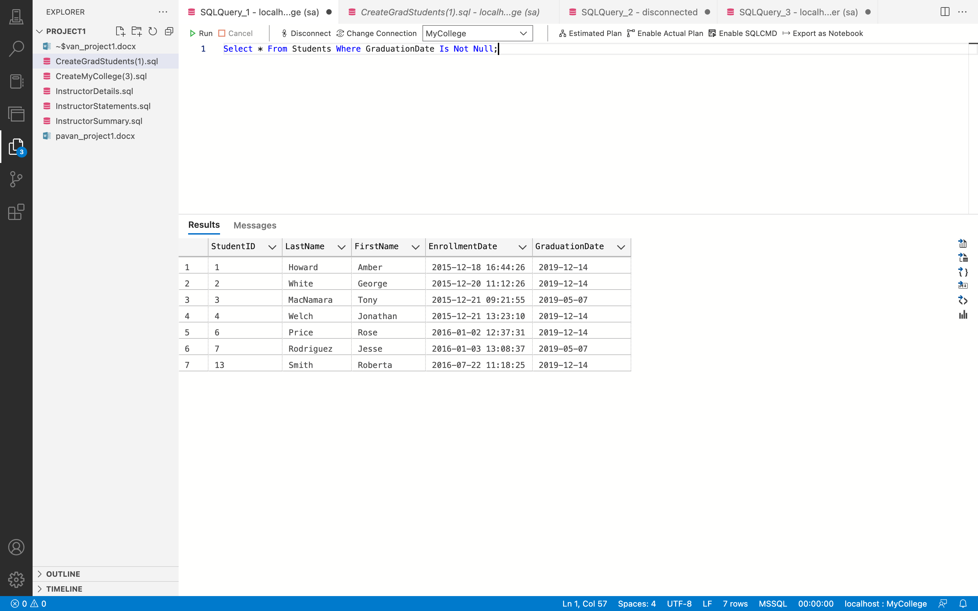

**Query: -**

Insert Into GradStudents Select * From Students Where GraduationDate Is Not Null;

**Output: -**

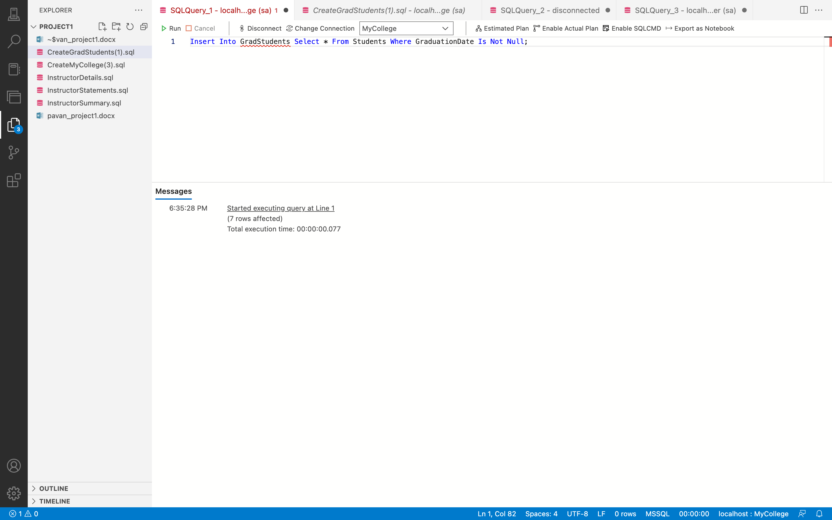

**Query: -**

Select * From GradStudents;

**Output: -**

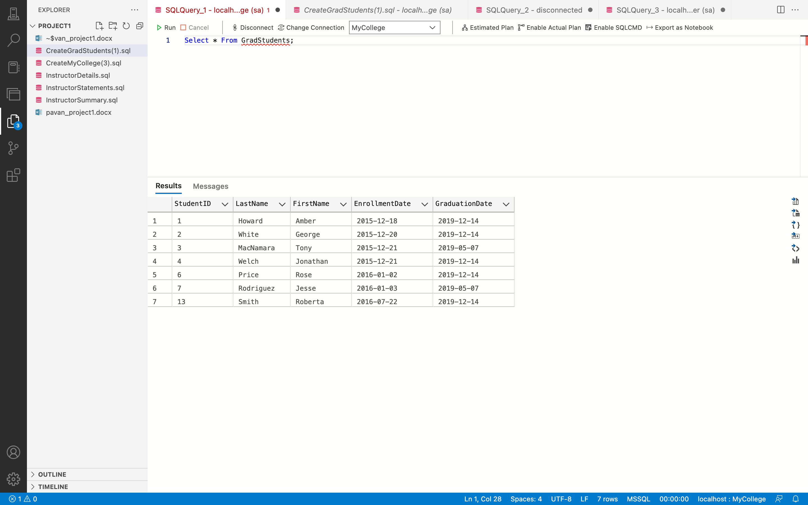

**Remarks: -**

* In this query, the rows are first selected using the SELECT statement from the Students table, and then they are added to the GradStudents table using the INSERT INTO command.
* The Select command selects the records from the Students table that have a GraduationDate that is not NULL.
* You can see all the code and the output above in the given screenshot.

1. Open the script named CreateMyCollege.sql. Then, run this script. That should restore the data that’s in the database. If an error message is displayed indicating that the database is in use, you’ll need to close and restart the Management Studio and then run the script again.

**Answer 24: -**

**Output: -**

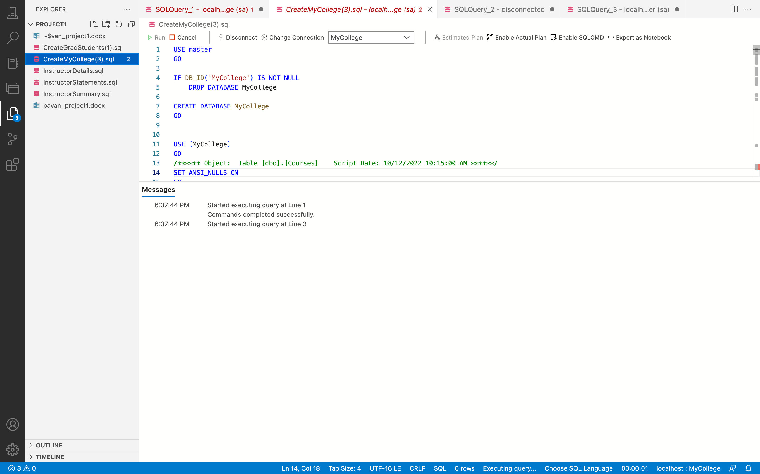

**Remarks: -**

* Close and restart SQL Server Management Studio, then launch the CreateMyCollege.sql script.
* The original version of the database will be restored by running this script.
* You can see all the code and the output above in the given screenshot.

1. Write a SELECT statement that returns these colums from the Students table:

● A column that uses the CONVERT function to return the EnrollmentDate column in this format: MM/DD/YYYY. In other words, use 2-digit months and days and a 4-digit year, and separate each date component with slashes.

● A column that uses the CONVERT function to return the EnrollmentDate column with the date, and the hours and minutes on a 12-hour clock with an am/pm indicator. ● A column that uses the CONVERT function to return the EnrollmentDate column with just the time in a 24-hour format, including the milliseconds.

● A column that uses the CONVERT function to return the EnrollmentDate column with just the month and day.

**Answer 25: -**

**Query: -**

Select Convert(VARCHAR, EnrollmentDate, 101) As 'Date', Convert(VARCHAR,

EnrollmentDate, 9) As 'EnrollementDate', Convert(VARCHAR, EnrollmentDate, 114) As

'EnrollemtDatewith24hrfor.', Convert(VARCHAR(5), EnrollmentDate, 101) As

'EnrollmentMonth&Day'From Students;

**Output: -**

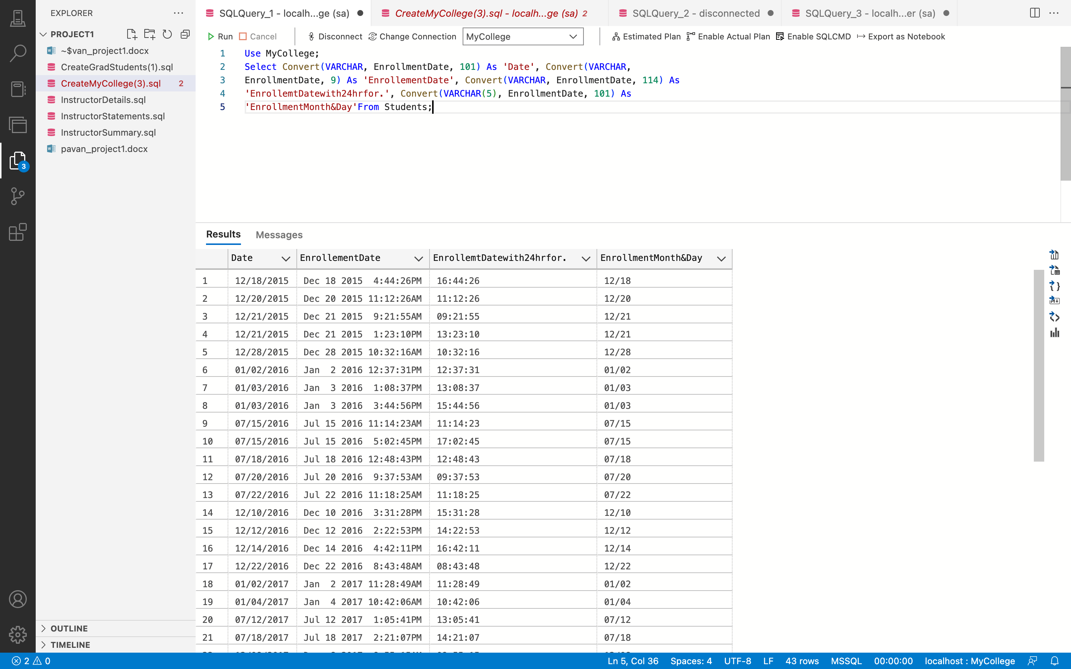

**Remarks: -**

Select statement is used in this case to select the column EnrollmentDate and run the

CONVERT() function. The CONVERT() function is used in the first column to convert the

EnrollmentDate datatype to VARCHAR and format style 101 is used to display it in

MM/DD/YYYY format.

● The CONVERT() method is used in the second column to convert EnrollmentDate to

VARCHAR datatype and format style 9 to display it in 12 hour date format.

● The CONVERT() function is used in the third column to convert the datatype of the

EnrollmentDate column to VARCHAR and set the format style to 114 to display it in 24-hour format.

● The CONVERT() function was used in the fourth column to convert the datatype of the

EnrollmentDate column to VARCHAR(5) and format style 101 to display it in MM/DD/YYYY format, and the VARCHAR(5) displays.

* You can see all the code and the output above in the given screenshot.

Section: C

Advanced SQL Skills

(views/stores procedures/ functions / scripts/triggers)

1. Create a view named DepartmentInstructors that returns these columns: the DepartmentName column from the Departments table and the LastName, FirstName, Status, and AnnualSalary columns from the Instructors table.

**Answer 1: -**

**Query: -**

Create View DepartmentInstructors As Select DepartmentName, LastName, FirstName, Status, AnnualSalary From Departments Join Instructors On Departments.DepartmentID =

Instructors.DepartmentID;

**Output: -**

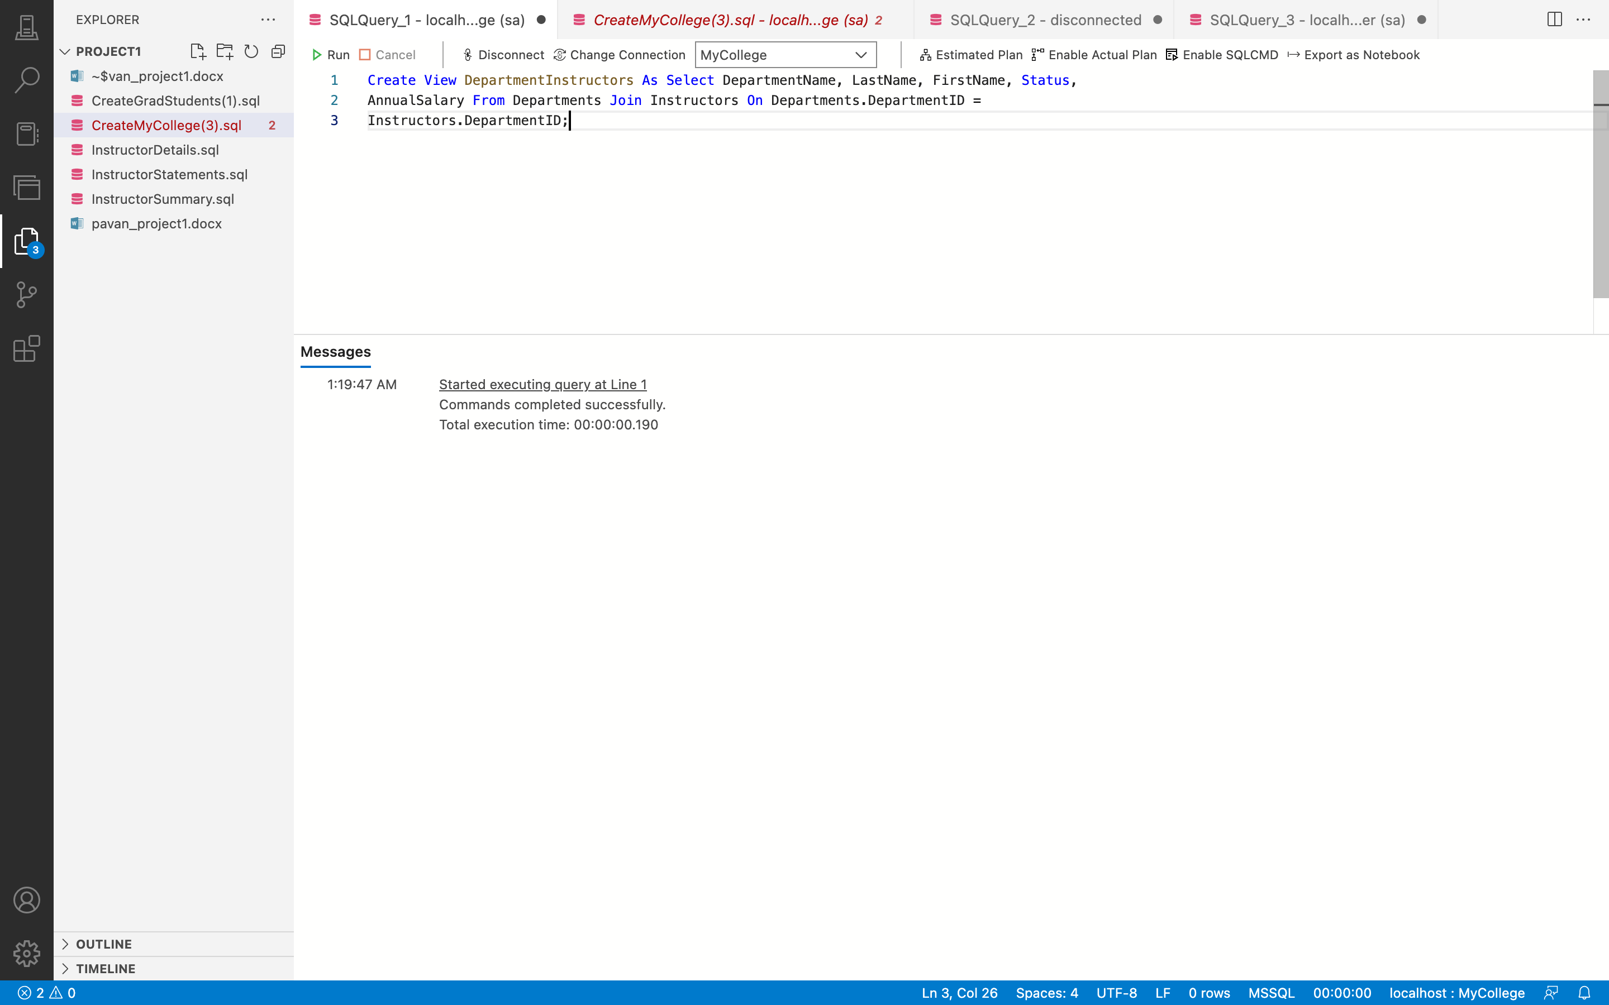

**Remarks: -**

* The Construct VIEW command is used in this case to create a view called DepartmentInstructors.
* This view returns the columns DepartmentName, LastName, FirstName, Status, and

AnnualSalary.

* This is accomplished through the use of a SELECT statement that retrieves these

columns from the Departments and Instructors tables through the JOIN keyword on the DepartmentID column.

* You can see all the code and the output above in the given screenshot.

1. Write a SELECT statement that returns all the columns from the DepartmentInstructors view that you created in exercise 1.

**Answer 2: -**

**Query: -**

Select * from DepartmentInstructors;

**Output: -**

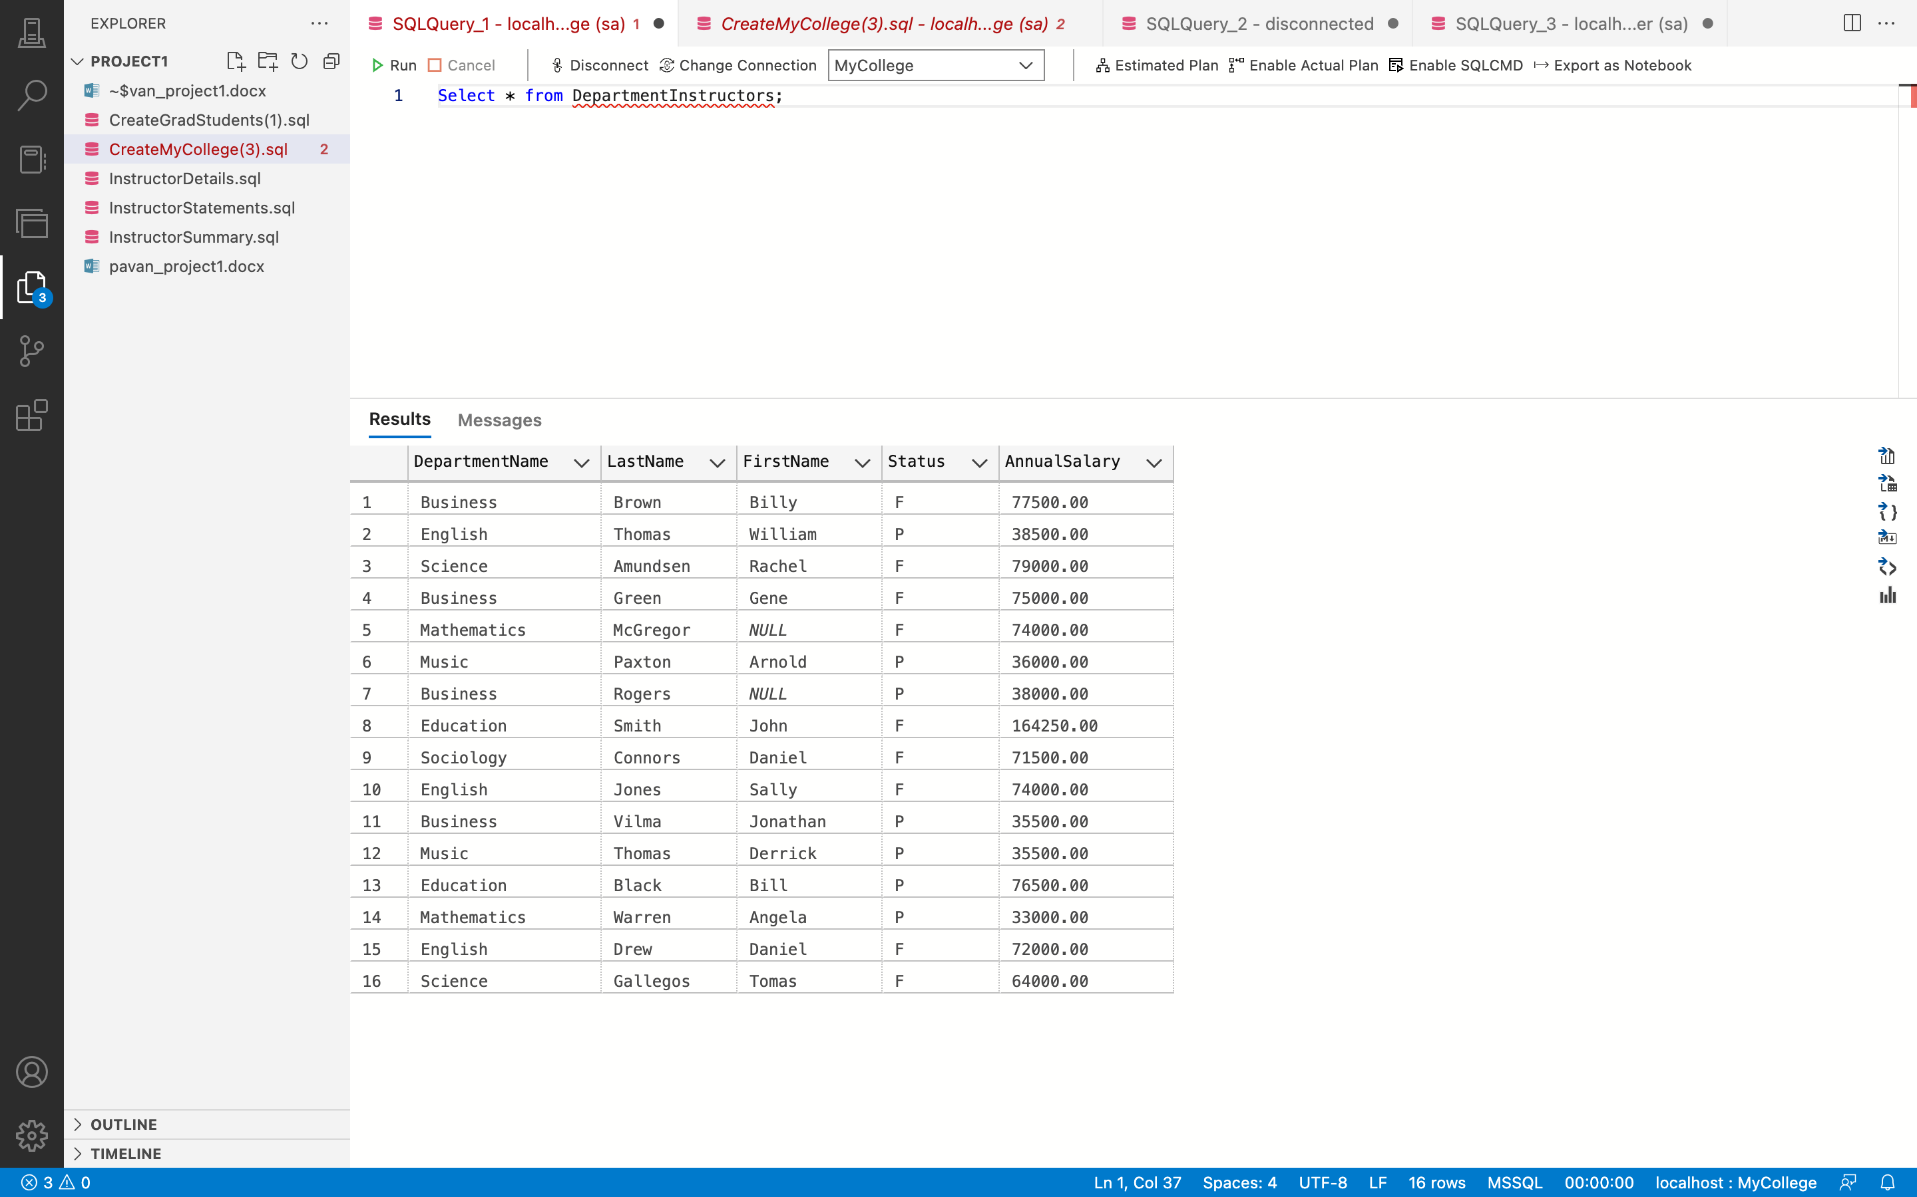

**Remarks: -**

* In this query, the SELECT * command is used to display all of the DepartmentInstructors view's data.
* You can see all the code and the output above in the given screenshot.

1. Return one row for each fulltime instructor in the English department.

**Answer 3: -**

**Query: -**

Select * From DepartmentInstructors Where DepartmentName ='English' And Status = 'F';

**Output: -**

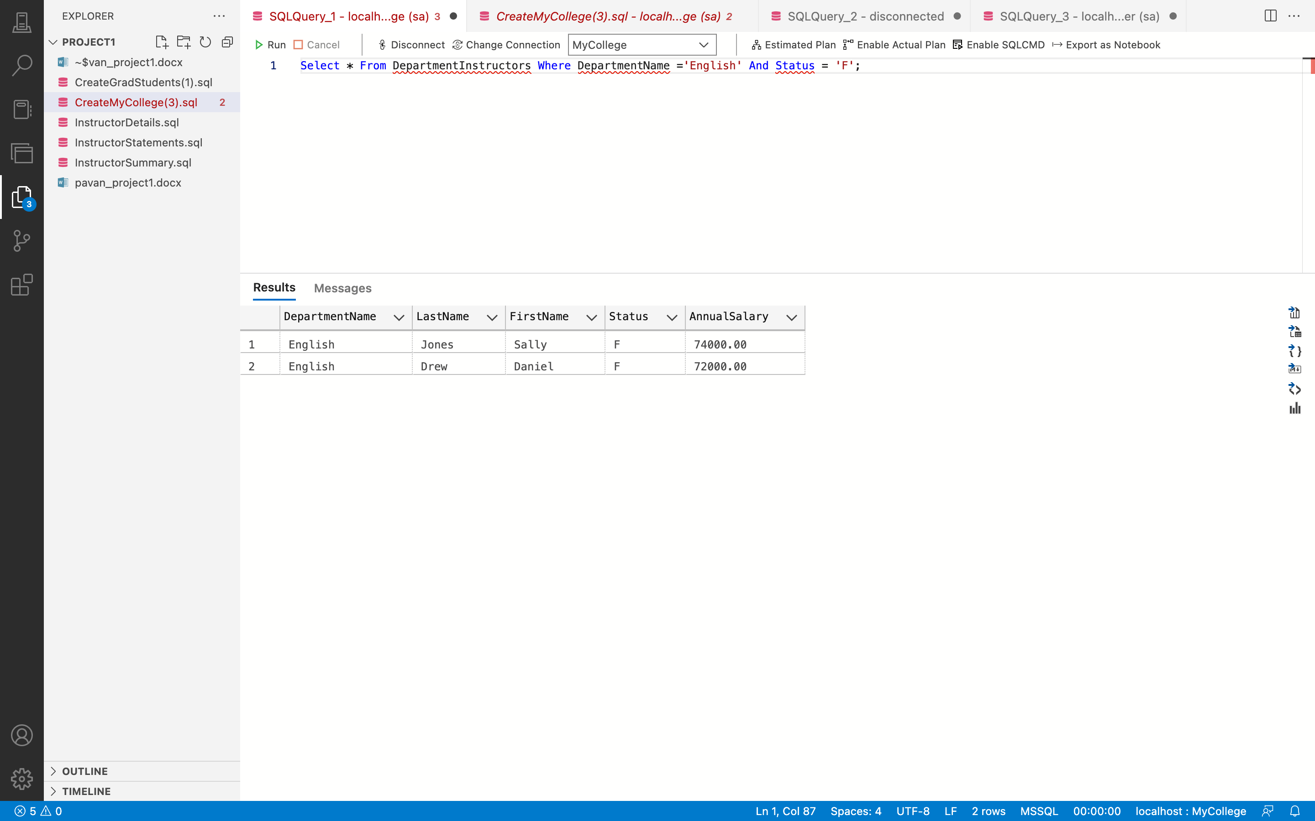

**Remarks: -**

* Here, all of the table's information is selected using the SELECT * statement.
* Filter the DepartmentInstructors view so that the DepartmentName is "English" and the Status is "F" using the WHERE clause.
* You can see all the code and the output above in the given screenshot.

1. Write an UPDATE statement that updates the DepartmentInstructors view you created in exercise 1 so it increases the annual salary for each fulltime instructor in the English department by 10%. Then, run the SELECT statement you wrote in exercise 2 to be sure this worked correctly.

**Answer 4: -**

**Query: -**

Update DepartmentInstructors Set AnnualSalary = AnnualSalary +

(AnnualSalary * 0.1) Where DepartmentName = 'English' And Status = 'F';

**Output: -**

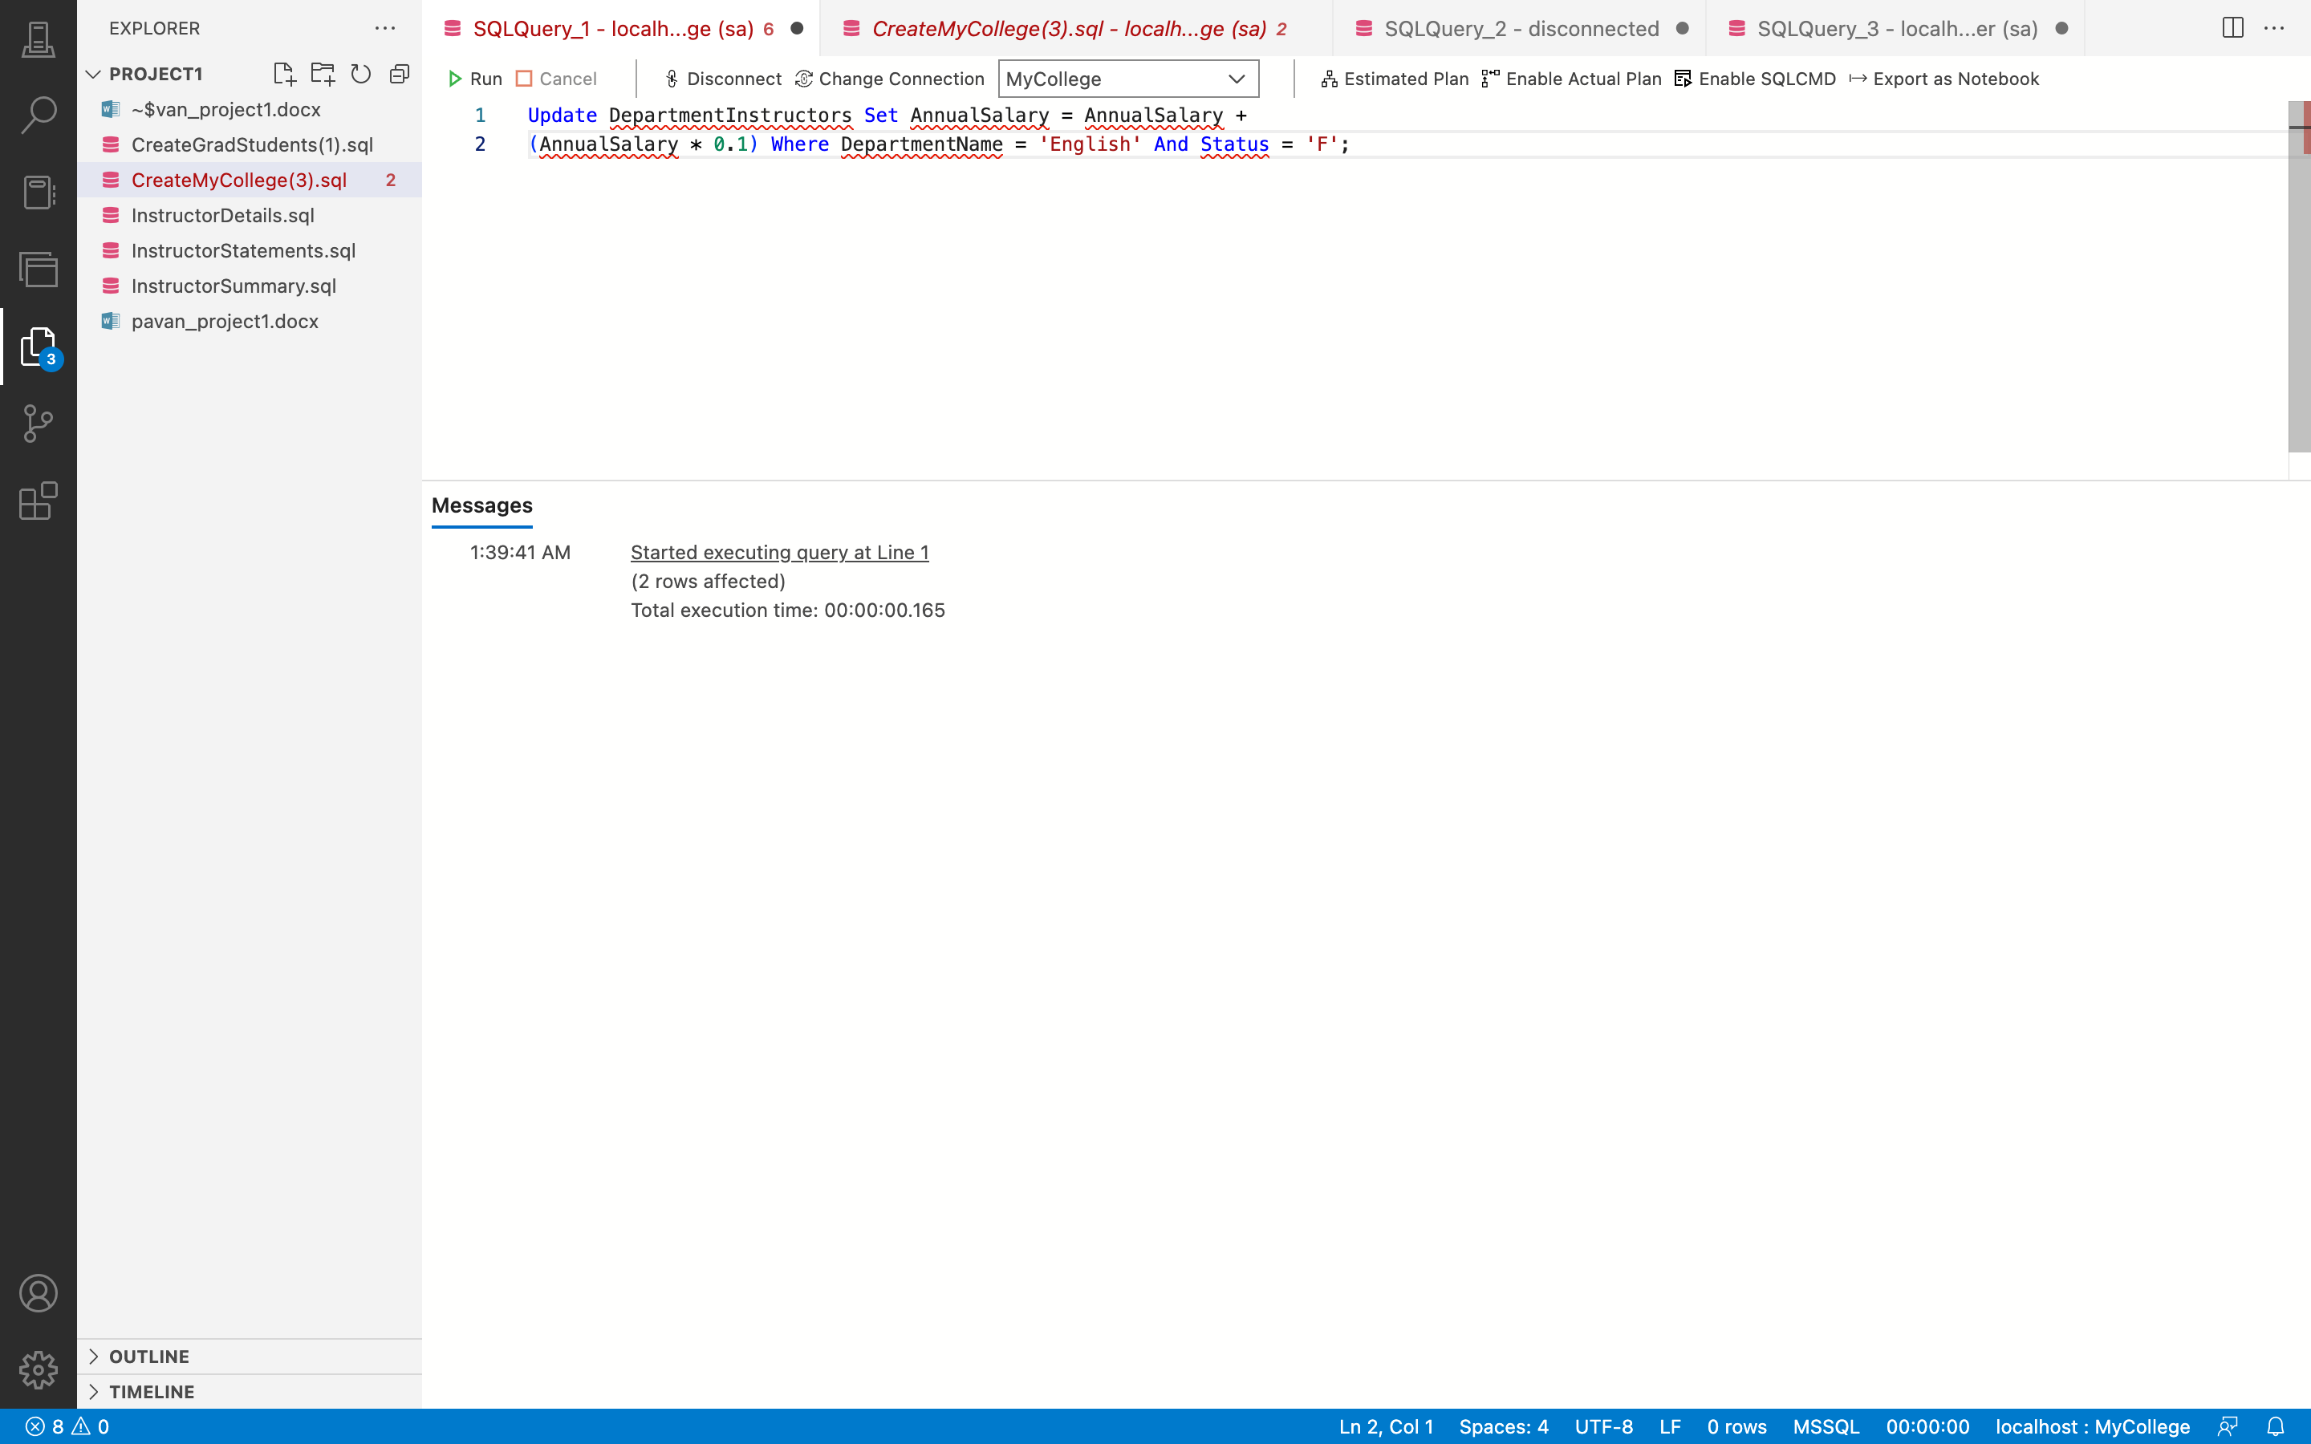

**Query: -**

Select * From DepartmentInstructors Where DepartmentName ='English' And Status = 'F';

**Output: -**

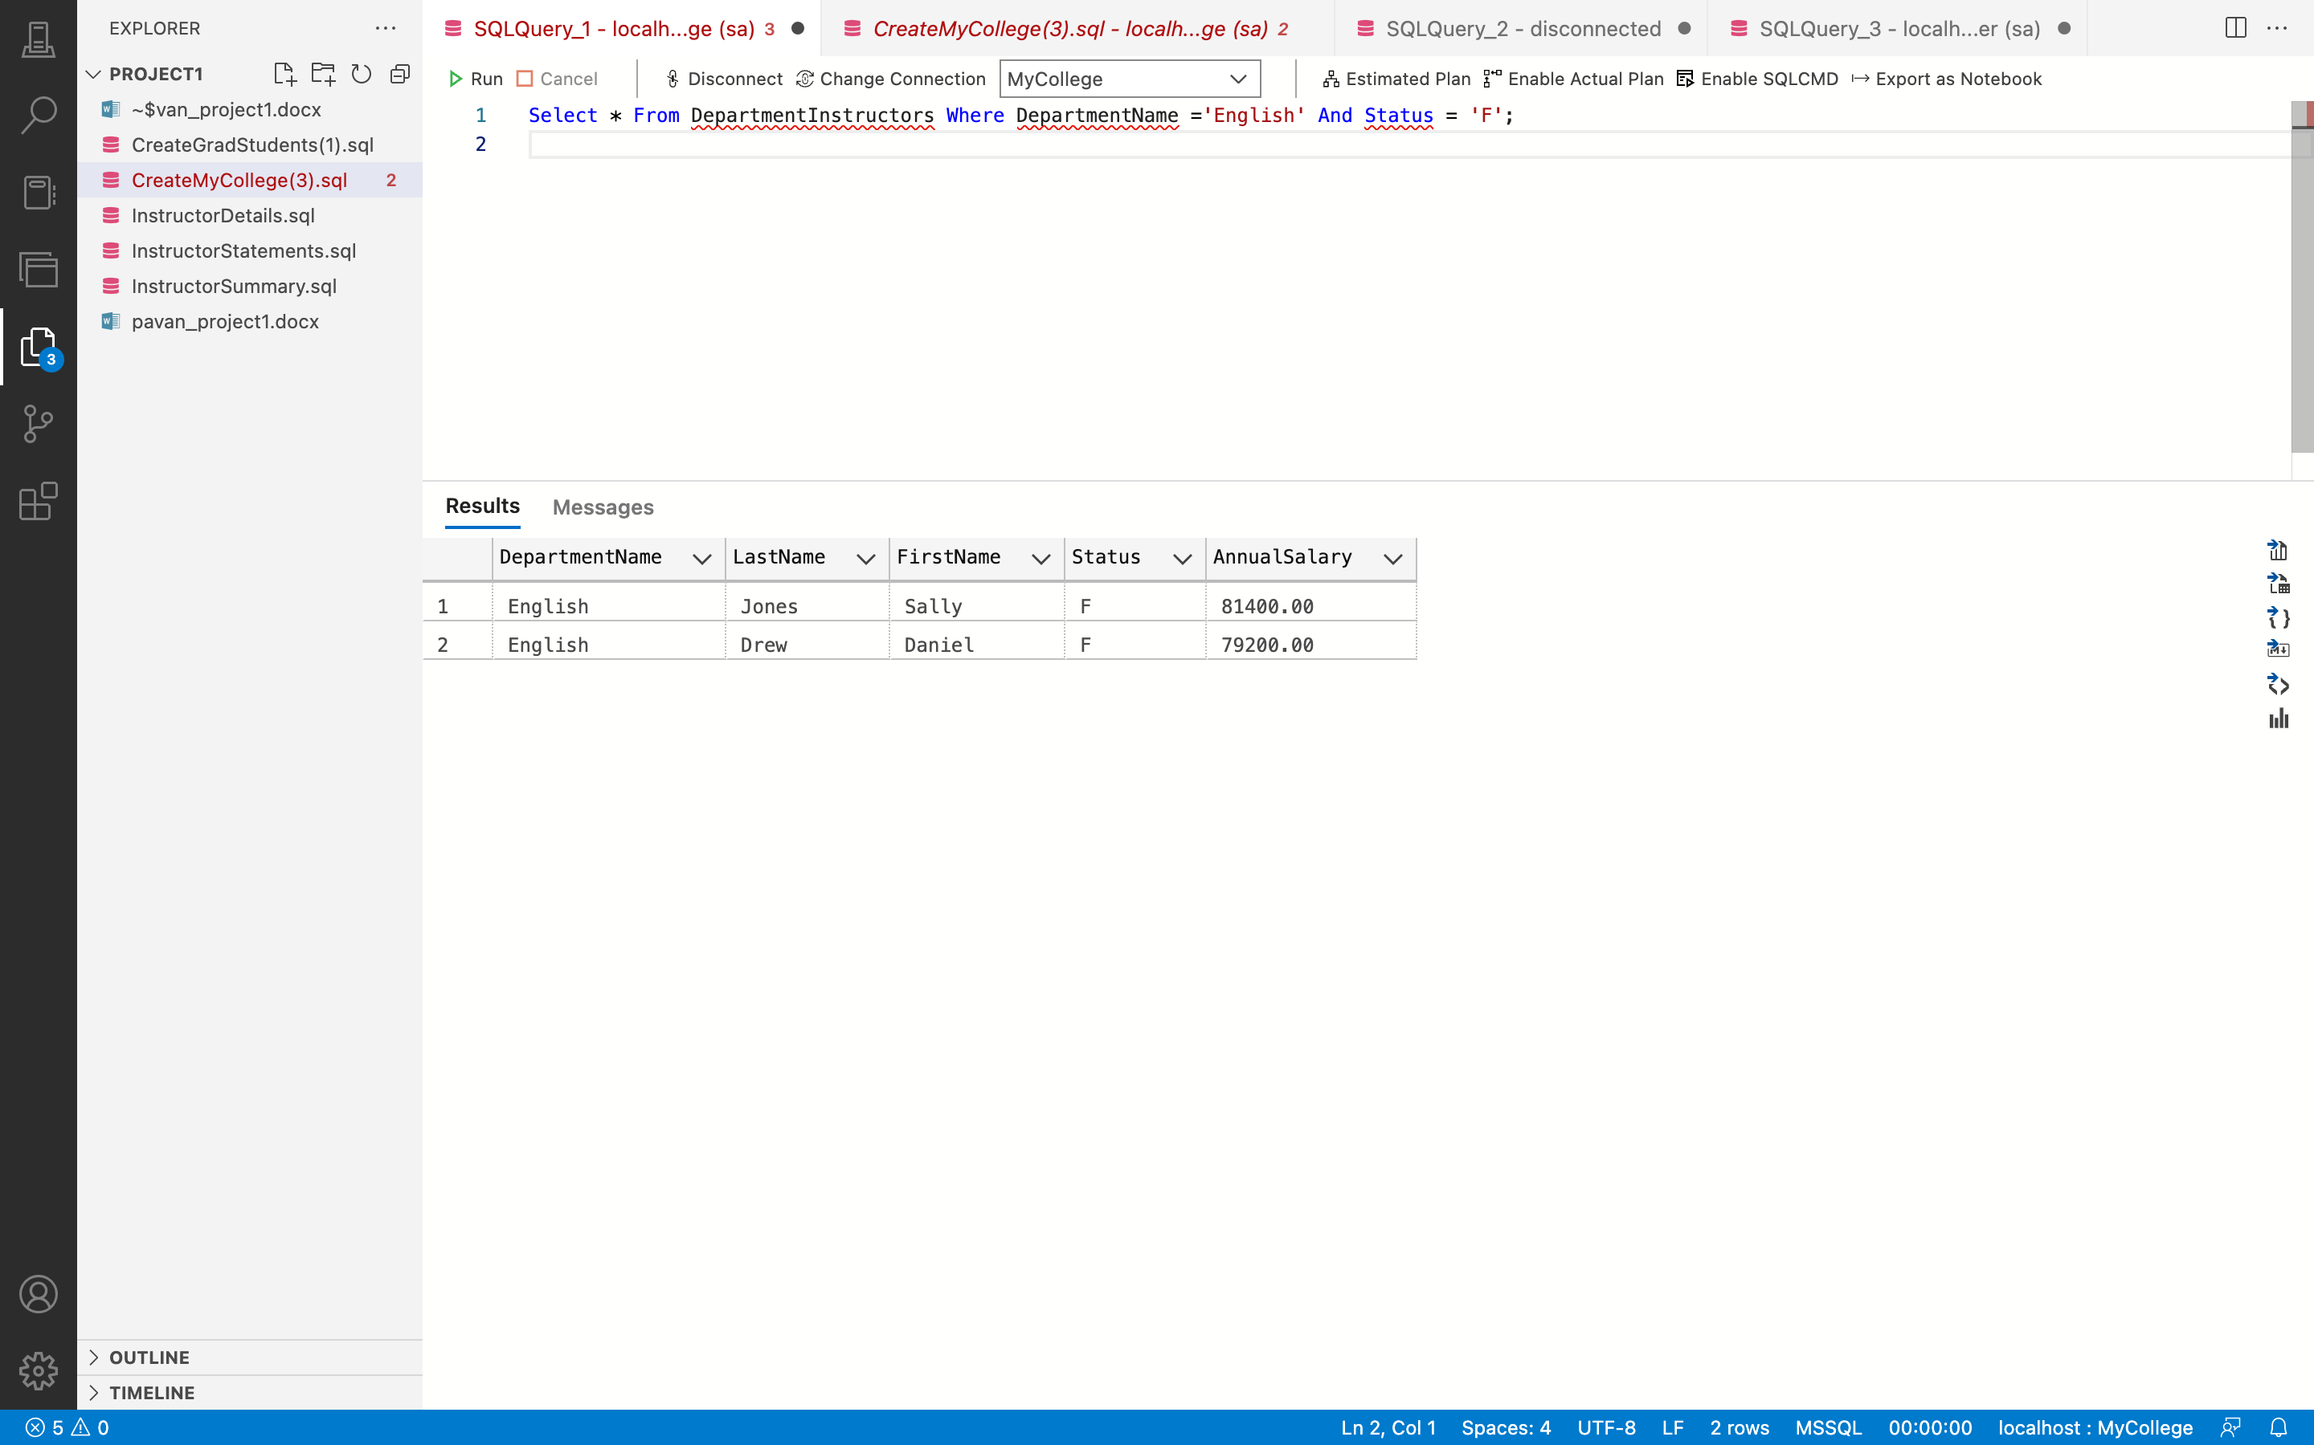

**Remarks: -**

* Using the WHERE clause, the UPDATE statement is used to update the DepartmentInstructors view and increase the AnnualSalary by 10% for entries whose DepartmentName is 'English' and the Status is 'F.'
* You can see all the code and the output above in the given screenshot.

1. Create a view named StudentCoursesMin that returns these columns: the FirstName and LastName from the Students table and the CourseNumber, CourseDescription, and CourseUnits from the Courses table.

**Answer 5: -**

**Query: -**

Create View StudentCoursesMin As Select FirstName, LastName,

CourseNumber, CourseDescription, CourseUnits From Students Join

StudentCourses On Students.StudentID = StudentCourses.StudentID

Join Courses On StudentCourses.CourseID = Courses.CourseID;

**Output: -**

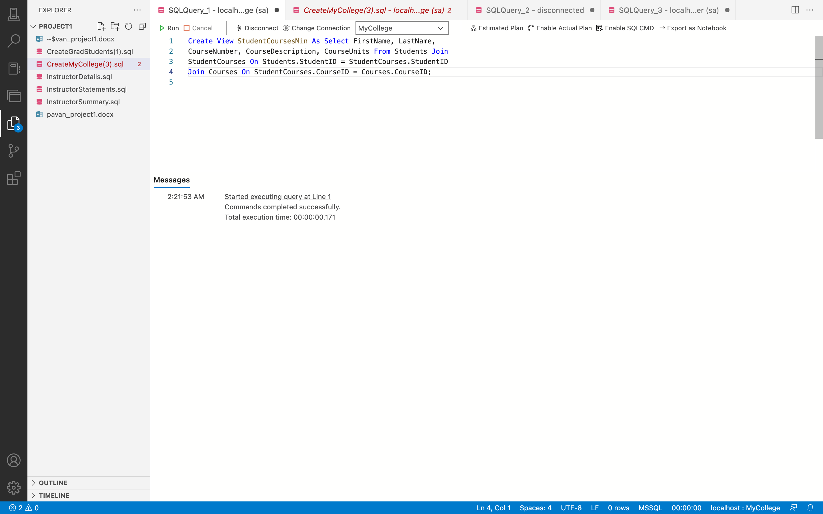

**Query: -**

Select * From StudentCoursesMin;

**Output: -**

**Remarks: -**

* In this instance, a view called StudentCoursesMin is made using the Construct VIEW command.
* The SELECT statement links the Student, StudentCourses, and Courses databases by using the JOIN keyword on the StudentID and CourseID columns to extract the FirstName, LastName, CourseNumber, CourseDescription, and CourseUnits columns.
* You can see all the code and the output above in the given screenshot.

1. Write a script that declares a variable and sets it to the count of all students in the Students table that haven’t graduated. If the count is greater than or equal to 100, the script should display a message that says, “The number of undergrad students is greater than or equal to 100”. Otherwise, it should say, “The number of undergrad students is less than 100”.

**Answer 6: -**

**Query: -**

Use MyCollege;

Declare @TotalNotGraduated Int;

Set @TotalNotGraduated = (Select Count(StudentID) From Students Where GraduationDate Is Null);

If @TotalNotGraduated >= 100

Print 'The number of undergrad students is greater than or equal to 100';

Else --@TotalNotGraduated < 100

Print 'The number of undergrad students is less than 100';

**Output: -**

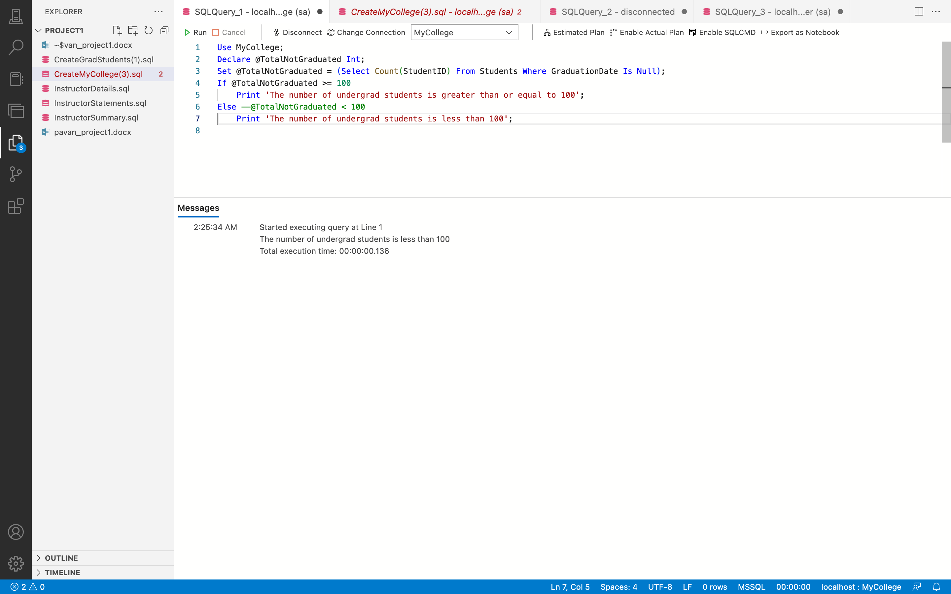

**Remarks: -**

* In order to conduct the query in the MyCollege database, USE MyCollege is used to access the MyCollege database.
* A variable after the (@) symbol is declared using the DECLARE statement.
* The datatype of the variable is also mentioned. A variable that has been declared with the DECLARE statement is given a value using the SELECT command. NotGraduated was a variable declared using the DECLARE declaration and datatype.
* When GraduationDate IS NULL, the COUNT() aggregate function and WHERE clause are used to assign the variable the count of the students from the Students database.
* Printing messages requires the usage of the IF...ELSE statement. Print "The number of undergrad students is more than or equal to 100" if NotGraduated is greater than or equal to 100.
* You can see all the code and the output above in the given screenshot.

1. Write a script that uses two variables to store (1) the count of all of the instructors in the Instructors table and (2) the average annual salary for those instructors. If the instructor count is greater than or equal to 10, the script should print a message that displays the values of both variables. Otherwise, the script should print a message that says, “The number of fulltime instructors is less than 10”.

**Answer 7: -**

**Query: -**

Use MyCollege;

Declare @TotalInsructors Int;

Declare @AvgAnnualSalary Money;

Set @TotalInsructors = (Select Count(InstructorID) From Instructors);

Set @AvgAnnualSalary = (Select Avg(AnnualSalary) From Instructors);

If @TotalInsructors >= 10

Print 'Total number of instructors : ' + Convert(varchar,@TotalInsructors, 3) + ' And Avg

of their Annual Salary : '+ Convert(varchar, @AvgAnnualSalary, 4);

Else --@TotalInsructors < 10

Print 'The number of fulltime instructors is less than 10';

**Output: -**

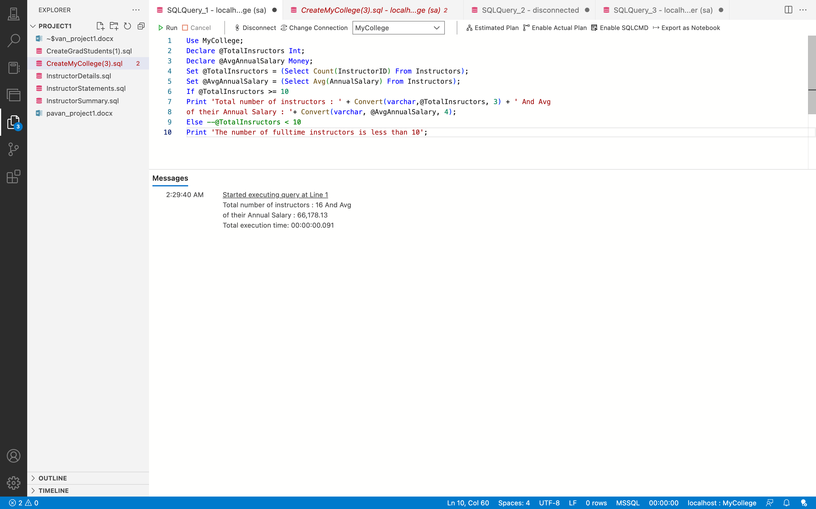

**Remarks: -**

* To access the MyCollege database and do a query within it, use the USE MyCollege command.
* A variable after the (@) symbol is declared using the DECLARE statement.
* The datatype of the variable is also mentioned. The SELECT statement is used to assign a value to a variable that has been declared with the DECLARE statement, in this case, the DECLARE statement is used to declare two variables: NoOfInstructors with an int datatype and AvgAnnualSalary with a money datatype.
* The AVG() aggregate function is used in a SELECT query to assign the average of the AnnualSalary obtained from the Instructors database.
* The messages are printed using the IF...ELSE phrase.
* Use the CONVERT() function to print a message displaying the values of both variables if the NoOfInstructors variable is more than or equal to 10.
* If not, print the message "There are less than 10 full-time teachers."
* You can see all the code and the output above in the given screenshot.

1. Write a script that attempts to delete the department with the name ‘Sociology’ from the

Departments table.If the delete is successful, the script should display this message:

SUCCESS: Record was deleted.

If the delete is unsuccessful, the script should display a message something like this:

FAILURE: Record was not deleted.

Error 547: The DELETE statement conflicted with the REFERENCE constraint

"FK__Instructo__Depar__267ABA7A".The conflict occurred.

**Answer 8: -**

**Query: -**

Begin Try

Begin Transaction

Delete From Departments

Where DepartmentName= 'Sociology'

Print 'SUCCESS: Record was deleted.'

Commit Transaction

End Try

Begin Catch

Rollback Transaction

Print 'FAILURE: Record was not deleted.'

Print 'Error 547: ' + ERROR_MESSAGE()

End Catch;

**Output: -**

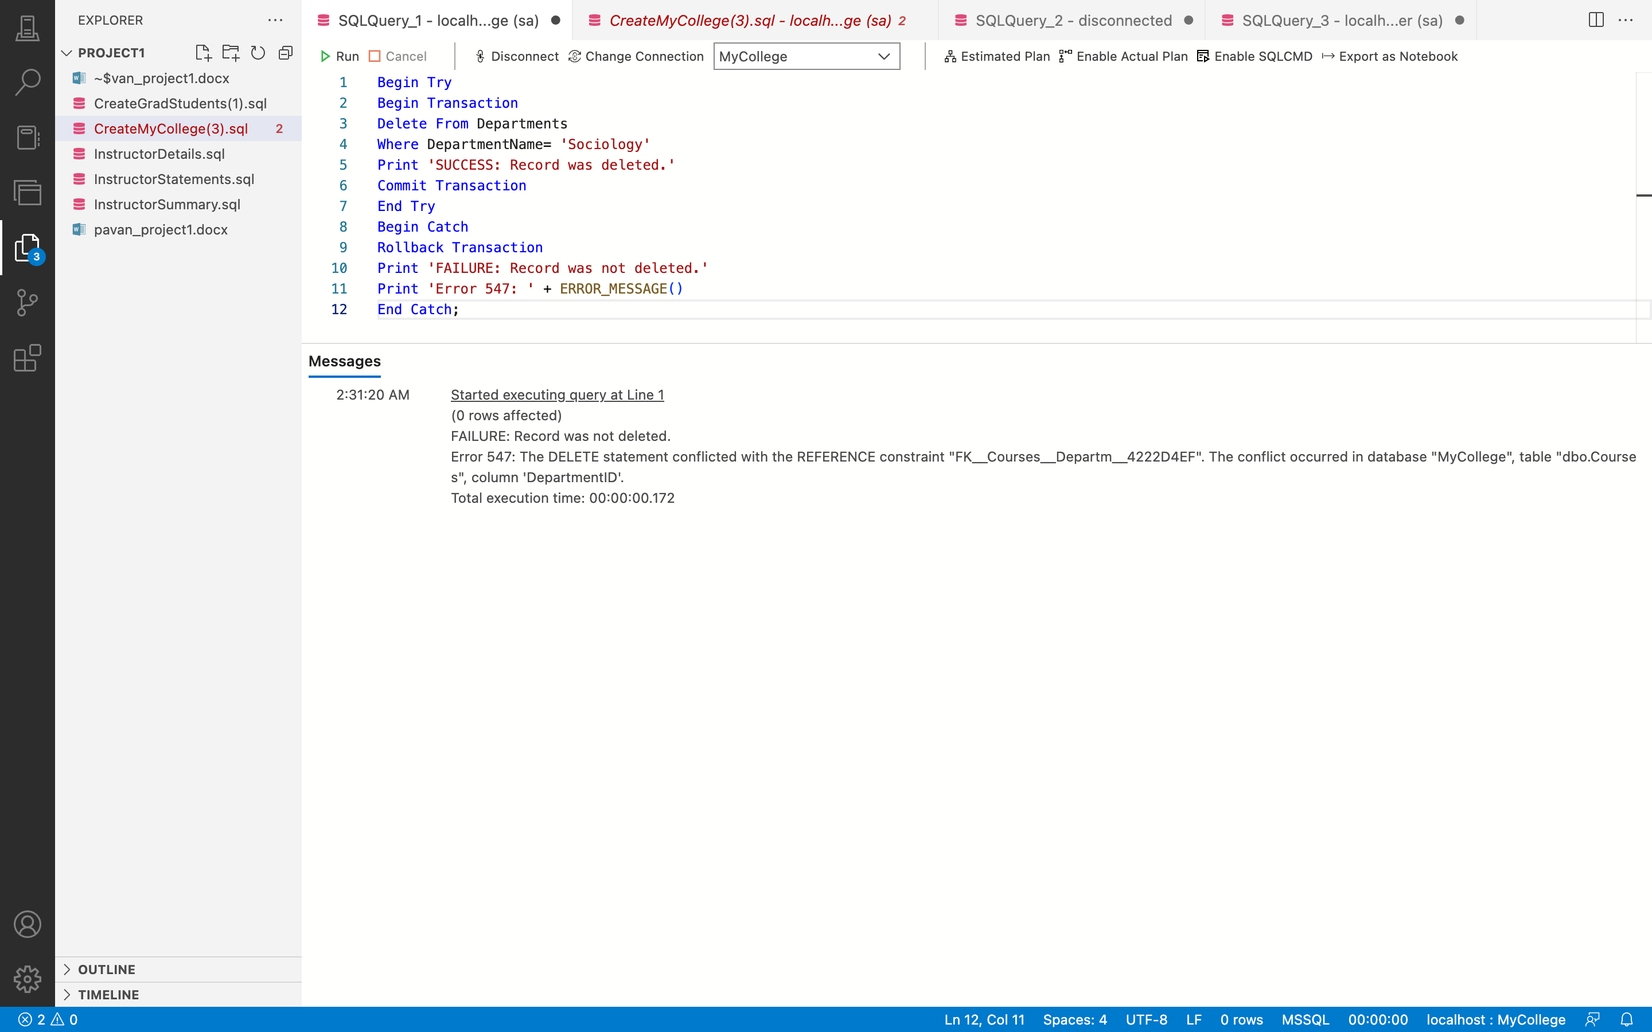

**Remarks: -**

* Here, the BEGIN TRY...END TRY block serves as a representation of the try block. GET THE DEAL DONE...
* When a transaction starts and successfully completes, it is committed using the COMMIT TRANSACTION block.
* In order to successfully delete records with the DepartmentName "Sociology," a DELETE FROM statement is added inside this block. As a result, the transaction is committed and the message "SUCCESS: Record Was Deleted" is printed.
* If deletion fails due to an error, the transaction is undone and the message "FAILURE: Record was not destroyed." is written. This is followed by the ERROR MESSAGE() method, which is used to return the proper error message for the mistake that occurred.
* You can see all the code and the output above in the given screenshot.

1. Write a script that creates and calls a function named fnStudentUnits that calculates the total course units of a student in the StudentCourses table. To do that, this function should accept one parameter for the student ID, and it should return the sum of the course units for the student.

**Answer 9: -**

**Query: -**

Create Function fnStudentUnits

(

@studentID Int

)

Returns Int

As

Begin

Declare @totalUnits Int

Set @totalUnits = 0

Select @totalUnits = Sum(CourseUnits) From StudentCourses sc Inner Join Students s On s.StudentID = sc.StudentID

Inner Join Courses c ON c.CourseID = sc.CourseID;

Return @totalUnits

End

Go

**Output: -**

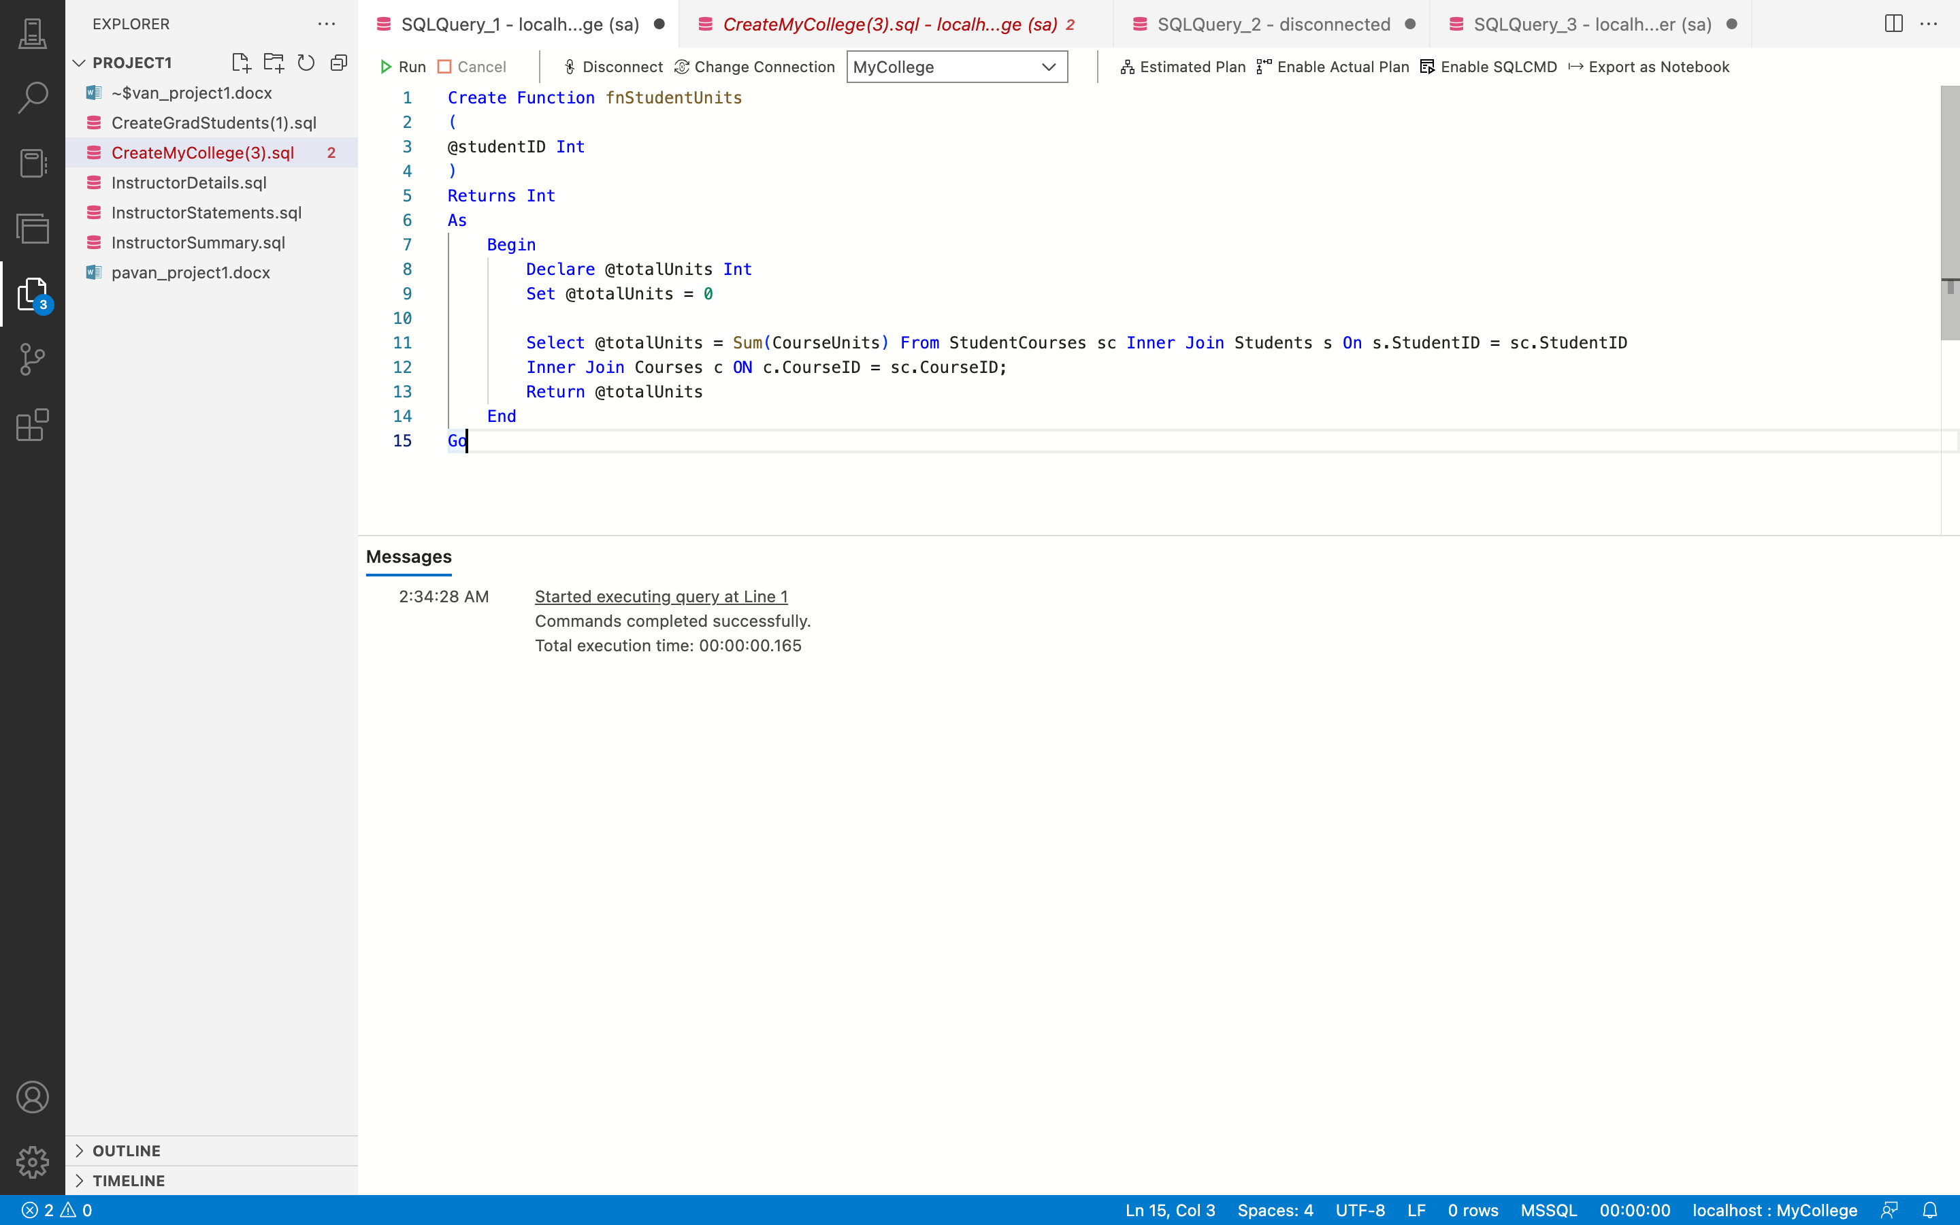

**Remarks: -**

* With the CREATE FUNCTION command, a function called fnStudentUnits is created, returning an int value and taking an int type parameter called @StudentID.
* The variable @NoOfUnits has the datatype int and a value of 0. Data from StudentCourses, Students, and Courses tables on StudetID and CourseID, whose NoOfUnits is the sum of CourseUnits computed using the SUM() aggregation function, are selected using the Select statement.
* You can see all the code and the output above in the given screenshot.

1. The SELECT statement that calls the function should return the StudentID from the StudentCourses table, the CourseNumber and CourseUnits from the Courses table, and the value return by the fnStudentUnits function for that student.

**Answer 10: -**

**Query: -**

Select StudentID, C.CourseID, CourseUnits, MyCollege.dbo.fnStudentUnits (StudentID) AS 'TotalUnits'

From StudentCourses SC Inner Join Courses C ON C.CourseID = SC.CourseID;

**Output: -**

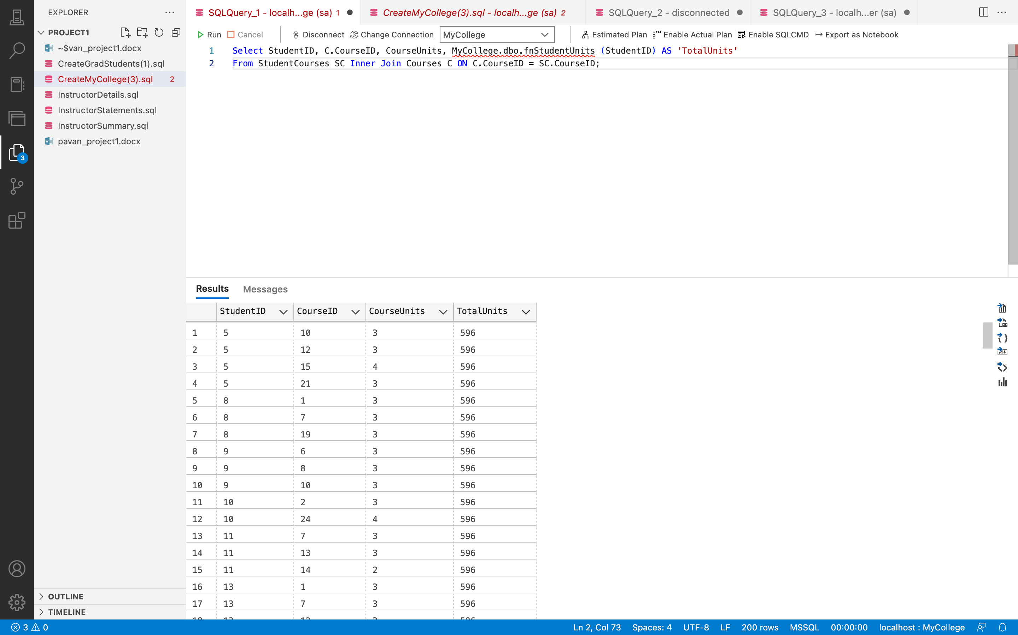

**Remarks: -**

* The SELECT statement is used in this case to select the StudentID, CourseID,

CourseUnits, and the StudentID returned by the function fnStudentUnits from the

StudentCourses and Courses database using the JOIN keyword on the CourseID column.

* You can see all the code and the output above in the given screenshot.

1. Write a script that creates and calls a stored procedure named spUpdateInstructor that updates the AnnualSalary column in the Instructors table. This procedure should have one parameter for the instructor ID and another for the annual salary. If the value for the AnnualSalary column is a negative number, the stored procedure should raise an error that indicates that the value for this column must be a positive number. Code at least two EXEC statements that test this procedure.

**Answer 11: -**

**Query: -**

create procedure spUpdateInstructor

@InstructorID int,

@AnnualSalary decimal (10, 2)

as

begin

if @AnnualSalary < 0

begin

raiserror('The annual salary must be a positive number.', 16, 1)

return

end

update Instructors

set AnnualSalary = @AnnualSalary

where InstructorID = @InstructorID

end

**Output: -**

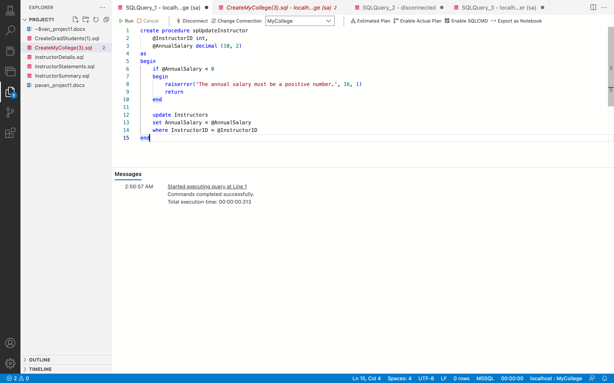

**Remarks: -**

* The given query creates a stored procedure named spUpdateInstructor that updates the AnnualSalary column in the Instructors table. This procedure accepts two parameters, @InstructorID for the instructor ID and @AnnualSalary for the new annual salary.
* Inside the stored procedure, there is a check to ensure that the value for @AnnualSalary is not negative. If it is negative, the procedure raises an error message and stops the execution of the stored procedure.
* If the value for @AnnualSalary is positive, the procedure updates the AnnualSalary column in the Instructors table with the new value for the given @InstructorID.
* The script also includes two EXEC statements to test the stored procedure with positive and negative values for the @AnnualSalary parameter.
* You can see all the code and the output above in the given screenshot.

1. Create a trigger named Instructors_UPDATE that checks the new value for the AnnualSalary column of the Instructors table. This trigger should raise an appropriate error if the annual salary is greater than 120,000 or less than 0. If the new annual salary is between 0 and 12,000, this trigger should modify the new annual salary by multiplying it by 12. That way, a monthly salary of 5,000 becomes an annual salary of 60,000. Test this trigger with an appropriate UPDATE statement.

**Answer 12: -**

**Query: -**

CREATE TRIGGER Instructor_UPDATE

ON Instructors

AFTER UPDATE

AS

BEGIN

IF EXISTS (SELECT * FROM inserted WHERE AnnualSalary>120000 OR AnnualSalary<0)

BEGIN

RAISERROR('AnnualSalary must be between 0 and 120,000.', 16, 1)

ROLLBACK TRANSACTION

RETURN

END

UPDATE Instructors

SET AnnualSalary = inserted.AnnualSalary * 12

FROM Instructors

INNER JOIN inserted ON Instructors.InstructorID = inserted.InstructorID

WHERE inserted.AnnualSalary >= 0 AND inserted.AnnualSalary <= 120000

END

**Output: -**

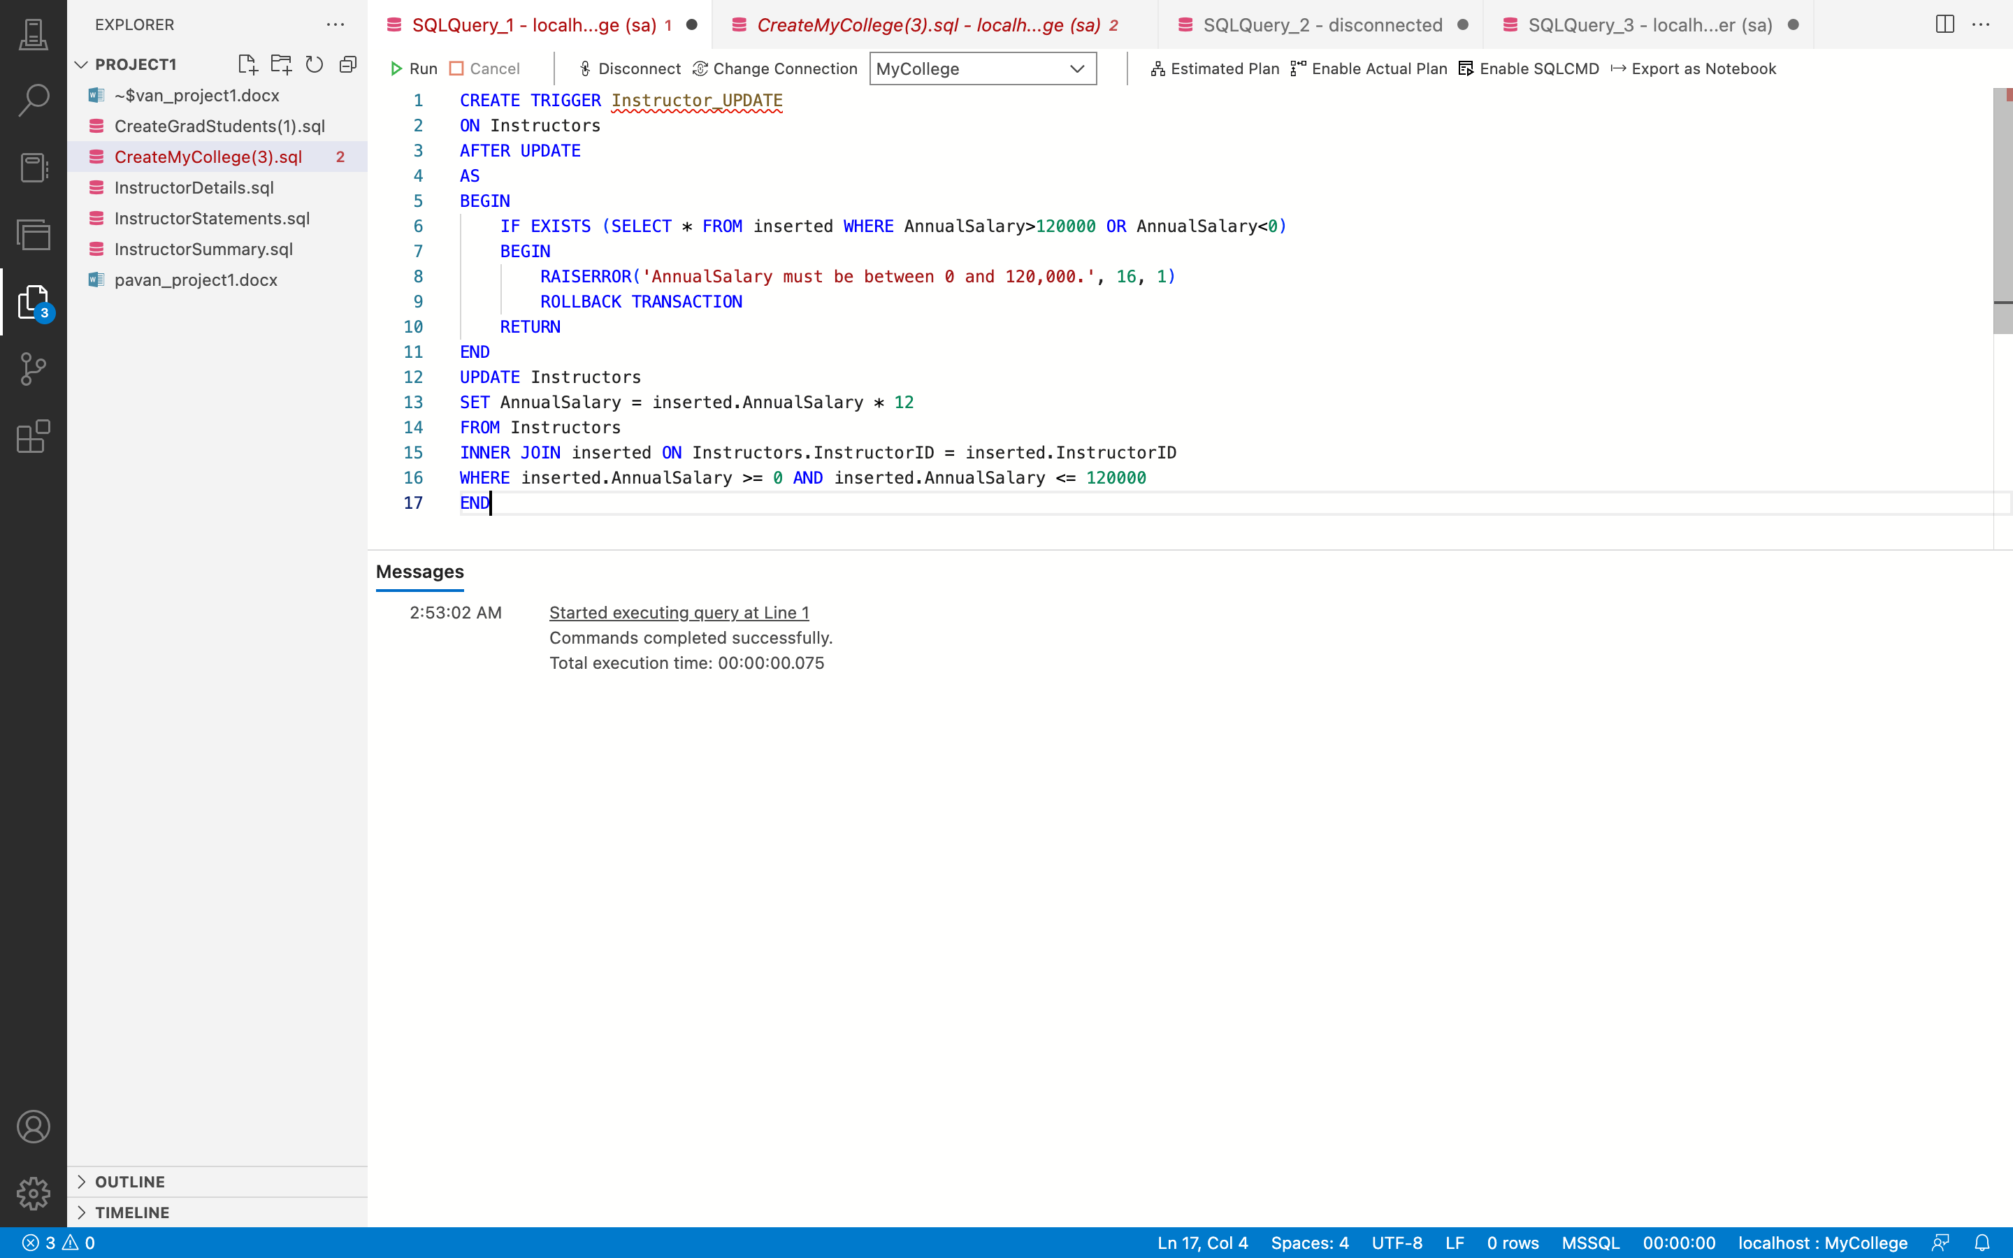

**Remarks: -**

* This is a SQL query that creates a trigger named "Instructors_UPDATE" on the "Instructors" table. The trigger is set to check the new value of the "AnnualSalary" column after an update is performed on the table.
* If the new value of the "AnnualSalary" column is greater than 120,000 or less than 0, an error message is raised, and the transaction is rolled back. If the new value of "AnnualSalary" is between 0 and 120,000, the trigger modifies the value by multiplying it by 12 to convert monthly salary to annual salary.
* This trigger is designed to ensure that the "AnnualSalary" column of the "Instructors" table remains within a specified range, and it helps to maintain data accuracy and consistency. The trigger is tested with an appropriate UPDATE statement to ensure that it works as intended.
* You can see all the code and the output above in the given screenshot.

1. Create a trigger named Instructors_INSERT that inserts the current date for the HireDate column of the Instructors table if the value for that column is null. Test this trigger with an appropriate INSERT statement.

**Answer 13: -**

**Query: -**

CREATE TRIGGER Instructors_INSERT

ON Instructors

AFTER INSERT

AS

BEGIN

UPDATE Instructors

SET HireDate = GETDATE()

FROM Instructors

INNER JOIN inserted ON Instructors.InstructorID = inserted.InstructorID

WHERE inserted.HireDate IS NULL

END

**Output: -**

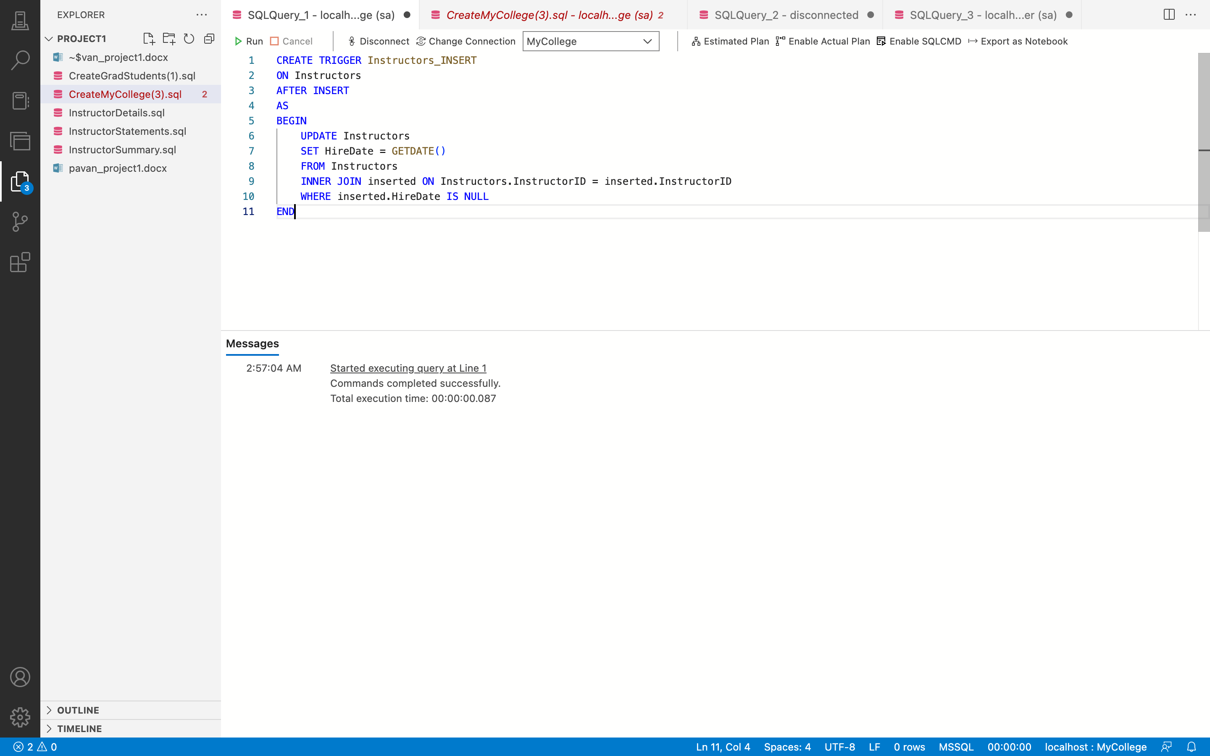

**Remarks: -**

* This query creates a trigger named "Instructors_INSERT" on the "Instructors" table. The trigger fires after an INSERT operation is performed on the table.
* The trigger checks if the "HireDate" column of the newly inserted record is null or not. If the "HireDate" is null, the trigger updates the "HireDate" column with the current date using the GETDATE() function.
* This trigger ensures that the "HireDate" column is always populated with a value, and prevents any future issues that may arise due to missing values in this column.
* To test the trigger, an appropriate INSERT statement can be executed on the "Instructors" table, which inserts a new record with null value in the "HireDate" column. The trigger will then automatically update the "HireDate" column with the current date for that record.
* You can see all the code and the output above in the given screenshot.

1. Write a script that includes two SQL statements coded as a transaction to delete the row with a student ID of 10 from the Students table. To do this, you must first delete all courses for that student from the StudentCourses table. If these statements execute successfully, commit the changes. Otherwise, roll back the changes.

**Answer 14: -**

**Query: -**

BEGIN TRANSACTION

BEGIN TRY

DELETE FROM StudentCourses

WHERE StudentID = 10

DELETE FROM Students

WHERE StudentID = 10

COMMIT TRANSACTION

END TRY

BEGIN CATCH

ROLLBACK TRANSACTION

PRINT 'Error occurred - changes rolled back'

END CATCH

**Output: -**

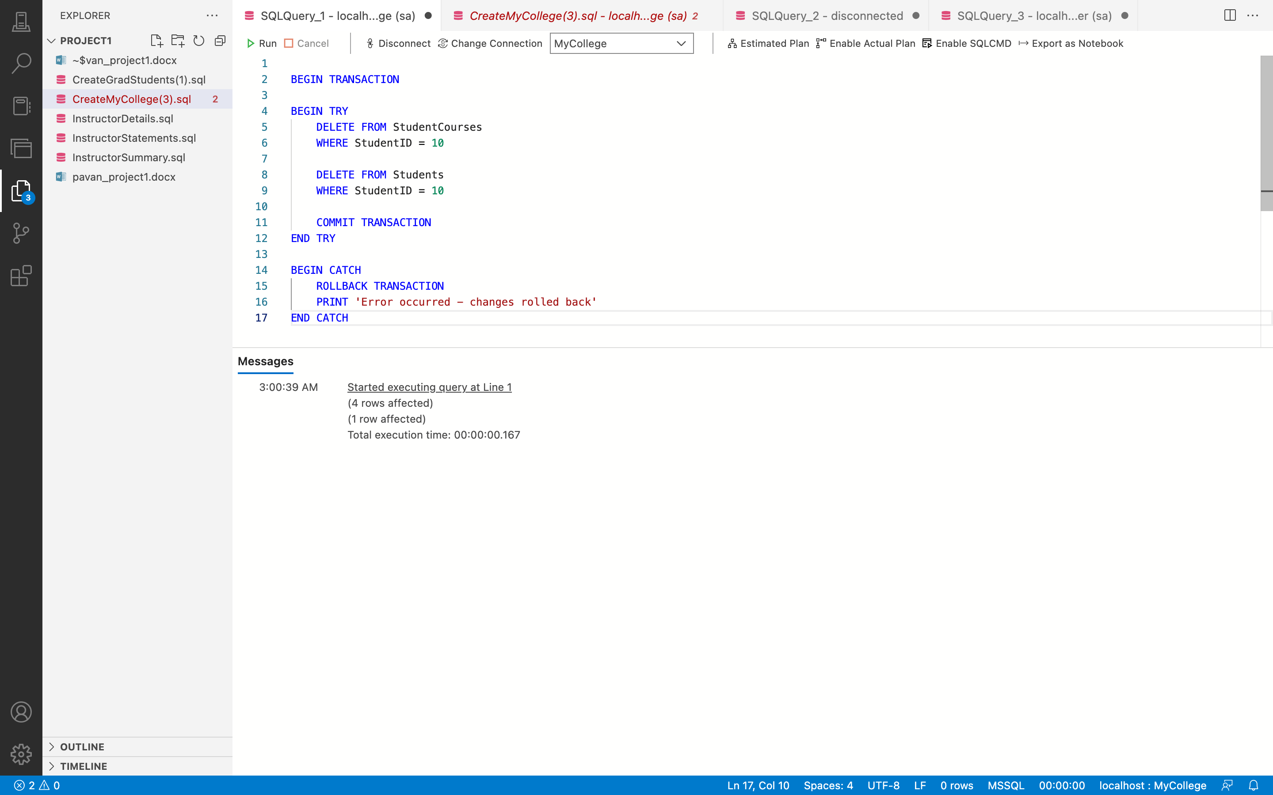

**Remarks: -**

* This SQL query is a transaction that includes two statements to delete a student with ID 10 from the Students table. The first statement deletes all courses for that student from the StudentCourses table, and the second statement deletes the student from the Students table. If both statements execute successfully, the changes are committed. However, if an error occurs during execution, the transaction is rolled back, and any changes are undone. This helps ensure data integrity and consistency by preventing partial updates or data loss. The BEGIN TRY and BEGIN CATCH statements are used to handle any errors that may occur during the execution of the transaction.
* You can see all the code and the output above in the given screenshot.

Section: - D

Database Design

1. Create a database diagram that shows the relationships between the tables in the MyCollege database. You can use any digital tool to draw your diagrams. "Resources and Links" tab on this Blackboard page lists several tools for drawing E/R diagrams.

**Answer 1: -**

**Remarks: -**

* The table for students has five columns. The primary key is the StudentID column, which has the data type int. The columns for first and last names are of the varchar type (25). The datetime2 type is used for the EnrollmentDate column (0). GraduationDate is a date-typed field.
* The Table of Courses has six columns. The primary key is an int-type column called CourseID. The type of the CourseNumber column is an int. The type of the CourseDescription column is varchar (50). The int type applies to the CourseUnits column. Foreign keys for the DepartmentID and InstructorID columns were created using the Departments and Instructors tables, respectively.
* The StudentCourses table has two columns. Int foreign keys from the Students and Courses tables, respectively, are used in the StudentID and CourseID columns. There are eight columns in the table called Teachers. InstructorID serves as the primary key for the type int. The columns for first and last names are of the varchar type (25). The status column is a char column (1).
* The column headed "DepartmentChairman" is of the bit variety. Date data can be found in the HireDate field. The annual salary field contains monetary data. A foreign key from the Departments database was used to create the int-type DepartmentID column. The Departments table has two columns. DepartmentID is an integer-type primary key. DepartmentName is a varchar type column (40). The table for tuition has three columns. The smallmoney type applies to the columns PartTimeCost, FullTimeCost, and PerUnitCost. Each table has a one-to-many relationship, including the tables for students and student courses, courses and student courses, departments and courses, instructors and courses, and departments and instructors.
* You can see all the code and the output above in the given screenshot.

**Design:**

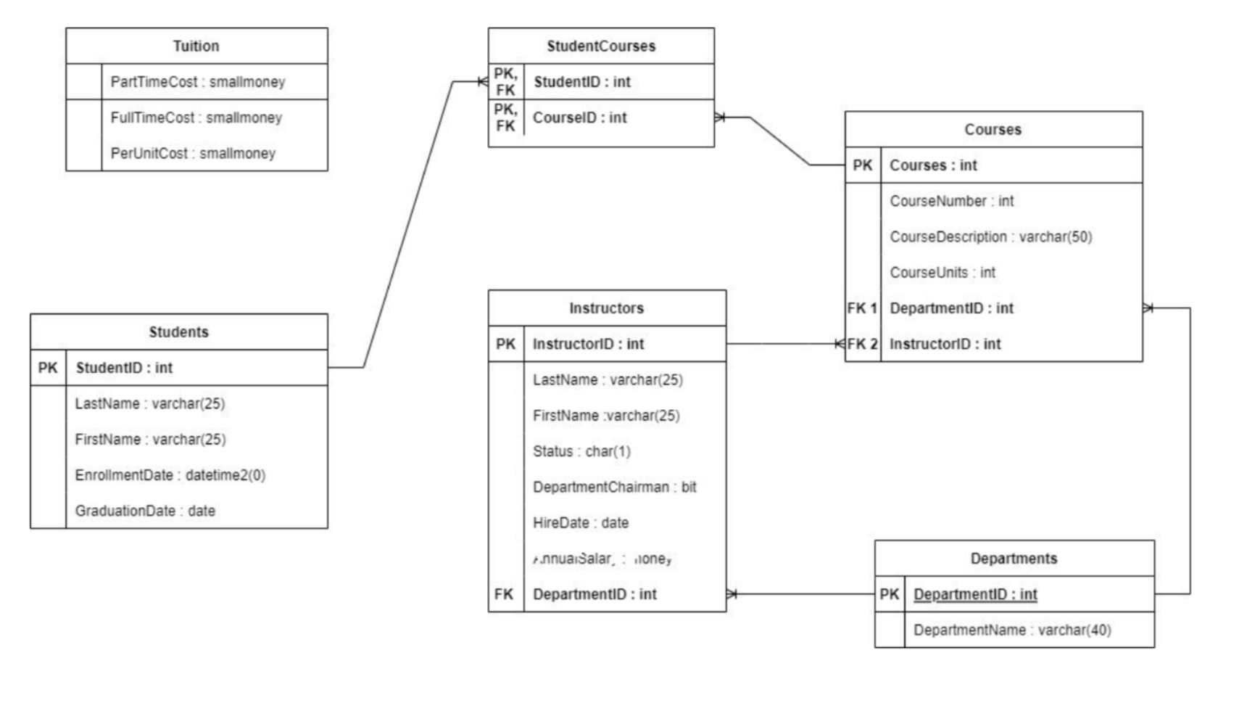

1. Design a database diagram for a database that stores information about the downloads that users make from a book website.
   * Each user must have a user name, email address, first name, and last name.
   * Each user can have zero or more downloads.
   * Each download must have a filename, download date/time, the IP of the downloading site.
   * Each book can be related to zero or more downloads.
   * Each book must have a filename, title, authors, publisher, ISBN, publisher, year.

**Answer 2: -**

**Output: -**

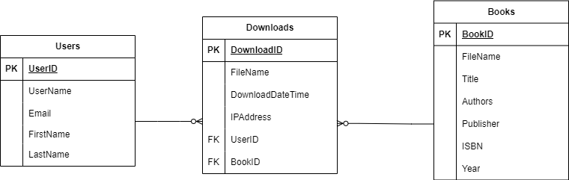

**Remarks: -**

* In this diagram, the "User" table stores information about users, including their user ID, username, email, first name, and last name. Each user can have zero or more downloads, which are captured in the "Download" table. The "Download" table contains information about each download, including the download ID, filename, downloadDateTime, IP address of the downloading site, and the IDs of the user and book associated with the download and both of them are foreign key.
* The "Book" table stores information about books, including the book ID, filename, title, authors, publisher, ISBN, and year. Each book can be related to zero or more downloads, which are captured in the "Download" table through the book ID.
* Note that this is just one possible design for a database that stores information about downloads from a book website, and there are many other ways you could organize this data. The optimal design will depend on the specific requirements and constraints of the system you are building.

1. Analyze your diagram and normalize it to its third-normal form.

**Answer 3: -**

**Output: -**

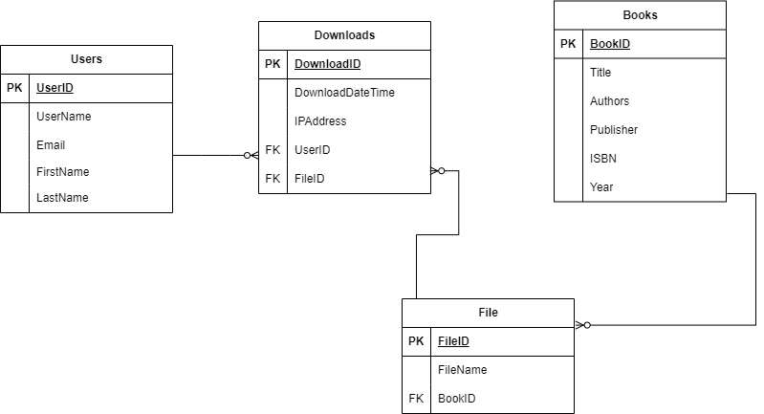

**Remarks: -**

* In the revised structure, we have removed the "File" column from the "Book" table and added a foreign key "BookID" column that references the "File" table. This allows us to eliminate the transitive dependency between the "File" and "Book" tables.
* Therefore, the tables are now in third-normal form, and each column depends only on the primary key of the respective table, and there are no transitive dependencies.

Remarks

This project effectively uses SQL Server Management Studio to load and manipulate databases. The following topics are covered: fundamental queries, keywords, statements, operators, joins, subqueries, summary queries, aggregate functions, datatypes, and tables. Insertion, deletion, and updating are all types of data change. The subjects addressed include views, scripts, scalar and table valued functions, database implementation, and others. Additionally, creating a database using an E-R diagram is a crucial step. The bulk of the important SQL and database principles are the subject of this project.